5.1 SUBSTANCE ABUSE SERVICES OPEN ENROLLMENT
APPLICATION

INSTRUCTIONS

Application must be completed and signed in Section 5 (Certification) for it to be accepted by DFPS.

Applicant will submit Application and all required documents in the format and order described in Appendix A to the Point of Contact in Open Enrollment Section 1.2.

If DFPS has difficulty accessing the Applicant’s documents, the Applicant will be required to re-submit documents as directed by DFPS.

- APPLICANT INFORMATION

Legal Name of Applicant/Entity
Office Address
City, State, Zip
Mailing Address
City, State, Zip
Phone
Vendor ID Number: | Federal ID Number – If different from Vendor ID:  Applicant:  Parent Organization:
Doing Business As Name (DBA) or Parent Organization – If different from Legal Name above:

Attach a copy of Assumed Name Certificate

If an Applicant has a Parent Organization, attach a copy of the agreement between the Applicant and the Parent Organization
Type of Applicant – Check appropriate box(es) and attach documentation as indicated
Sole Proprietorship
Private Corporation  For Profit  Non-Profit | State of Incorporation:  Charter Number:  Attach a copy of Certificate of Incorporation
Limited Liability Company (LLC) | Attach a copy of the Articles of Formation
Partnership  Limited  General | Attach a list of names, addresses for each partner and provide a copy of the Partnership Agreement.
Governmental Entity
Do you have taxing authority? Yes No
Are you a certified Texas HUB?
Yes – Attach a copy of HUB certification form.
No – Select all that apply if you fall into one or both of the categories
below:
Minority Owned Business Woman Owned Business
Person Authorized to Sign Contract:
Name |  | Title
E-mail |  | Phone
Contact for Service Delivery:
Name |  | Title
E-mail |  | Phone
Contact for Invoicing:
Name |  | Title
E-mail |  | Phone

- ELIGIBILITY REQUIRMENTS
(See Section 2.16 Contractor Qualifications of the Open Enrollment)

  - Does Applicant hold a valid and current Texas State Licensure and Credentials, in Section 2.16.2, at the time this Application is submitted?

Yes If yes, attach copy of License.
No If no, STOP – Applicant does not qualify.

  - Does Applicant meet the insurance requirements in Section 2.17 of the Open Enrollment?

Yes If yes, attach documentation of coverage provided for in Section 2.20. The certificate of insurance must be issued to DFPS or designate DFPS as a Certificate Holder.
No If no, STOP – Applicant does not qualify.

- SERVICES TO BE PROVIDED

Contractor must provide Substance Abuse Assessment and Treatment Services as specified in Provider Enrollment HHS00011952. Contractor must provide all Support Services specified in HHS0011952 upon DFPS request.

Substance Abuse Assessment and Treatment Services
Service | Service Type | Applying For
Substance Abuse Services | Substance Abuse Assessment  Individual and Group Counseling | Yes | No
Support Services | Court Related Services  Diagnostic Consultation  Translator & Interpreter | As requested by DFPS

- SERVICE DELIVERY LOCATIONS

- You must determine which counties will be served and mark them in Attachment A-4 Service Delivery Areas. Contractor must provide services within each county selected.

- Will you, your staff, or subcontractors be delivering services from established office sites other than the location listed in Section c. (below) of this application?
Yes No

If yes, services from these satellite locations are to be billed as In-Office. Designate any satellite office on Attachment A-4 Service Delivery Areas.

- Indicate locations in which the Contractor is willing to provide services.

In-Office Out-of-Office Home-Based (client's home)

- Will you, your staff, or other subcontractors be delivering telehealth services in addition to at least one of the locations listed in Sections a - c of this application? Note: If you elect to provide telehealth services, you must also provide either In-Office, Out-of-Office or Home-based services in the same region(s) and counties in which you are electing to provide telehealth services.

Yes No

NOTE: If yes, telehealth services must be billed as In-Office.

- CERTIFICATION

I certify that the information provided in this application is, to the best of my knowledge, complete and accurate; that the named legal entity has authorized me, as its representative, to submit this application; and that the legal entity complies with all terms of this Open Enrollment.
Signature of Authorized Representative | Date
Name of Authorized Representative (Printed) | Title of Authorized Representative (Printed)

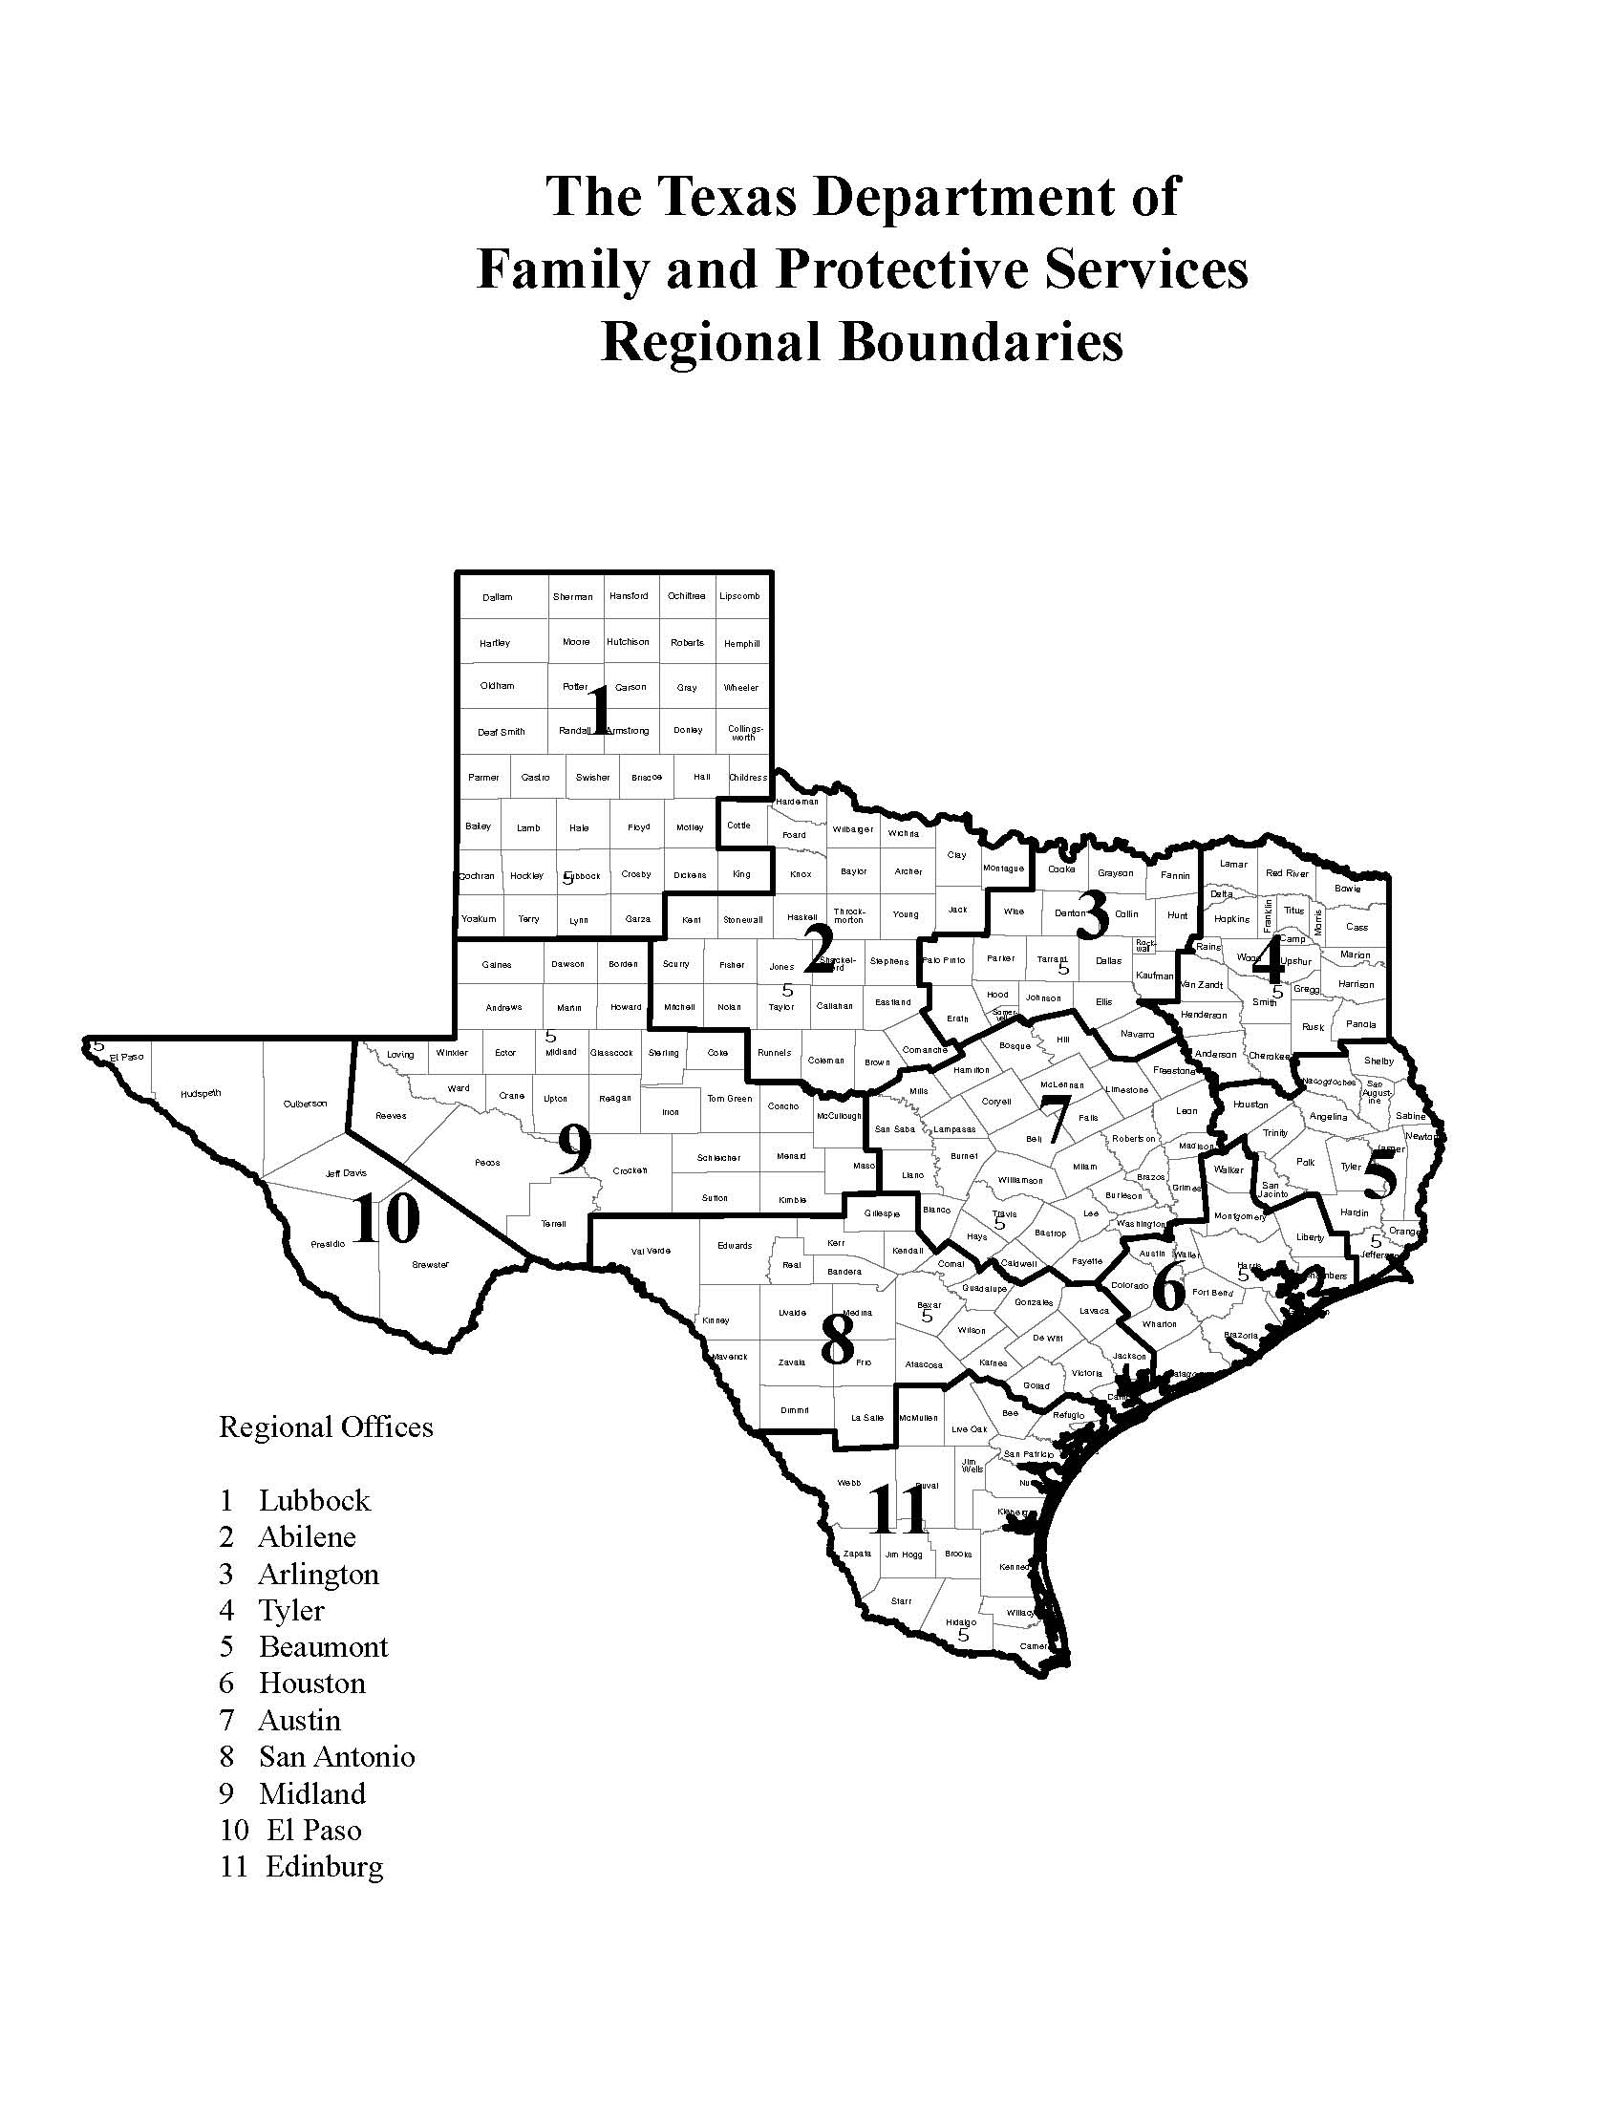

Attachment A-4 Service Delivery Area

Service Delivery Area
Counties To Be Served – Region 1
Choose the counties within the Region where services will be provided. Check (“√”) the box in front of the county name. Choose a single county or any combination of counties.
Regional Counties
☐ Armstrong |  | ☐ Hockley
☐ Bailey |  | ☐ Hutchinson
☐ Briscoe |  | ☐ King
☐ Carson |  | ☐ Lamb
☐ Castro |  | ☐ Lipscomb
☐ Childress |  | ☐ Lubbock
☐ Cochran |  | ☐ Lynn
☐ Collingsworth |  | ☐ Moore
☐ Crosby |  | ☐ Motley
☐ Dallam |  | ☐ Ochiltree
☐ Deaf Smith |  | ☐ Oldham
☐ Dickens |  | ☐ Parmer
☐ Donley |  | ☐ Potter
☐ Floyd |  | ☐ Randall
☐ Garza |  | ☐ Roberts
☐ Gray |  | ☐ Sherman
☐ Hale |  | ☐ Swisher
☐ Hall |  | ☐ Terry
☐ Hansford |  | ☐ Wheeler
☐ Hartley |  | ☐ Yoakum
☐ Hemphill

Service Delivery Area
Counties To Be Served – Region 2
Choose the counties within the Region where services will be provided. Check (“√”) the box in front of the county name. Choose a single county or any combination of counties.
Regional Counties
☐ Archer |  | ☐ Kent
☐ Baylor |  | ☐ Knox
☐ Brown |  | ☐ Mitchell
☐ Callahan |  | ☐ Montague
☐ Clay |  | ☐ Nolan
☐ Coleman |  | ☐ Runnels
☐ Comanche |  | ☐ Scurry
☐ Cottle |  | ☐ Shackelford
☐ Eastland |  | ☐ Stephens
☐ Fisher |  | ☐ Stonewall
☐ Foard |  | ☐ Taylor
☐ Hardeman |  | ☐ Throckmorton
☐ Haskell |  | ☐ Wichita
☐ Jack |  | ☐ Wilbarger
☐ Jones |  | ☐ Young

Service Delivery Area
Counties To Be Served – Region 3
Choose the counties within the Region where services will be provided. Check (“√”) the box in front of the county name. Choose a single county or any combination of counties.
Regional Counties
☐ Collin |  | ☐ Johnson
☐ Cooke |  | ☐ Kaufman
☐ Dallas |  | ☐ Navarro
☐ Denton |  | ☐ Palo Pinto
☐ Ellis |  | ☐ Parker
☐ Erath |  | ☐ Rockwall
☐ Fannin |  | ☐ Somervell
☐ Grayson |  | ☐ Tarrant
☐ Hood |  | ☐ Wise
☐ Hunt

Service Delivery Area
Counties To Be Served – Region 4
Choose the counties within the Region where services will be provided. Check (“√”) the box in front of the county name. Choose a single county or any combination of counties.
Regional Counties
☐ Anderson |  | ☐ Marion
☐ Bowie |  | ☐ Morris
☐ Camp |  | ☐ Panola
☐ Cass |  | ☐ Rains
☐ Cherokee |  | ☐ Red River
☐ Delta |  | ☐ Rusk
☐ Franklin |  | ☐ Smith
☐ Gregg |  | ☐ Titus
☐ Harrison |  | ☐ Upshur
☐ Henderson |  | ☐ Van Zandt
☐ Hopkins |  | ☐ Wood
☐ Lamar

Service Delivery Area
Counties To Be Served – Region 5
Choose the counties within the Region where services will be provided. Check (“√”) the box in front of the county name. Choose a single county or any combination of counties.
Regional Counties
☐ Angelina |  | ☐ Polk
☐ Hardin |  | ☐ Sabine
☐ Houston |  | ☐ San Augustine
☐ Jasper |  | ☐ San Jacinto
☐ Jefferson |  | ☐ Shelby
☐ Nacogdoches |  | ☐ Trinity
☐ Newton |  | ☐ Tyler
☐ Orange

Service Delivery Area
Counties To Be Served – Region 6
Choose the counties within the Region where services will be provided. Check (“√”) the box in front of the county name. Choose a single county or any combination of counties.
Regional Counties
☐ Austin |  | ☐ Liberty
☐ Brazoria |  | ☐ Matagorda
☐ Chambers |  | ☐ Montgomery
☐ Colorado |  | ☐ Walker
☐ Fort Bend |  | ☐ Waller
☐ Galveston |  | ☐ Wharton
☐ Harris

Service Delivery Area
Counties To Be Served – Region 7
Choose the counties within the Region where services will be provided. Check (“√”) the box in front of the county name. Choose a single county or any combination of counties.
Regional Counties
☐ Bastrop |  | ☐ Hill
☐ Bell |  | ☐ Lampasas
☐ Blanco |  | ☐ Lee
☐ Bosque |  | ☐ Leon
☐ Brazos |  | ☐ Limestone
☐ Burleson |  | ☐ Llano
☐ Burnet |  | ☐ Madison
☐ Caldwell |  | ☐ McLennan
☐ Coryell |  | ☐ Milam
☐ Falls |  | ☐ Mills
☐ Fayette |  | ☐ Robertson
☐ Freestone |  | ☐ San Saba
☐ Grimes |  | ☐ Travis
☐ Hamilton |  | ☐ Washington
☐ Hays |  | ☐ Williamson

Service Delivery Area
Counties To Be Served – Region 8
Choose the counties within the Region where services will be provided. Check (“√”) the box in front of the county name. Choose a single county or any combination of counties.
Regional Counties
☐ Atascosa |  | ☐ Karnes
☐ Bandera |  | ☐ Kendall
☐ Bexar |  | ☐ Kerr
☐ Calhoun |  | ☐ Kinney
☐ Comal |  | ☐ La Salle
☐ De Witt |  | ☐ Lavaca
☐ Dimmit |  | ☐ Maverick
☐ Edwards |  | ☐ Medina
☐ Frio |  | ☐ Real
☐ Gillespie |  | ☐ Uvalde
☐ Goliad |  | ☐ Val Verde
☐ Gonzales |  | ☐ Victoria
☐ Guadalupe |  | ☐ Wilson
☐ Jackson |  | ☐ Zavala

Service Delivery Area
Counties To Be Served – Region 9
Choose the counties within the Region where services will be provided. Check (“√”) the box in front of the county name. Choose a single county or any combination of counties.
Regional Counties
☐ Andrews |  | ☐ Mason
☐ Borden |  | ☐ McCulloch
☐ Coke |  | ☐ Menard
☐ Concho |  | ☐ Midland
☐ Crane |  | ☐ Pecos
☐ Crockett |  | ☐ Reagan
☐ Dawson |  | ☐ Reeves
☐ Ector |  | ☐ Schleicher
☐ Gaines |  | ☐ Sterling
☐ Glasscock |  | ☐ Sutton
☐ Howard |  | ☐ Terrell
☐ Irion |  | ☐ Tom Green
☐ Kimble |  | ☐ Upton
☐ Loving |  | ☐ Ward
☐ Martin |  | ☐ Winkler

Service Delivery Area
Counties To Be Served – Region 10
Choose the counties within the Region where services will be provided. Check (“√”) the box in front of the county name. Choose a single county or any combination of counties.
Regional Counties
☐ Brewster |  | ☐ Hudspeth
☐ Culberson |  | ☐ Jeff Davis
☐ El Paso |  | ☐ Presidio

Service Delivery Area
Counties To Be Served – Region 11
Choose the counties within the Region where services will be provided. Check (“√”) the box in front of the county name. Choose a single county or any combination of counties.
Regional Counties
☐ Aransas |  | ☐ Live Oak
☐ Bee |  | ☐ McMullen
☐ Brooks |  | ☐ Nueces
☐ Cameron |  | ☐ Refugio
☐ Duval |  | ☐ San Patricio
☐ Hidalgo |  | ☐ Starr
☐ Jim Hogg |  | ☐ Webb
☐ Jim Wells |  | ☐ Willacy
☐ Kenedy |  | ☐ Zapata
☐ Kleberg

Satellite Offices and Additional Office Information:

Please provide a schedule in the table(s) below indicating days and times routinely available to provide services at each service location. These represent only routine days and times. Applicant will be expected to adjust schedule to accommodate the needs of clients and DFPS. Refer to PEN Section 2.5 for additional information. Use additional copies of this section, as necessary, to provide complete information.

Name of Applicant/Contractor

1.
Service Delivery Address
City, State, Zip
Phone |  | Fax
Contact Person |  | E-mail

 | HOURS
DAY | From | To | From | To
Example | 7 AM | Noon | 2 PM | 7 PM
Monday
Tuesday
Wednesday
Thursday
Friday
Saturday
Sunday

2.
Service Delivery Address
City, State, Zip
Phone |  | Fax
Contact Person |  | E-mail

 | HOURS
DAY | From | To | From | To
Monday
Tuesday
Wednesday
Thursday
Friday
Saturday
Sunday

3.
Service Delivery Address
City, State, Zip
Phone |  | Fax
Contact Person |  | E-mail

 | HOURS
DAY | From | To | From | To
Monday
Tuesday
Wednesday
Thursday
Friday
Saturday
Sunday

Appendix A – Application Instructions

- Applicant must submit a completed Application and Required Forms, as applicable, in the order listed below for File Folder 1 and File Folder 2.
- Access the forms by the link or icon provided below by holding down the "Ctrl" key while clicking on the link.
- Save forms in an electronic file.
- For the Application and the forms that require signature, print, sign and scan in an electronic format. Scanned documents must be clear and legible.
- Attach File Folders 1 and 2 to email and submit the completed Application to the Point of Contact listed in the Open Enrollment Section 1.2.

Appendix B – Required Forms

File Folder 1: Application and Service Delivery Area

Electronic File Name | Description | Required or  If Applicable
Application | Application for Enrollment | Required
Insurance | Insurance Documentation | Required
Attachment A-4 | Service Delivery Area Form | Required
DBA | Assumed Name Certificate Attachment | If applicable
Incorporation | Certificate of Incorporation Attachment | If applicable
LLC | LLC Articles of Formation Attachment | If applicable
Partnership | Partnership Agreement Attachment | If applicable
Partners | Names and addresses and for each partner | If applicable
HUB | HUB Certification Form | If applicable

File Folder 2: Supporting Documentation

Exhibit No. | Type of Supporting Documentation
Exhibit 1 | Completed PCS-102SUD
Exhibit 2 | Copy of LCDC License of direct service providers listed on the PCS-102SUD

File Folder 3: Required Forms

The following forms are located on the DFPS public website, Doing Business with DFPS, Contracting Forms: https://www.dfps.state.tx.us/Doing_Business/forms.asp

Electronic File Name | Form Number and Name | Purpose
AP-152 | AP-152, Application for Texas Identification Number [If you already have a Vendor ID set up for another DFPS contract, print form, note “Already Set Up” at top of page, and provide number | Application for identification number
74-176 | 74-176, Vendor Direct Deposit Form | Direct Deposit Authorization
9007FFS | 9007FFS, Internal Control Structure Questionnaire | Contractor's disclosure of internal controls. Instructions included.
9105 | 9105, Risk Analysis Questionnaire (RAQ) | Questionnaire for provider to assist staff with the completion of the Risk Assessment Instrument (RAI).

The following form is located on the DFPS public website, Doing Business with DFPS, Contracting Forms, Regional CPS Contracting Forms, General Documents:
https://www.dfps.state.tx.us/Doing_Business/Purchased_Client_Services/Regional_CPS_Contracts/forms.asp

Electronic File Name | Form Number and Name | Purpose
PCS-102SUD | PCS-102SUD, Contracting Entity and List of Staff, Subcontractors and Volunteers | Contractors must list the contracting entity, all service providers, and requested provider information on this form and submit it electronically to DFPS.
2970C | Disclosure and Consent to Release of Information | Release of information regarding criminal history or DFPS abuse and neglect history.
2971C | Request for Criminal History and DFPS History Check | Application for requesting criminal history and DFPS abuse or neglect history.

