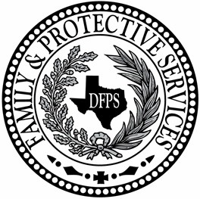 **Texas Department of Family and Protective Services**

**ADDENDA**

#### To

**Open Enrollment**

**HHS0011952**

**For**

**Substance Abuse Services**

**________________________________________________**

Notice is hereby given to prospective applicants to the above referenced open enrollment that changes have been made to requirements or information in the open enrollment, as noted in the addenda below.

**(Note**: In the column with the heading "Open Enrollment Reference", the references to "Package" refer to the link, as listed on the HHSC Open Enrollment Opportunities webpage and Electronic State Business Daily (ESBD) posting of this open enrollment.)

|  |  |  |  |
| --- | --- | --- | --- |
| **Addendum #1**  **June 17, 2024** | | | |
| |  |  |  |  | | --- | --- | --- | --- | | **Item** | **Open Enrollment**  **Reference** | **Previous** | **Revised Language** | | | | |
| **1.** | Package 1 Cover Page:  (Provider  Enrollment for: Substance Abuse Services) | **Jaime Masters, DFPS Commissioner** | **Stephanie Muth, DFPS Commissioner** |
| **2.** | Package 2: (Application & Required Forms) | **Attachment A-4 Service Delivery Area**  All counties in all regions open. | **Attachment A-4 Service Delivery Area**  Region 6 is closed and not accepting applications. |