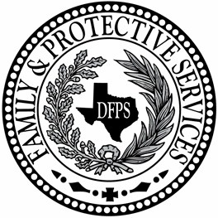 Texas Department of Family and Protective Services

ADDENDA

To
Open Enrollment
HHS0011802

For

Out of State Courtesy Supervision Services

________________________________________________

Notice is hereby given to prospective applicants to the above referenced open enrollment that changes have been made to requirements or information in the open enrollment, as noted in the addenda below.

(Note: In the column with the heading "Open Enrollment Reference", the references to "Package" refer to the link, as listed on the HHSC Open Enrollment Opportunities webpage posting of this open enrollment.)

ADDENDUM #1 –
September 9, 2025

Item No. | Reference | Previous Information | Revised Information
1. | Provider Enrollment for Out of State Courtesy Supervision | Cover Page: Jamie Masters, DFPS Commissioner | Audrey O’Neill, Acting Commissioner, Acting Commissioner
2. | Provider Enrollment for Out of State Courtesy Supervision | N/A | Added: Section 1.7.3 The Contractor must review and sign the DFPS Vendor Certifications and Affirmations (Form 4543). See Appendix B of the Application.
3. | Provider Enrollment for Out of State Courtesy Supervision | Electronic State Business Daily (ESBD) references in Section 1. | Removed all references to the ESBD
4. | Application and Required Forms | Section 6. Certification | Section 6. DFPS VENDOR CERTIFICATIONS AND AFFIRMATIONS  The Applicant must review and sign the DFPS Vendor Certifications and Affirmations (Form 4543), which are incorporated by reference to the Contract. See Appendix B.
5. | Application and Required Forms | Section 6. Certification | Section 7. Certification
6. | Application and Required Forms | Appendix B – Required Forms  File Folder 1: Application | New form included:  Texas Department of Family and Protective Services Vendor Certifications and Affirmations (Form 4543)

