NOTICE OF OPEN ENROLLMENT (OE)

Residential Treatment Center Private Purchase Beds

Health and Human Services Commission

OE # HHS0006821

Enrollment Period Opens: 10/28/2019

Enrollment Period Closes: 08/31/2024

Class/Item No.: 952/62

Table of Contents
I. INTRODUCTION AND DEFINITIONS 3
A. Introduction 3
B. Definitions 3
II. PROCUREMENT TERM 6
III. ELIGIBLE APPLICANTS 6
IV. PROGRAM INFORMATION 7
A. Scope of Work 7
B. Performance Measures 15
C. Invoice and Payment 16
D. Legal Authority 16
E. Civil Rights Requirements 17
V. PROCUREMENT AND ADMINISTRATIVE REQUIREMENTS 17
A. OE Point of Contact 17
B. Submission 18
C. Screening and Evaluation Process 18
D. Rejection of OE Applications 18
E. Right to Amend or Withdraw OE 19
F. Administrative Requirements 19
VI. APPLICATION INSTRUCTIONS AND CRITERIA FOR ACCEPTANCE 19
VII. BLANK FORMS AND INSTRUCTIONS 20
FORM A: Respondent Information 20
FORM B: Contact Person Information Form 22
FORM C: Description of RTC Services 23
FORM D: RTC Re-Enrollment 25
VIII. APPENDICIES 26
APPENDIX A: HHSC Assurances - Non-Construction Programs 26
APPENDIX B: HHSC Uniform Terms and Conditions 30
APPENDIX C: HHSC Data Use Agreement 52
APPENDIX D: Contract Affirmations 64

I. INTRODUCTION AND DEFINITIONS

A. Introduction

The Health and Human Services Commission (HHSC) announces this Open Enrollment (OE) requesting applications to support the provision of Residential Treatment Center (RTC) services for children under the age of 18 with a serious emotional disturbance. All children or youth referred for treatment will be identified by HHSC as having a medical and behavioral health need for a Residential Treatment Center level of care. HHSC will pay contracted providers the Intense Plus Residential Treatment Center rate established by the Department of Family and Protective Services (DFPS) and published on the DFPS 24-Hour Residential Child Care Reimbursement Rates webpage. Contracted providers must bill Medicaid or other third-party payors for all other services provided within the Residential Treatment Center, which includes, but is not limited to psychiatric, nursing or medication management services, or psychological, psychotherapy or counseling services.

B. Definitions

Standard Definitions

Appendix – Additional information and/or forms that are located at the end of this document, which are part of this solicitation document.

Applicant – A person or entity that submits a response to a solicitation. For purposes of this document, “applicant” is intended to include such phrases as “offeror”, “applicant”, “bidder”, “responder”, or other similar terminology employed by HHSC to describe the person or entity that responds to a solicitation.

Contingency Contract – Also called a "contract" in this OE, a written document referring to promises or agreements for which the law establishes enforceable duties and remedies between a minimum of two parties.

Contract Term – The period during which the contract will be effective from begin date to end, or renewal date.

Cost Reimbursement – A payment mechanism in which funds are provided to carry out approved contract activities. Reimbursement is based on actual allowable costs incurred that comply with contractual requirements.

Debarment – An exclusion from contracting or subcontracting with state agencies based on cause set forth in Title 34, Texas Administrative Code, §20.581 et seq.

Deliverables – Goods or services contracted for delivery or performance.

Due Date – Established deadline for submission of a document or deliverable.

Effective Date – The date the contract term begins.

Fee-for-Service – Payment mechanism for services that are reimbursed on an agreed rate per unit of service.

Fully Executed – A contract that is signed by all the parties to form a legal binding contractual relationship. Activities under the contract will not begin and payments to the contractor will not be made until the contract is fully executed.

Procurement and Contracting Services – The division within the Health and Human Services Commission (HHSC) that provides direction and support of purchasing, contracting and HUB services. PCS oversees, coordinates, and assists the Mental Health & Substance Abuse Division with procurement needs, issues open enrollments and competitive procurements. PCS maintains the official contract file from procurement to contract closeout.

Program – Depending upon the context, either a coordinated group of activities carried out by HHSC, as authorized by state or federal law, for a specific purpose (“program”) or HHSC staff located in a program, region, or hospital that identify and request procurement needs (“Program”). The Program partners with PCS on procurements.

Scope or Statement of Work (SOW) – A description of the services and/or goods to be delivered by the HHSC contractor specifying the type, level and quality of service, that directly relate to program objectives within this solicitation.

Section 504 -- Section 504 of the Rehabilitation act of 1973

Solicitation – The process of notifying prospective contractors of an opportunity to provide goods or services to the state (e.g., this OE).

Special Provisions – Modifications or additions to the General Provisions for a funded program activity, which are usually customized for the Program’s requirements and contain provisions specific to the Program Attachment.

Subcontractor – A written agreement between the HHSC contractor and a third party to provide all or a specified part of the services, goods, work, and materials required in the original contract. The contractor remains entirely responsible to HHSC for performance of all requirements of the contract with HHSC. The contractor must closely monitor the subcontractor’s performance. Subcontracting can be done only when expressly allowed in the program attachment.

Taxpayer Identification Number (TIN) – Eleven-digit identification number used by the Internal Revenue Service (IRS) in the administration of tax laws. It is issued either by the Social Security Administration (SSA) or by the IRS.

Vendor Identification Number (Vendor ID No. or VIN) – Fourteen-digit number needed for any entity to contract with the State of Texas and which must be set up with the State Comptroller’s Office. It consists of a ten-digit identification number (IRS number, state agency number, or social security number) + check digit + three-digit mail code. The VIN includes all the numbers in the TINs (defined above), including a three-digit mail code for a total of 14 digits.

The remainder of this page is intentionally left blank.

II. PROCUREMENT TERM

Grant contracts will be awarded only for the purposes specifically defined in this OE, and applications will be reviewed in the order in which they are received. Grant contracts awarded under this OE will begin on the effective date defined in the contract and will terminate August 31, 2024. HHSC, at its own discretion, may renew contracts up to one additional five-year term.

The remainder of this page is intentionally left blank.

III. ELIGIBLE APPLICANTS

Respondents must be established as a legal entity and have the authority to do business in Texas. In addition, Respondents must meet and comply with the criteria listed below at the time the application is submitted and continue to meet the eligibility conditions throughout the procurement term.

- The address at which the RTC operates must be within the State of Texas.
- The RTC must be licensed by HHSC Residential Child Care Regulation (RCCR)as a General Residential Operations (GRO) RTC and be in good standing with RCCR based on RCCR regulation activities.
- HHSC will perform a check for debarment/suspension through the Federal System for Award Management (SAM) and the Comptroller of Public Accounts (CPA). In compliance with CPA’s rules, HHSC’s verification of eligibility will also conduct a name search of applicants during the contract award phase using the websites listed in this section. A Respondent will be considered ineligible to contract with HHSC, regardless of the funding source, if a name match is found on any of the following lists:
- CPA’s list of Vendors Debarred from doing business with the State of Texas;
- CPA Franchise Tax Check (for status of good standing);
- CPA’s Divestment Statute Lists
  - list of companies that boycott Israel;
  - list of Scrutinized Companies with Ties to Sudan;
  - list of Scrutinized Companies with Ties to Iran;
  - list of Designated Foreign Terrorist Organization, and
  - list of Scrutinized Companies with Ties to Foreign Terrorist Organizations.
- The System of Award Management (SAM) for parties excluded from receiving federal contracts, certain subcontracts and from certain types of federal financial and non-financial assistance and benefits at https://www.sam.gov/SAM/; and
- The Office of the Inspector General (OIG) List of Excluded Individuals/Entities.

The remainder of this page is intentionally left blank.

IV. PROGRAM INFORMATION

A. Scope of Work

- HHSC/DFPS will refer children or youth for RTC services based on the following variables:
  - geographic proximity to the family’s county of residence;
  - age and gender of the child or youth;
  - family choice of provider;
  - clinical needs of the child or youth;
  - Grantee’s available treatment protocols;
  - Grantee’s availability of a bed; and
  - Grantee’s willingness to admit the child or youth based on face-to-face interviews with the child or youth and family and/or a thorough review of all assessment and treatment documents submitted as part of a standard referral packet.
- HHSC will provide Grantee with the following information to make an admission determination:
- DFPS Referral Form 2037;
- A completed common application for RTC placement;
- A psychological assessment completed within the past year;
- Any additional requested behavioral health treatment history not included in the common application for RTC placement;
- A copy of the most recent Child and Adolescent Needs and Strengths (CANS) assessment completed by the LMHA; and
- A Relinquishment of Avoidance Understanding form indicating parent’s/guardian’s/Legally Authorized Representative (LAR)’s commitment to reunification and engagement throughout treatment.
- Grantee’s admitting psychiatrist and office of admissions shall make the final determination of the Child/Youth’s eligibility for admission to the RTC.
- Grantee shall admit the Child/Youth for treatment if the admitting psychiatrist recommends the Child/Youth is an appropriate clinical match with the RTC.
  - Grantee shall review the referral packet and make the determination of service eligibility. Grantee must be able to meet the acute clinical needs of the referred Child/Youth. Grantee shall notify HHSC of said eligibility determination within 2 business days.
  - Upon determination of appropriateness for admission, Grantee shall notify HHSC and an admission date will be established. An authorization form for admission will be signed by the Children’s Mental Health Manager for bed payment and forwarded to Grantee.
  - Throughout the Child’s/Youth’s treatment, the Grantee shall work with HHSC and the respective Local Mental Health Authority (LMHA) to ensure continuity of care, discharge planning and follow-up treatment services are available to the Child/Youth upon discharge from the RTC. The Grantee’s Case Manager and the LMHA’s Case Manager shall have at least weekly communication regarding progress toward discharge and reunification of the Child/Youth and parent/guardian/LAR.
  - Should the Grantee determine at any point throughout treatment that the referred Child/Youth is not appropriate for the RTC, Grantee shall notify HHSC and the LMHA by phone or email and provide written documentation to the RTC Coordinator no later than the following business day. An emergency staffing shall occur by phone or in person to include the LAR, Clinical Staff of the RTC, Case managers, and other relevant participants to ensure appropriate notification and after-care planning. Refer to Section Transition and Discharge Planning of this document regarding procedures for planned/unplanned discharge.
  - Grantee shall send follow-up notification to HHSC and the LMHA describing the issues preventing the Child/Youth from continuing in treatment at the RTC.
- Grantee Requirements for Intense Plus Rate
  - Grantee must provide individualized and strength-based, child guided, and family driven clinical treatment services to the Child. These services shall be provided with cultural and linguistic competency. Clinical treatment services shall ensure that a trauma-informed approach is used when assessing a child fo treatment. Services shall link residential treatment services with community services. Services shall be research-based, and evidence and practice-informed.
  - Grantee must provide the following services in alignment with the Intense-Plus rate:
    - 24-hour supervision to ensure the child’s safety and sense of security, including adequate supervision up to constant one-to-one monitoring during waking hours by an employee trained on the therapeutic interventions and able to provide immediate on site response;
    - Participation in individual and group therapy sessions that are research-supported, reimbursable by Medicaid, and readily available in the community. These include but are not limited to specialized therapies such as Eye Movement Desensitization and Reprocessing Therapy, Applied Behavior Analysis (certified), Treatment for Anorexia/Bulimia/Eating Disorders, and others as appropriate;
    - Use of therapeutic programs that are documented as either well supported, supported, promising practice of evidence based and are appropriate to the child’s age and development to promote the child’s well-being.
    - Therapy must address trauma and the behaviors resulting in the need for Intense-Plus level of care;
    - Contact, in a manner that is deemed in the best interest of the child, with siblings, family members, and other persons significant to the child in order to maintain a sense of identity and culture;
    - Services to help the child learn or improve skills and functioning for daily living
    - Medical intervention and therapy that is structured daily, and professionally designed and supervised to help the child attain functioning more appropriate to the child’s age and development and to address the behavior resulting in the need for Intense-Plus services;
    - Consistent and constant direction, intervention, and structured support to help the child attain stabilization and connect appropriately with the child’s environment;
    - Professionally directed, designed and monitored interventions for a child with intellectual or developmental disabilities, to enhance mobility, communication, sensory, motor, cognitive development, behavioral and self-help skills.
- Grantee shall provide comprehensive residential treatment services to the Child/Youth admitted to the RTC for treatment. Required elements of comprehensive residential treatment services include but are not limited to:
- Assessment and evaluation:
- Grantee shall assess and plan treatment for the Child/Youth using professional, trained, skilled, and competent staff. Such assessment and treatment planning shall take into consideration:
- The child’s/youth’s and parent’s/guardian’s/LAR’s values;
- Religious affiliations;
- Motivation;
- Disabilities (physical and cognitive);
- Developmental level;
- Literacy;
- Language;
- Culture;
- Age;
- Medical conditions;
- Substance use history;
- Trauma history;
- Child’s/youth’s/family’s strengths; and
- Transition plans with family's reunification goals.
    - Grantee shall assess the Child/Youth for treatment needs through a Recovery Team. The Recovery Team shall include:
- Clinical Director;
- Program Director;
- Administrator;
- Therapist;
- Case Manager;
- Parent/Guardian/LAR;
- Child/Youth; and
- House Manager.
iii. The Recovery Team may also include:
- Natural Supports;
- Community Supports; and
- Other Medical Professional(s), if warranted.
iv. Grantee’s supervising psychiatrist shall provide the Child/Youth with an initial psychiatric evaluation upon admission. This must describe the reason for admission and must support the admission diagnosis given based on the current version of the Diagnostic and Statistical Manual of Mental Disorders (DSM).
v. The Recovery Team and the psychiatrist, shall identify the Child’s/Youth’s current health status to determine if referral to other providers (i.e., consultant medical staff, psychologist, speech/hearing therapist, physical therapy, etc.) for additional assessment is indicated during treatment. The Child/Youth admitted to the RTC must be medically stable and not require 24 hour medical/nursing care.
vi. Grantee shall provide the Child/Youth with immediate access to medical care throughout the course of treatment.
vii. Grantee shall provide psychotropic medications to the Child/Youth as prescribed.
viii. The Child’s/Youth’s educational level and needs shall be assessed to determine grade level and appropriate methods of instruction. Grantee shall provide appropriate grade level educational services based on the results of the educational assessment. The Child’s/Youth’s primary teacher shall complete a current Individual Education Plan (IEP) that conforms to local school district IEP requirements. Grantee shall place the IEP in the chart and review it quarterly to ensure the IEP remains current.
ix. Grantee shall assess the need for, and provide social, recreational, and habilitation services throughout treatment. These services should be provided during after school/evening and weekend hours, and when education classes are not in session. Grantee shall provide both on and off-campus socialization events to promote integration into the community. Grantee shall determine the Child’s/Youth’s eligibility to participate in various programs based on their level of treatment progress and approval by the attending Recovery Team.
x. Grantee shall administer a nutritional assessment to the Child/Youth and, based on the assessment results, Grantee shall provide the Child/Youth with well-balanced, nutritious meals. Food allergies must be considered.
6. Clinical Treatment Services:
- Grantee shall provide individualized and strength-based, child/youth guided, and family driven clinical treatment services to the Child/Youth. These services shall be provided with cultural and linguistic competency. Clinical treatment services shall ensure that a trauma-informed approach is used when assessing a child/youth for treatment. Services shall link residential treatment services with community services. Services shall be research-based, and evidence and practice-informed. Grantee’s attending psychiatrist, (on-staff psychiatrist or consulting psychiatrist) shall provide direct treatment of the Child/Youth as well as the following services:
i. Supervise Recovery Team staff in the development and implementation of the Individual Treatment Plan (ITP) for the Child/Youth. The ITP will be conducted according to the following clinical schedule:
- The initial ITP shall be conducted at the 14th day after admission;
- The ITP update shall be conducted at the 3rd month post-admission;
- The Transition Plan and Discharge Summary and/or ITP update shall be conducted at the 6th month post admission. A Transition Plan must be developed and included at this stage to measure preparedness of the family for the child/youth to return to the community and ensure community resources are in place;
- The Transition Plan and Discharge Summary and/or ITP update shall be conducted at the 9th month post admission; and
- Where applicable, the Transition Plan, Discharge Summary, and ITP update shall be conducted at the final month services are provided.
ii. Evaluate for and, when indicated, prescribe the appropriate psychotropic medication and monitoring for response and adverse reaction(s) with indicated adjustment of medications. Provide psychiatric consults monthly at a minimum.
iii. Order and follow-up on indicated laboratory tests for medication(s) prescribed.
iv. Maintain contact with parent/guardian/LAR and community treatment and support staff and obtain consent for prescribing medication from the parent/guardian/LAR.
v. At time of discharge, complete or review and approve the transition and discharge summary to provide meaningful treatment information for continuity of care purposes.
b. The Recovery Team Coordinator shall perform the following services:
i. Under the direction of the Director of Treatment Services, provide therapeutic services to the Child/Youth and serve as a member of the Recovery Team
ii. Consult with the Recovery Team and facility staff regarding daily programs, individual and group dynamics of residential living, treatment of high-risk behaviors, special interventions and training on various aspects of the behavioral health treatment of the Child/Youth.
iii. Develop the ITP in conjunction with the Recovery Team, and under direction of the psychiatrist. The ITP shall include, but is not limited to:
  - Brief description of the Child/Youth;
  - Summary of child/youth and family strengths;
  - Summary of psychosocial history;
  - Health and developmental history;
  - Treatment history to-date;
  - Presenting problems and needs;
  - Diagnostic formulation (data substantiating the diagnosis);
  - Diagnosis based on the current DSM;
  - Case formulation (the clinician’s hypotheses about underlying dynamics/issues that drive and maintain problematic behaviors, emotions and/or cognitions);
  - Criteria for completing treatment; and
  - Objectives and measurable treatment goals that focus on skill building, family involvement, and community integration.
iv. Conduct Recovery Team conference calls at least once a month that involve HHSC, the LMHA, and the LAR. During this time, the RTC shall provide updates on measurable treatment goals and objectives, and communication regarding treatment of the Child/Youth.
c. Grantee shall provide the following required elements of comprehensive treatment services:
i. Psychopharmacological Therapy (if indicated based on psychiatric evaluation): The treatment of psychiatric illness with psychotropic medication on an ongoing basis.
ii. Psychotherapy and counseling: Individual, family, and group therapy focused on the reduction or elimination of a Child’s/Youth’s symptoms of serious emotional disturbance and increasing the individual’s ability to perform activities of daily living must be provided.
- Grantee shall engage the Child/Youth and the parent/guardian/LAR in family therapy no later than six weeks after the Child/Youth has been admitted to the RTC. This process shall be coordinated by the RTC Case Manager.
- Grantee shall provide the following sessions for the Child/Youth:
  - Individual;
  - Family; and
  - Group (Optional).
- All sessions should be enacted on a weekly basis by the 6th week after the Child/Youth has been admitted to the RTC.
- Grantee shall give preference to treatment interventions considered evidence-based practices.
- Grantee shall provide all counseling services to the Child/Youth by a Licensed Professional of the Healing Arts (LPHA) practicing within the scope of their own license or by an individual with a master’s degree in a human services field pursuing licensure under the direct supervision of an LPHA, if not billed to Medicaid.
iii. Behavior Management: The Grantee shall provide a Child/Youth-centered, evidence-based, and Trauma-Informed Care treatment approach. Behavior management treatment approaches shall be provided with a focus on reinforcement and prevention methods while using the least restrictive procedures likely to be effective. The grantee shall use evidence-based practices to prevent, reduce or eliminate the use of punishment procedures, seclusion, and restraint.
iv. Recreation: Therapeutic Recreation is a planned process which utilizes techniques to assess, prescribe, treat, and evaluate the success of treatment for the Child/Youth who experiences significant barriers to leisure fulfillment. These barriers include the lack of physiological, psychological, and/or social skills. Recreational and other leisure-time activity services provide for the development, maintenance, and expression of an appropriate leisure/social lifestyle for Child’s/Youth’s with mental, physical, emotional, or social limitations.
v. Habilitation: This includes training in competencies and skills that Children/Youth will need in the specific environments where they will reside when they leave the facility. Vocational evaluation and prevocational training shall be made available to Children/Youth for whom those services are clinically indicated.
vi. Educational Requirements: Children/Youth who are determined to meet eligibility criteria to receive Section 504 or special education services shall receive those services at the RTC or in partnership with the local independent school district in accordance with federal and state rules and regulations. The education team shall complete an IEP or Section 504 plan for each Child/Youth under their direction. This does not preclude a Child/Youth from being enrolled in regular education classes if that setting meets the identified education needs of the Child/Youth and the Child/Youth has the social skills to adequately learn in that setting. The school calendar may be based on the year-round attendance model.
vii. Family/Youth Engagement and Inclusion: The Grantee shall extend efforts to provide clinical strategies for engaging families to ensure treatment is Child/Youth guided; Family-driven; and Culturally Competent. Evidence-based practices should be used to meet the needs of the youth and family that is strength based and includes the child/youth, parent/guardian, natural supports, community supports, and clinical/therapeutic staff. The child/youth should be permitted to have access to parents/guardians via phone calls upon admission and throughout the duration of their participation in services at the RTC, notwithstanding punishment or denial of access due to reasons of adjustment from initial separation from the parent/guardian. Parents shall engage in Family Therapy on a weekly basis after enacted by the RTC upon the 6th week after the Child/Youth has been admitted. In cases where transportation is a barrier for the parent(s)/guardian(s) to attend family therapy in person, the Grantee shall provide alternative ways to include them. Parents shall be active participants in the recovery process and reunification goals/strategies shall be assessed at each ITP meeting. (Please refer to section I.,C.,2. Clinical Treatment Services, a.,1) of this document for schedule of ITP Meetings)
viii. Transition and Discharge Planning: Planning for discharge starts at the time of the initial assessments by the Recovery Team and shall be coordinated with HHSC and respective LMHA. Discharge planning should be youth and family driven, as families decide which services and supports they will need from the residential program and from the community for the youth to return home. Transition of the child/youth shall be assessed at each ITP update to determine child/youth’s readiness to return home and to the community. Prior to discharge, a “Continuity of Care” conference shall be held with participation by the Child’s/Youth’s Recovery Team, RTC Coordinator, referring LMHA, and any other relevant designated parties. The attending psychiatrist (or other psychiatrist providing coverage) must write the discharge order. Grantee shall document this process and provide the discharge summary assessment to the parent/guardian/LAR at discharge. An additional written copy of the discharge summary shall be provided to HHSC within two business days. If there are unforeseen circumstances that prompt an immediate discharge, the Grantee shall communicate with the parent/guardian/LAR, HHSC and all parties involved in the Child’s/Youth’s treatment. If there are geographical constraints involving an unplanned discharge, the Grantee and the parent/guardian/LAR shall come to an agreement regarding transportation at the time of discharge. Grantee shall maintain physical custody of the Child/Youth until such point that a safe transfer is scheduled. After date of discharge, HHSC will no longer be responsible for payment of bed through the RTC Project.
ix. Chaplaincy Services: Chaplaincy services include but are not limited to:
- Regularly scheduled worship based on the Child’s/Youth’s religious affiliation;
- Pastoral care if requested by the Child/Youth; and
- Special religious activities for the Child’s/Youth’s religious development and spiritual formation which include but are not limited to:
- Bible studies;
- Religious movies;
- Community gospel music events;
- Youth participation in chapel music; and
- Other religious activities as needed and requested.
- Grantee’s Documentation Requirements
        - Treatment records shall be filed in the Child’s/Youth’s on-site chart (hard copy or electronic) including:
i. Copies of all referral documents;
ii. Copies of all assessments, evaluations, and treatment summaries performed by the Grantee;
iii. A copy of the Child’s/Youth’s ITP, including documentation of treatment plan reviews and Recovery Team staffing related to the Child/Youth;
iv. Copies of progress notes for all treatment modalities (individual therapy, group therapy, family therapy, recreational therapy, psychiatric consultation, case management activity, etc.);
v. A copy of the transition and discharge plan;
vi. A copy of the Child’s/Youth’s IEP or Section 504 plan;
vii. Medical progress notes; and
viii.A copy of the reunification agreement signed by the parent/guardian/LAR.
        - The Child’s/Youth’s charts and all records relating to the care of the Child/Youth shall be made available to HHSC and the referring LMHA upon request.
        - While the Child/Youth is receiving services from Grantee and post-discharge, Grantee shall provide copies of Child’s/Youth’s medical records to the Child’s/Youth’s parent/guardian/LAR upon request. Grantee shall provide medical records directly to the Child’s/Youth’s parent/guardian/LAR.
- Additional Grantee Requirements
              - Safety: Grantee shall provide 24- hour supervision to ensure the Child’s safety and sense of security, including constant one-to-one monitoring during waking hours by an employee trained on the Child’s therapeutic interventions and able to provide immediate on-site response. Grantee shall provide professionally directed, designed and monitored interventions for a Child with intellectual or developmental disabilities, to enhance mobility, communication, sensory, motor, cognitive development, behavioral and self-help skills.
              - Grantee shall deliver all services by appropriately licensed/certified/trained staff. Personnel records must reflect current licenses/certifications/training records for all staff.
              - Grantee shall comply with Health Information Portability and Accountability Act (HIPAA) requirements and all other applicable laws at all times.
              - Grantee shall supply the Child/Youth and parent/guardian/LAR with a list of residents’ rights and responsibilities as well as a formal complaint process while a resident of the RTC.
              - Grantee shall provide families with a clear system for communicating with the Child/Youth. In accordance with this section, nothing herein shall be construed as prohibiting or penalizing communication between Grantee and the Child/Youth and parent/guardian/LAR regarding available treatments options, including Medically Necessary or appropriate care for the Child/Youth. The Grantee shall facilitate access to the Child/Youth so long as it is not interfering with the course of treatment.
              - Grantee shall ensure physical safety of all RTC residents at all times.
              - Grantee shall maintain an inventory of the Child’s/Youth’s clothing and personal items that are of substantial medical, monetary, or sentimental value by:
i. Completing an inventory of clothing and personal items at admission; and
ii. Updating the inventory of clothing and personal items at least quarterly and at time of discharge.
              - Regarding room, board and furnishings, Grantee shall:
i. Provide the Child/Youth with a bed, sheets, towels, blankets, bedspreads, pillows, mattresses, and other furnishings necessary to meet the Child’s/Youth’s needs. Grantee shall ensure that items are kept clean and in good repair.
ii. Ensure the Child/Youth has personal storage space for their clothing and personal items.
iii. Ensure the Child/Youth wears clothing that is clean, in good repair, and appropriate to the weather and/or activity in which the Child/Youth is participating.
iv. Provide behavioral, gender and age-appropriate living arrangements for the Child/Youth.
              - Grantee shall conduct and document in personnel files DFPS background checks, found at: https://www.dfps.state.tx.us/Background_Checks/default.asp, on the Grantee’s employees, subcontractors, volunteers, and all individuals who have direct contact with the Child/Youth or direct access to their records.
              - Grantee shall maintain at all times a written disaster and emergency response plan, policies and procedures to address internal and external emergencies. Disasters may include but are not limited to acts of nature (such as floods, hurricanes, fires or tornadoes), chemical or hazardous material spills, critical equipment failure, weapons of mass destruction events, and acts of terrorism. In the event of an emergency requiring evacuation or quarantine, the Grantee is responsible for maintaining the safety and placement of the Child/Youth resident in its care. All staff and subcontractor of the Grantee must be aware of the disaster plan requirements and be prepared to fulfill their role in executing the plan.
              - Grantee shall at all times, permit access to all Children/Youth placed by HHSC, to the respective LMHA Continuity of Care Officer and parent/guardian/LAR.
              - Grantee shall communicate disaster plans to HHSC and parent/guardian/LAR in the case of a disaster response initiative.
              - Grantee shall ensure the family remains connected to the LMHA throughout the duration of residential services If LAR chooses not to participate in LMHA services, RTC services may be at risk.
              - It is recommended that the Grantee should engage in ongoing training and technical assistance as recommended or provided by HHSC or seek training opportunities independently.
              - Grantee shall report number of available beds to HHSC’s RTC subject matter expert on a bi-weekly basis via email. If Grantee is aware of vacancies prior to the standard two-week notification, such information should be provided immediately.
- Additional Grantee Services
- Grantee shall refer the Child/Youth to other resources when the Child/Youth has special needs the facility cannot provide for or when another resource may be more appropriate to provide for those needs. These resources, where applicable, will abide by the Joint Commission (formerly the Joint Commission on Accreditation of Healthcare Organizations) standards concerning confidentiality of client information. Referrals may include but are not limited to:
i. Computerized Tomography (CT) Scans, magnetic resonance imaging (MRIs), and other radiographic assessments;
ii. Clinical examinations, assessments, and consultations that are not within the professional domain of the RTC staff;
iii. All procedures (elective and non-elective);
iv. Dental care; and
v. The prescription and preparation of appropriate hearing aids, eyeglasses, and other prosthetic devices.
- Grantee shall make referrals for medical/dental services only to appropriately licensed facilities or clinicians that have been approved by the RTC Director of Medical Services.
- Grantee shall provide emergency first aid at the RTC. More definitive and comprehensive emergency services shall be provided by licensed emergency transports and a Joint Commission accredited hospital/facility.
- Appeals of Clinical Necessity:
- Appeals: In the event that HHSC notifies Grantee that (i) proposed treatment or services for a referred Child/Youth will not be Certified; or (ii) treatment or services for a referred Child/Youth which had previously been Certified will no longer be Certified, Grantee shall not be entitled to an appeal of such non-Certification.
- Section Survival: The terms of this Article shall survive the termination of this Agreement and shall supersede any oral or written agreement entered into by any Child/Youth or other person acting on the Child’s/Youth’s behalf that is contrary to this Article.
- Records and Information:
- Maintaining Records: Grantee shall retain all records and information related to services provided pursuant to this Agreement for seven years from the date of service, except records relating to matters in litigation must be retained for seven years or five years following the termination or resolution of such litigation, whichever is longer. Grantee’s obligations to retain records and provide information hereunder shall survive the termination of this Agreement. The records maintained by Grantee with respect to the Child/Youth shall be and remain the property of Grantee.
- Access to Records: HHSC shall have access during all hours of program operation to the clinical information, books, records and papers of Grantee regardless of the media in which they are maintained relating to: (i) treatment or services provided to any referred Child/Youth, (ii) payments received from referred Child/Youth Members or from others on their behalf (hereinafter collectively referred to as “Documentation”). Upon five (5) days prior notice and without any cost to HHSC, Grantee shall allow HHSC to conduct an on-site audit of such Documentation. At Grantee’s discretion, Grantee may send HHSC copies of the Documentation with the letter of request, so that HHSC may conduct such audit in HHSC’ office.
- Transferred Records: Upon request of HHSC, Grantee shall, at its own expense, promptly provide HHSC with electronic or paper copies of all clinical records and information in specific to a referred Child/Youth in accordance with such request.
- Record Confidentiality: The obligations set forth in this Article shall be subject to applicable law pertaining to the confidentiality of medical, mental health or substance abuse records and shall survive the termination of this Agreement. Grantee will be responsible for obtaining any necessary referred Child/Youth consent to release such records to HHSC.
- Incident Reports: Grantee shall complete incident report forms and submit them to the RTC Coordinator within 24 hours of the incident or upon knowledge of when the incident occurred. A system of incident reporting will be made available through HHSC.

- Extension of Services:
Grantee shall assess the Child/Youth’s progress in treatment at the 7th month. If the Child/Youth does not meet the expected progress in treatment, Grantee shall submit to HHSC, a written request to extend the length of stay for the Child/Youth. Based on review of progress in treatment by HHSC, the length of stay may be extended if clinically indicated.

B. Performance Measures

1. Grantee shall provide HHSC with 24-hour phone and email contact information.
2. Grantee shall provide focused, intensive treatment services as outlined in the Scope of Work with an expected length of stay of six to nine months.
3. Grantee shall submit to HHSC by the 7th month, and where applicable, a written request to extend the length of stay for the Child/Youth based on progress in treatment. Grantee shall include updated progress note(s) to support the request. This extension shall be approved by HHSC.
4. Grantee shall, at the time of discharge, document in the goal reviews contained in the discharge summary the percentage of goals and objectives on which the Child/Youth made improvement and shall describe the course of treatment. , In the description of the course of treatment, documentation of the specific treatment plan adjustments made each time the individual’s behavior or psychological condition deteriorated or plateaued, as well as, the individual’s response to the changes, should be included.
5. Grantee shall inform HHSC no later than the following business day should the Child/Youth experience a change in status which includes but is not limited to hospitalization or juvenile detention placement.
6. Contractor shall submit all ITPs within 5 days of completing an ITP.
7. Contractor shall submit all progress notes and supporting clinical documentation on a bi-weekly basis.
8. Contractor shall submit all monthly Recovery Team meeting notes by the 30th of each month.
9. Grantee shall timely submit all reports, documentation, and other information required by this Contract electronically to mhcontracts@hhsc.state.tx.us, with a copy to the assigned Contract Manager and HHSC RTC Subject Matter Expert. Alternative submission arrangements must be approved by the assigned Contract Manager.

C. Invoice and Payment

1. HHSC RTC Project will pay Grantee the Intense-Plus residential treatment facility rate established by the DFPS and published on the DFPS 24-Hour Residential Child Care Reimbursement Rates webpage. Grantee must bill Medicaid or other third-party payors for all clinical services provided with the Residential Treatment Center.

2. Grantee will request payment monthly on or before the 15th of the following month, using the State of Texas Purchase Voucher Form 4116, which is incorporated by reference and can be downloaded at: https://hhs.texas.gov/laws-regulations/forms/4000-4999/form-4116-state-texas-purchase-voucher and which is incorporated by reference. At a minimum, Form 4116 shall include:
a. Name, address, and telephone number of Grantee;
b. System Agency Contract Number and/or Purchase Order Number;
c. The System Agency assigned identifying number of each Child/Youth receiving services;
d. The total number of days and associated amount invoiced; and
e. Any additional supporting documentation required by this Contract, or as requested by System Agency.
3. Grantee shall electronically submit monthly invoices with any required or requested supporting documentation to the Claims Processing Unit at hhsc_ap@hhsc.state.tx.us with a copy to mhcontracts@hhsc.state.tx.us, the assigned Contract Manager and the Program Liaison. Alternative submission arrangements must be approved by the assigned HHSC Contract Manager.

D. Legal Authority

HHSC has statutory authority to contract for services described in this OE pursuant to Health and Safety Code Section § 12.051 as transferred under Texas Government Code § 531.005(k).

E. Civil Rights Requirements

Contractors shall conduct their activities in accordance with federal and state laws prohibiting discrimination. Guidance for adhering to non-discrimination requirements can be found on the Health and Human Services Commission (HHSC) Civil Rights Office website at: https://hhs.texas.gov/about-hhs/your-rights/civil-rights-office/your-civil-rights

Upon request, a contractor must provide the HHSC Civil Rights Office with copies of all the contractor’s civil rights policies and procedures. Contractors must notify HHSC’s Civil Rights Office of any civil rights complaints received relating to performance under the contract no more than 10 calendar days after receipt of the complaint. Notice must be directed to:

HHSC Civil Rights Office
701 W. 51st Street, Mail Code W206
Austin, TX 78751
Phone Toll Free (888) 388-6332
Phone: (512) 438-4313
TTY Toll Free (877) 432-7232
Fax: (512) 438-5885

A contractor must ensure its policies do not have the effect of excluding or limiting the participation of persons in the contractor’s programs, benefits or activities on the basis of national origin, and must take reasonable steps to provide services and information, both orally and in writing, in appropriate languages other than English, in order to ensure that persons with limited English proficiency are effectively informed and can have meaningful access to programs, benefits, and activities.

Contractors must comply with Executive Order 13279, and its implementing regulations at 45 CFR Part 87 or 7 CFR Part 16, which provide that any organization that participates in programs funded by direct financial assistance from the U.S. Dept. of Agriculture or U.S. Dept. of Health and Human Services must not, in providing services, discriminate against a program beneficiary or prospective program beneficiary on the basis of religion or religious belief.

The remainder of this page is intentionally left blank.

V. PROCUREMENT AND ADMINISTRATIVE REQUIREMENTS

A. OE Point of Contact

For purposes of submitting questions concerning this OE, the only contact is the Mental Health Contract Management Unit. All communications concerning this OE must be submitted by email to:

MHContracts@hhsc.state.tx.us
Re: Open Enrollment # HHS0006821

Other employees and representatives of HHSC are not permitted to answer questions or otherwise discuss the contents of this OE with any applicants or potential applicants or their representatives. Failure to observe this restriction may result in disqualification of this or other subsequent enrollment applications. This restriction does not preclude discussions between affected parties to conducting business unrelated to this OE.

Questions will not be answered verbally. Questions must be submitted by email to the address above.

B. Submission

The original enrollment application must be submitted to the OE point of contact. HHSC will accept enrollment applications via email only to MHContracts@hhsc.state.tx.us.

Any alternative submission arrangements must be approved in writing by MHContracts@hhsc.state.tx.us.

C. Screening and Evaluation Process

Enrollment applications will be screened and evaluated according to the criteria below. All enrollment applications will be retained by HHSC and will not be returned to the applicant. Enrollment applications are evaluated for eligibility and completeness, as well as programmatic readiness. The eligibility criteria requirements include the following:

1. The original enrollment application Form A. Respondent Information and enrollment application bears an original signature of the authorized official of the applicant organization.
2. All required forms are present and are numbered sequentially.
3. Applicant meets the OE outlined in Article III and can provide all services included in Article IV.

In conducting the evaluation process, HHSC at its sole discretion may give applicants an opportunity to submit missing information or correct identified areas of noncompliance within two weeks of written notification by HHSC.

D. Rejection of OE Applications

- HHSC reserves the right to reject any or all enrollment applications and is not liable for any costs incurred by the applicant in the development or submission of the enrollment application.
- Any attempt by an employee, officer, or agent of the applicant to influence the outcome of HHSC’s review through contact with any Commissioner or staff member of HHSC or other Texas Health and Human Services agency will result in rejection of the enrollment application.
3. Any material misrepresentation in an enrollment application submitted to HHSC will result in rejection of the enrollment application.
4. Enrollment applications may be rejected for failure to meet applicant eligibility criteria or inability to perform required activities.

E. Right to Amend or Withdraw OE

HHSC reserves the rights to alter, amend, or modify any provisions of this OE or to withdraw this OE at any time prior to the execution of a contract if it is in the best interest of HHSC and the State of Texas. The decision of HHSC is administratively final. If this OE is amended or withdrawn notice will be posted to the ESBD.

F. Administrative Requirements

Applicant is not required to return the HHSC Uniform Terms and Conditions (i.e., Appendix B), or the HHSC Data Use Agreement (i.e., Appendix C) with the application, but by signing the Form A: Respondent Information, Applicant agrees to be bound by these documents. Applicant must complete and return the HHSC Assurances - Non-Construction Programs (i.e., Appendix A) and the Contract Affirmations (i.e., Appendix D) with the application.

The remainder of this page is intentionally left blank.

VI. APPLICATION INSTRUCTIONS AND CRITERIA FOR ACCEPTANCE

Applicant must submit all documents required by this OE. An application must be complete to be considered. HHSC expressly reserves the right to review and analyze the documentation submitted and determine the applicant’s eligibility. Applications must contain original signatures on all forms requiring signatures, and Applicant must submit one original application. A complete application consists of responses to all required forms. Applicant must place the Respondent Information (FORM A) at the front of the application packet. Beginning with the Form A, Respondent Information, Applicant must number every page of the application consecutively in the lower righthand corner.

The following application documents are required for Respondents who have not contracted with HHSC (formerly the Department of State Health Services) for the provision of RTC services under Open Enrollment # 53700-5-0000142756.

FORM A: Respondent Information
FORM B: Contact Person Information Form
FORM C: Description of RTC
APPENDIX A: Federal Forms APPENDIX D: Contract Affirmations

The following application documents are required for Respondents who have contracted with HHSC (formerly the Department of State Health Services) for the provision of RTC services under Open Enrollment # 53700-5-0000142756.

FORM A: Respondent Information
FORM D: RTC Re-Enrollment
APPENDIX A: Federal Forms APPENDIX D: Contract Affirmations

The remainder of this page is intentionally left blank.

VII. BLANK FORMS AND INSTRUCTIONS

Contractor must abide by the requirements contained in the following exhibits, as applicable:

FORM A: Respondent Information
FORM B: Contact Person Information Form
FORM C: Description of RTC
APPENDIX A: Federal Forms
APPENDIX B: HHSC Uniform Terms and Conditions – Grant
APPENDIX C: HHSC Data Use Agreement
APPENDIX D: Contract Affirmations

The remainder of this page is intentionally left blank.

FORM A: Respondent Information
This form requests basic information about the respondent and project, including the signature of the authorized representative. The respondent information page is the cover page of the proposal and must be completed in its entirety.
RESPONDENT INFORMATION
1) LEGAL BUSINESS NAME:
2) MAILING Address Information (include mailing address, street, city, county, state and 9-digit zip code): |  |  |  |  |  |  |  |  |  |  |  |  |  | Check if address change
3) PAYEE Name and Mailing Address, including 9-digit zip code (if different from above): |  |  |  |  |  |  |  |  |  |  |  |  |  | Check if address change
4) | DUNS Number (9-digit) required if receiving federal funds:
5) Federal Tax ID No. (9-digit), State of Texas Comptroller Vendor ID Number (14-digit) or Social Security Number (9-digit):
*The respondent acknowledges, understands and agrees that the respondent's choice to use a social security number as the vendor identification number for the contract, may result in the social security number being made public via state open records requests.
6) TYPE OF ENTITY (check all that apply):
 |  | City |  |  |  |  | Nonprofit Organization* |  |  |  |  | Individual
 |  | County |  |  |  |  | For Profit Organization* |  |  |  |  | Federally Qualified Health Centers
 |  | Other Political Subdivision |  |  |  |  | HUB Certified |  |  |  |  | State Controlled Institution of Higher Learning
 |  | State Agency |  |  |  |  | Community-Based Organization |  |  |  |  | Hospital
 |  | Indian Tribe |  |  |  |  | Minority Organization |  |  |  |  | Private
 |  |  |  |  |  |  | Faith Based (Nonprofit Org) |  |  |  |  | Other (specify):
*If incorporated, provide 10-digit charter number assigned by Secretary of State:
7) PROJECT CONTACT PERSON
Name:
Phone:
Fax:
Email:
The facts affirmed by me in this proposal are truthful and I warrant the respondent is in compliance with the OE terms and conditions, including HHSC’s Uniform Contract Terms and Conditions. I understand the truthfulness of the facts affirmed herein and the continuing compliance with these requirements are conditions precedent to the award of a contract. This document has been duly authorized by the governing body of the respondent and I (the person signing below) am authorized to represent the respondent.
8) AUTHORIZED REPRESENTATIVE |  |  |  |  | Check if change |  |  | 9) SIGNATURE OF AUTHORIZED REPRESENTATIVE
Name:
Title:
Phone:
Fax:
Email:
 |  |  |  |  |  |  |  | 10) DATE

FORM A: Respondent Information Instructions

This form provides basic information about the respondent and the proposed project with the Health and Human Services Commission (HHSC), including the signature of the authorized representative. It is the cover page of the proposal and is required to be completed. Signature affirms the facts contained in the respondent’s response are truthful and the respondent is in compliance with the OE terms and conditions, including HHSC’s Uniform Contract Terms and Conditions and acknowledges that continued compliance is a condition for the award of a contract. Please follow the instructions below to complete the respondent information page form and return with the respondent’s proposal.

- LEGAL BUSINESS NAME - Enter the legal name of the respondent.
- MAILING ADDRESS INFORMATION - Enter the respondent’s complete physical address and mailing address, city, county, state, and 9-digit zip code.
- PAYEE NAME AND MAILING ADDRESS - Payee – Entity involved in a contractual relationship with respondent to receive payment for services rendered by respondent and to maintain the accounting records for the contract; i.e., fiscal agent. Enter the PAYEE’s name and mailing address, including 9-digit zip code, if PAYEE is different from the respondent. The PAYEE is the corporation, entity or vendor who will be receiving payments.
- DUNS Number – 9- digit Dun and Bradstreet Data Universal Numbering System (DUNS) number. This number is required if receiving ANY federal funds and can be obtained at: http://fedgov.dnb.com/webform
- FEDERAL TAX ID or STATE OF TEXAS COMPTROLLER VENDOR ID NUMBER OR SOCIAL SECURITY NUMBER - Enter the Federal Tax Identification Number (9-digit) or the Texas Vendor Identification Number assigned by the Texas State Comptroller (14-digit). *The respondent acknowledges, understands and agrees the respondent's choice to use a social security number as its vendor identification number for the contract, may result in the social security number being made public via state open records requests.
- TYPE OF ENTITY - Check the type of entity as defined by the Secretary of State at
http://www.sos.state.tx.us/corp/businessstructure.shtml and/or the Texas State Comptroller at
https://fmx.cpa.state.tx.us/fmx/pubs/tins/tinsguide/2009-04/TINS_Guide_0409.pdf and check all other boxes that describe the entity.
Historically Underutilized Business: A minority or women-owned business as defined by Texas Government Code, Title 10, Subtitle D, Chapter 2161. (http://www.window.state.tx.us/procurement/prog/hub/)
State Agency: an agency of the State of Texas as defined in Texas Government Code §2056.001.ii
Institutions of Higher Education as defined by §61.003 of the Education Code.
Minority Organization is defined as an organization in which the Board of Directors is made up of 50% racial or ethnic minority members.
If a Non-Profit Corporation or For-Profit Corporation, provide the 10-digit charter number assigned by the Secretary of State.
- PROJECT CONTACT PERSON - Enter the name, phone, fax, and email address of the person responsible for the proposed project.
- AUTHORIZED REPRESENTATIVE - Enter the name, title, phone, fax, and email address of the person authorized to represent the respondent. Check the “Check if change” box if the authorized representative is different from previous submission to HHSC.
- SIGNATURE OF AUTHORIZED REPRESENTATIVE - The person authorized to represent the respondent must sign in this blank.
- DATE - Enter the date the authorized representative signed this form.

FORM B: Contact Person Information Form
Legal Name of Applicant:

This form provides information about the appropriate contacts in the applicant’s organization in addition to those on the Form A – Respondent Information. If any of the following information changes during the term of the contract, please send written notification to the Contract Management Unit.

Contact: |  |  |  |  | Mailing Address (incl. street, city, county, state, & zip):
Title:
Phone: |  |  | Ext.
Fax:
E-mail:
Contact: |  |  |  |  | Mailing Address (incl. street, city, county, state, & zip):
Title:
Phone: |  |  | Ext.
Fax:
E-mail:
Contact: |  |  |  |  | Mailing Address (incl. street, city, county, state, & zip):
Title:
Phone: |  |  | Ext.
Fax:
E-mail:
Contact: |  |  |  |  | Mailing Address (incl. street, city, county, state, & zip):
Title:
Phone: |  | Ext.
Fax:
E-mail:
Contact: |  |  |  |  | Mailing Address (incl. street, city, county, state, & zip):
Title:
Phone: |  | Ext.
Fax:
E-mail:

FORM C: Description of RTC Services

The RTC must provide all programmatic activities and clinical services required by DFPS General Residential Operations licensure. List all services provided to a child/youth placed in the RTC and who will provide the services.
- Please enter your DFPS General Residential Operation Licensure #.

- Describe the mission and vision of the RTC

- Describe the target population of this RTC including but not limited to, age, gender, population served (e.g. diagnosis, clinical needs) in the following format:
a. Description of target population
b. Ages
c. Gender
d. Clinical Needs or Diagnosis
e. Other

- List any special sub-populations that you serve (i.e., adolescent sex offenders; children with psychosis; dual diagnosis of substance abuse and mental health disorder, Autism Spectrum Disorder, dual diagnosis of mental health disorder and intellectual disabilities, transition age youth (e.g. up to age 18), etc.).

- List any population of children under the age of 18 that you exclude from admission to the RTC. Describe which clinical needs you might exclude from treatment at the RTC facility (e.g. sex offenders, children on probation in TJJD, children with aggressive behavior, children with fire-setting behavior, Autism Spectrum Disorder, etc.).

- Describe the RTC facilities including but not limited to the following information:
a. Description of residential services: number of RTC beds, how beds or buildings are organized (gender, age, clinical needs, special populations, etc.).
b. Type and number of facilities, structures or rooms (e.g. residential buildings or rooms, school, cafeteria, recreational, medical/physician office, nurse office, therapy rooms, garden, common areas, library, computer, admission, administration, seclusion room, etc.).

- List any specialized programs (e.g., equine therapy; ROPES course experiential Therapy, EMD, etc.) offered at the RTC.

- List the clinical services that are provided within your facility.

- What credentials and/or licenses do your service providers have?

FORM D: RTC Re-Enrollment

1. Respondent continues to be licensed by HHSC Residential Child Care Regulation (RCCR) as a General Residential Operation (GRO) RTC and be in good standing with RCCR based on RCCR regulation activities

Yes No License Number:

- By submitting this re-enrollment form, Respondent certifies:
  - It has contracted with HHSC (formerly the Department of State Health Services) for the provision of RTC services under Open Enrollment # 53700-5-0000142756.
  - It has read the contents of the OE and the information in this re-enrollment is true, correct, and complete. If Respondent becomes aware that any information in this re-enrollment is not true, correct, or complete, Respondent agrees to notify HHSC immediately.
  - It accepts the terms of this OE and all attachments/exhibits/appendices to the OE.

Printed Name:

Title:

Signature: _____________________________________

Date of Signature:

APPENDIX A: HHSC Assurances - Non-Construction Programs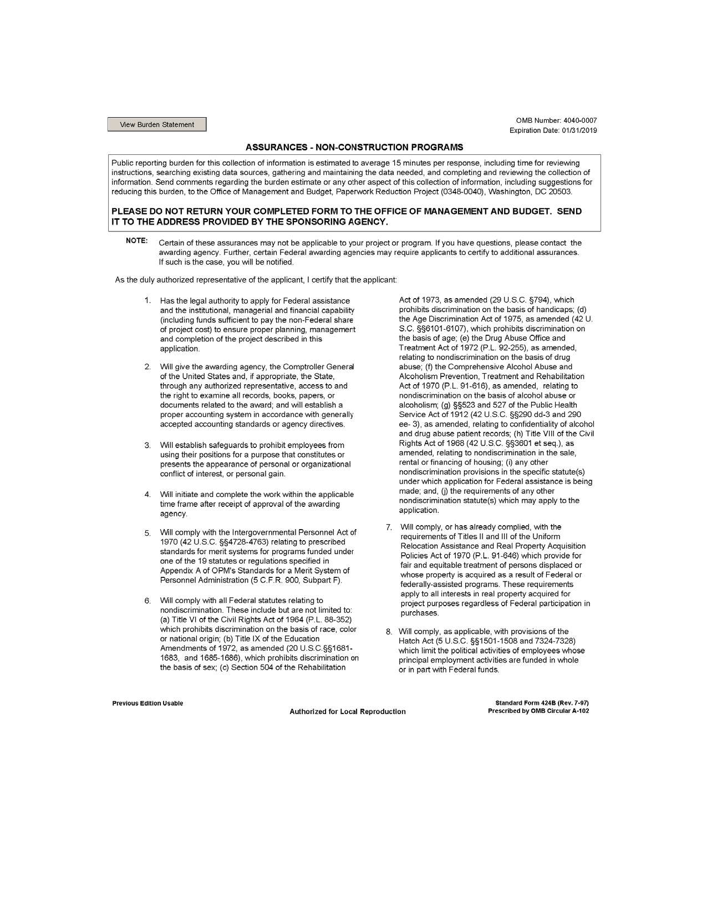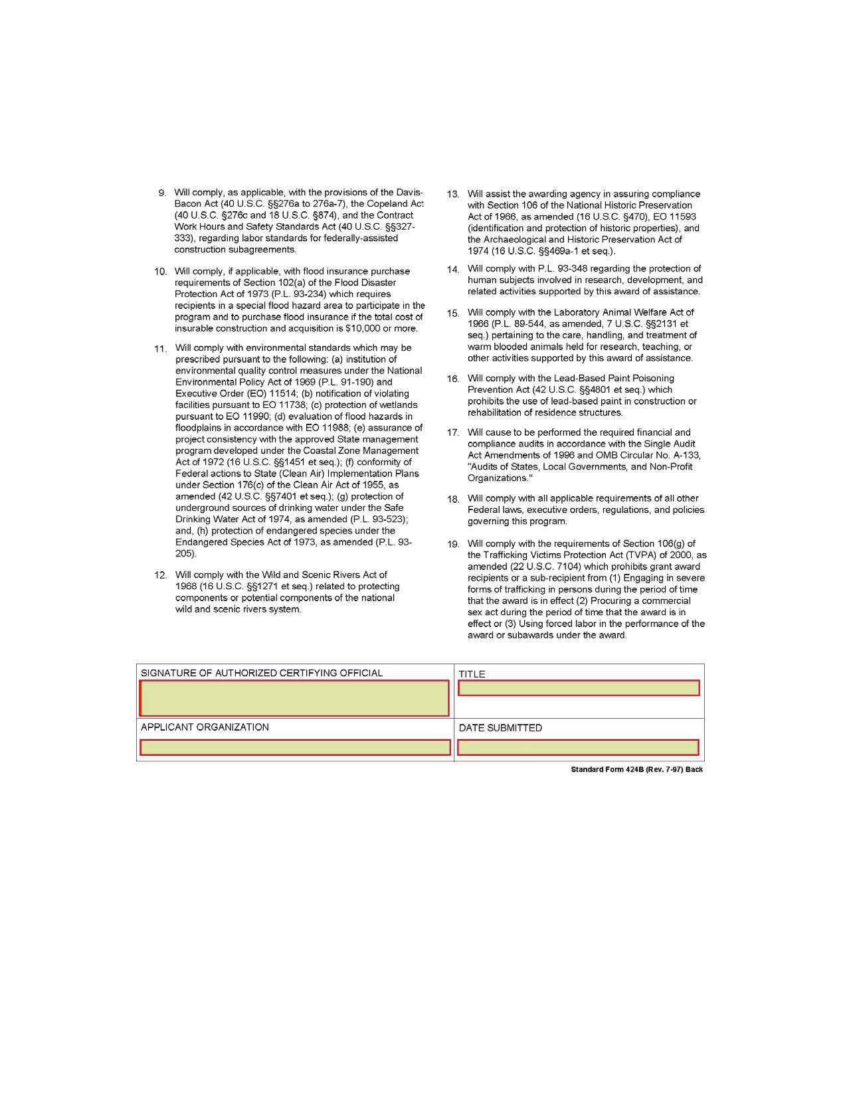

APPENDIX B: HHSC Uniform Terms and Conditions
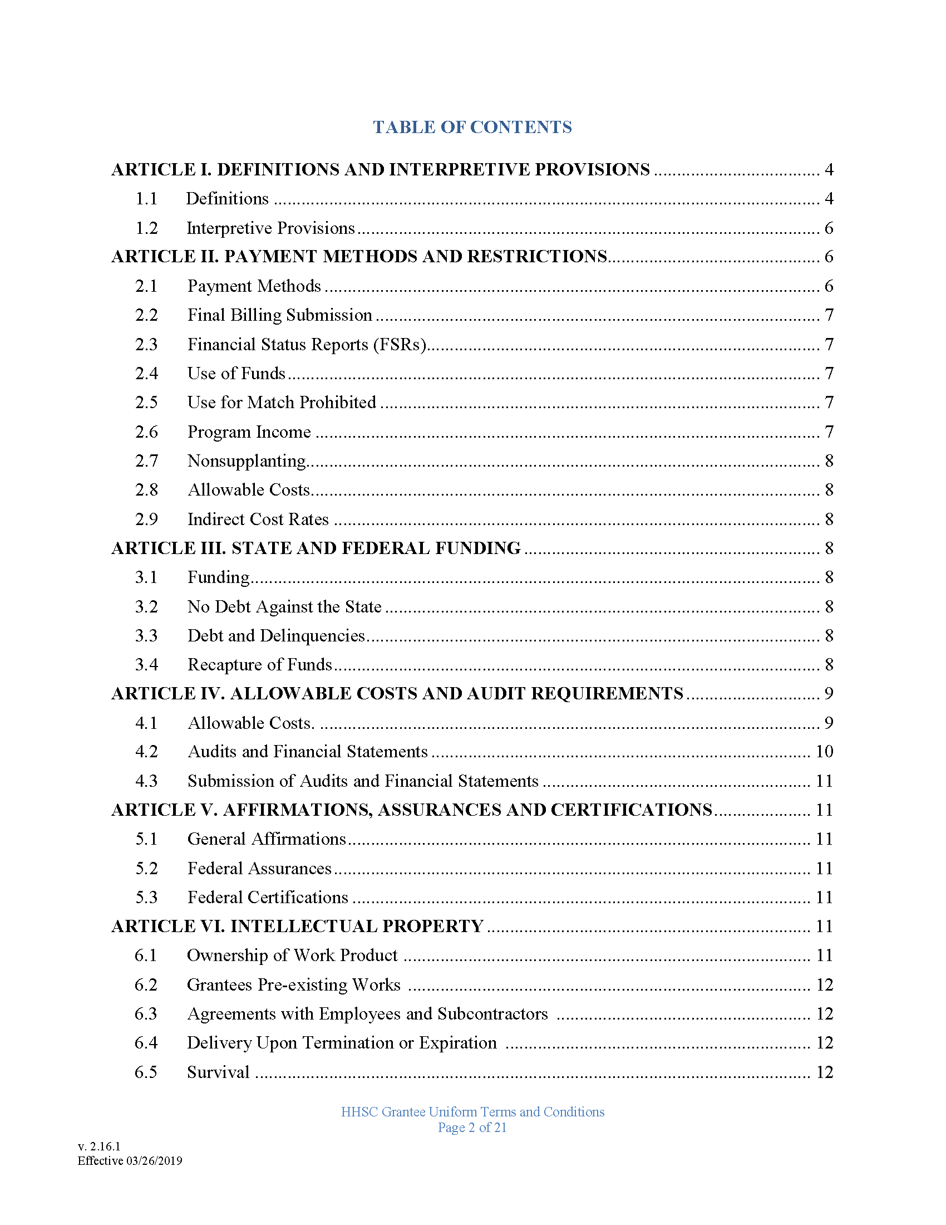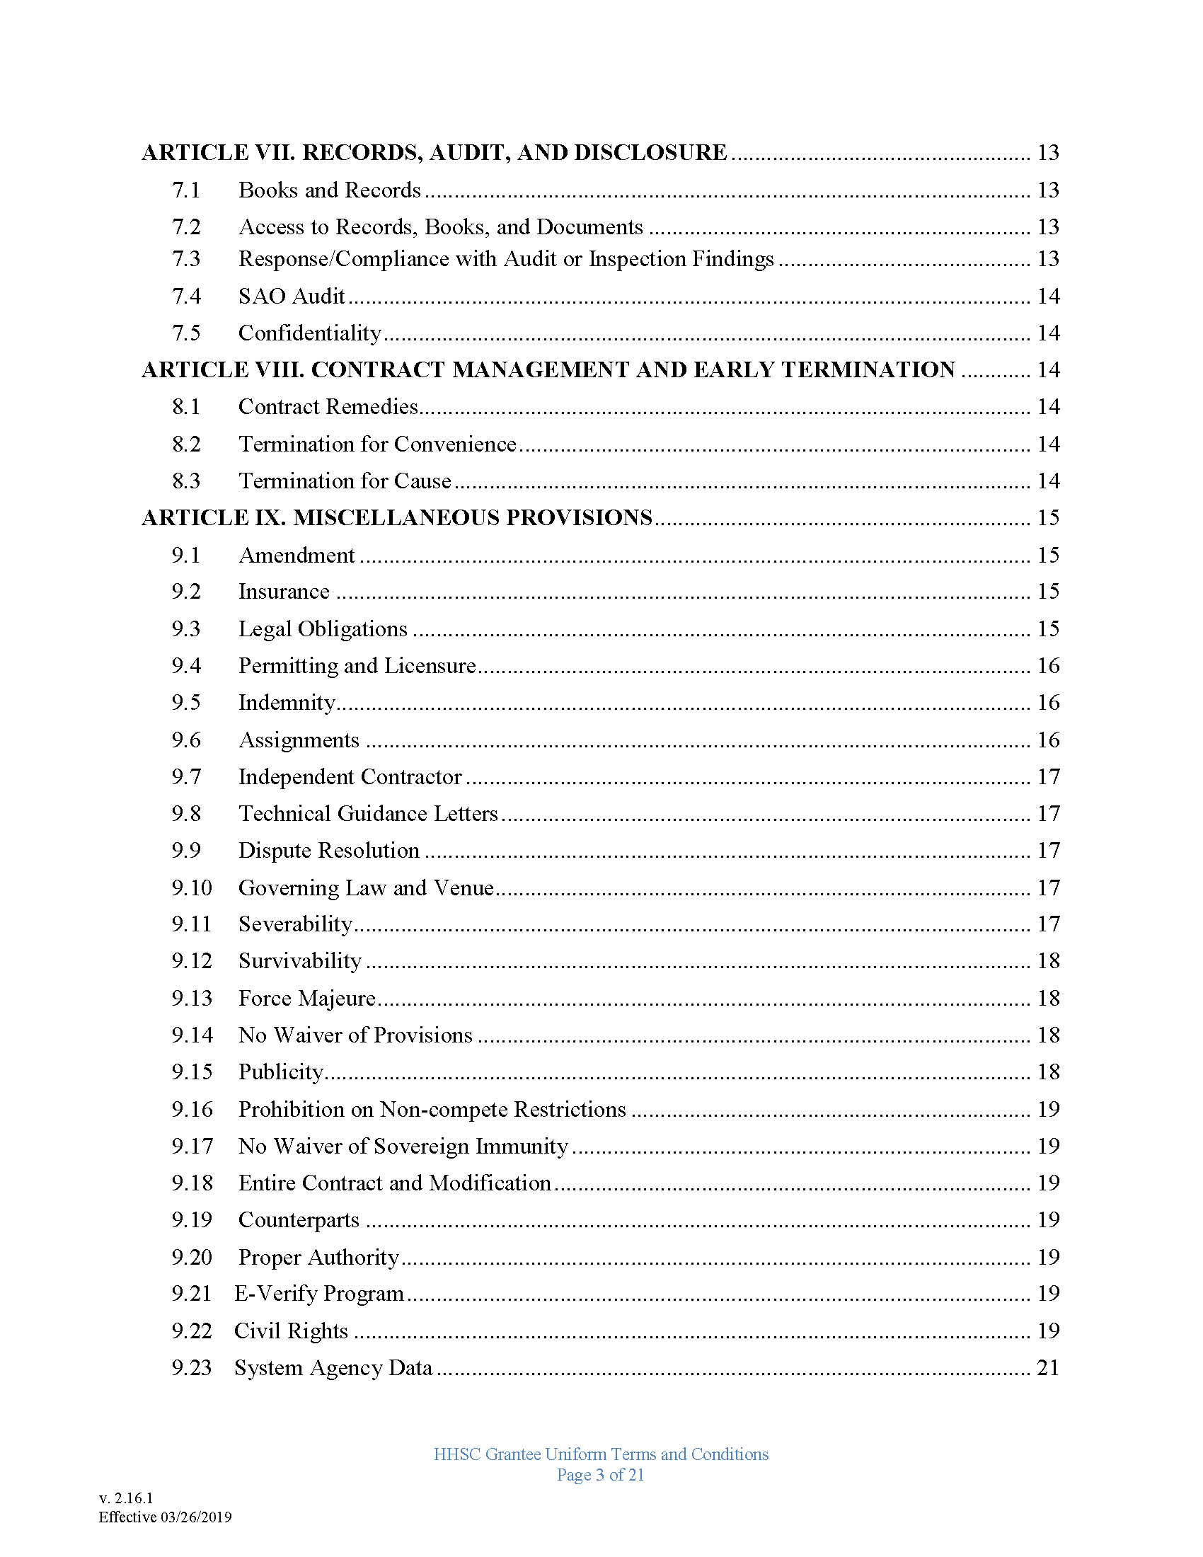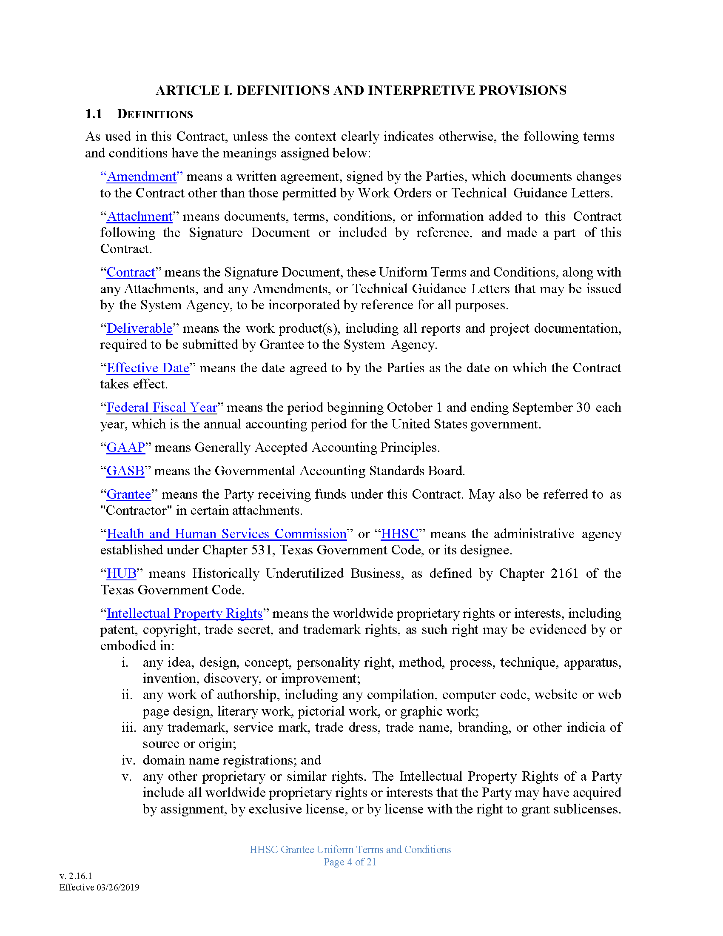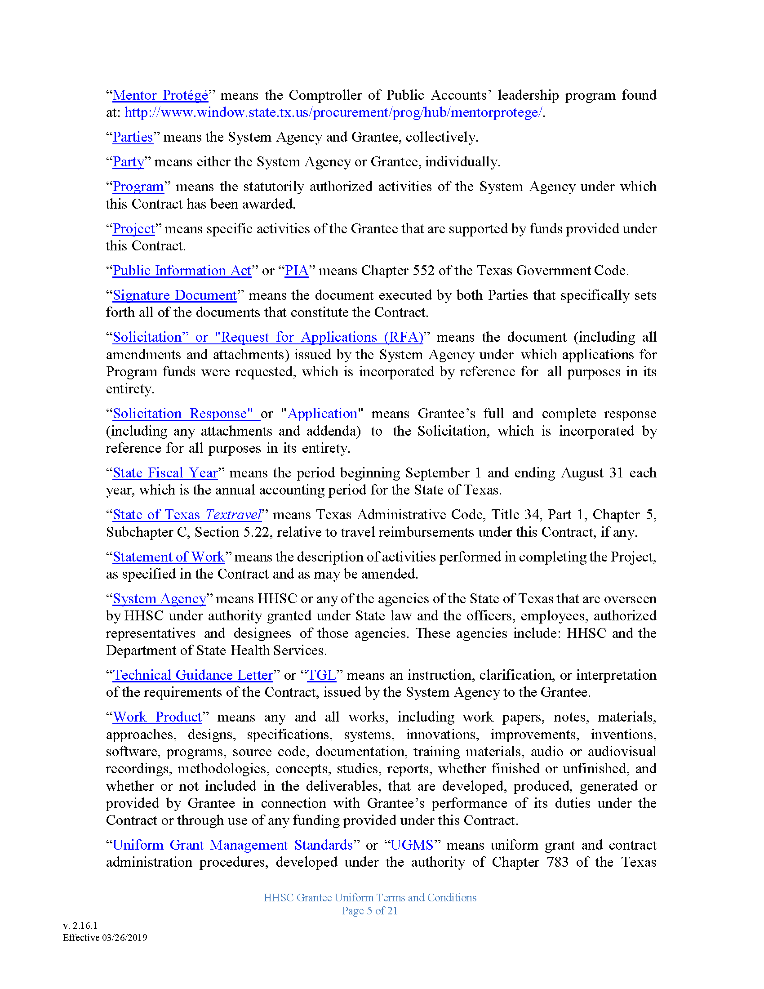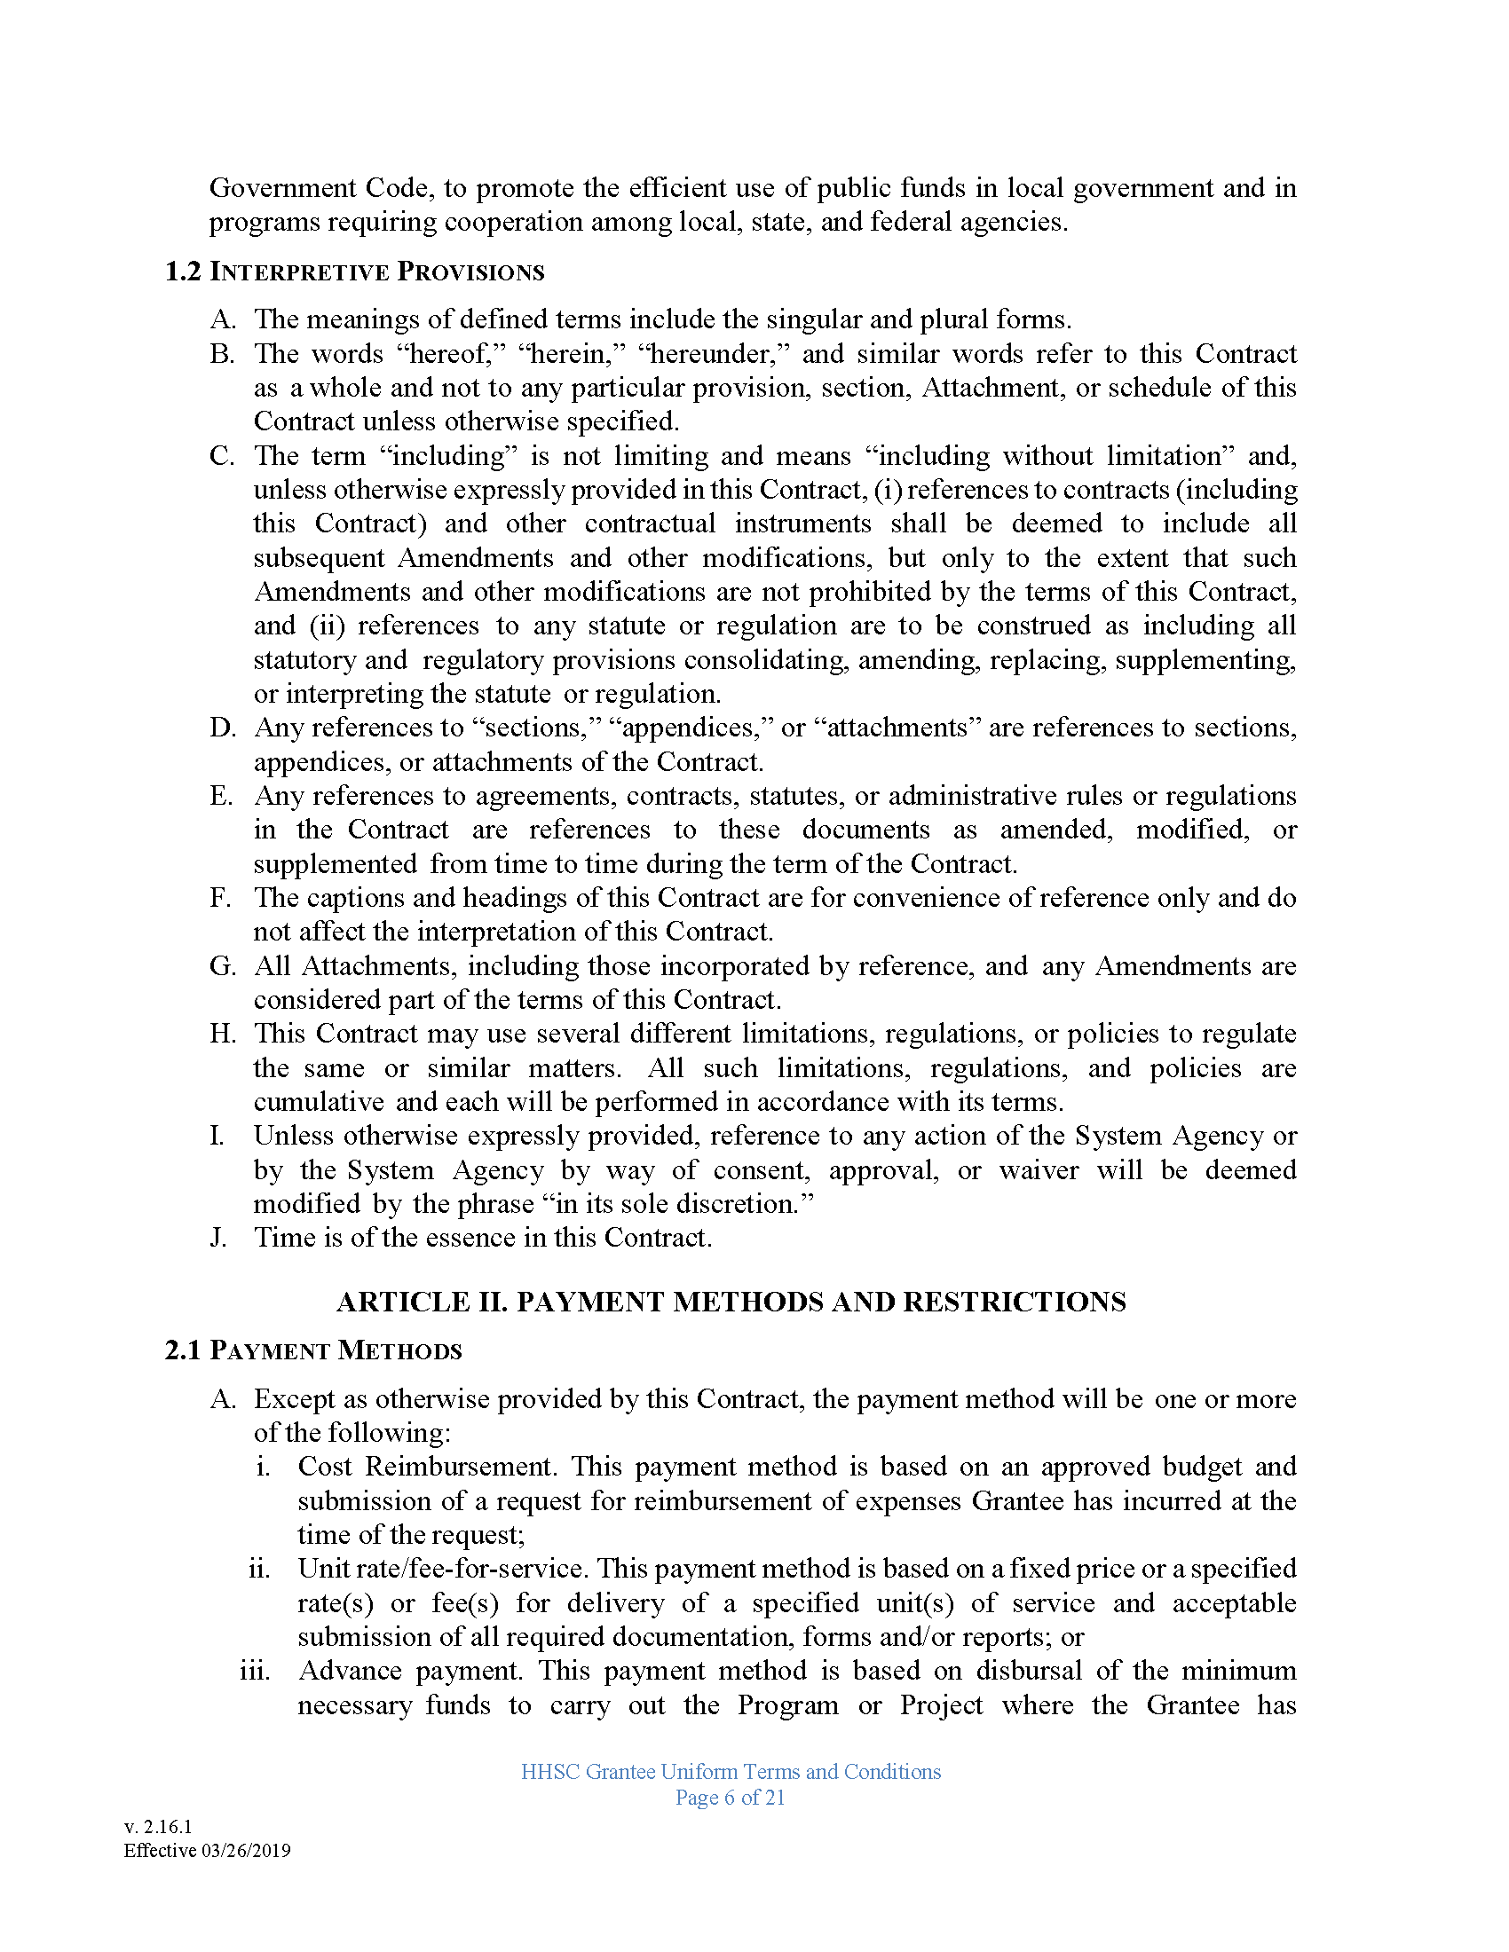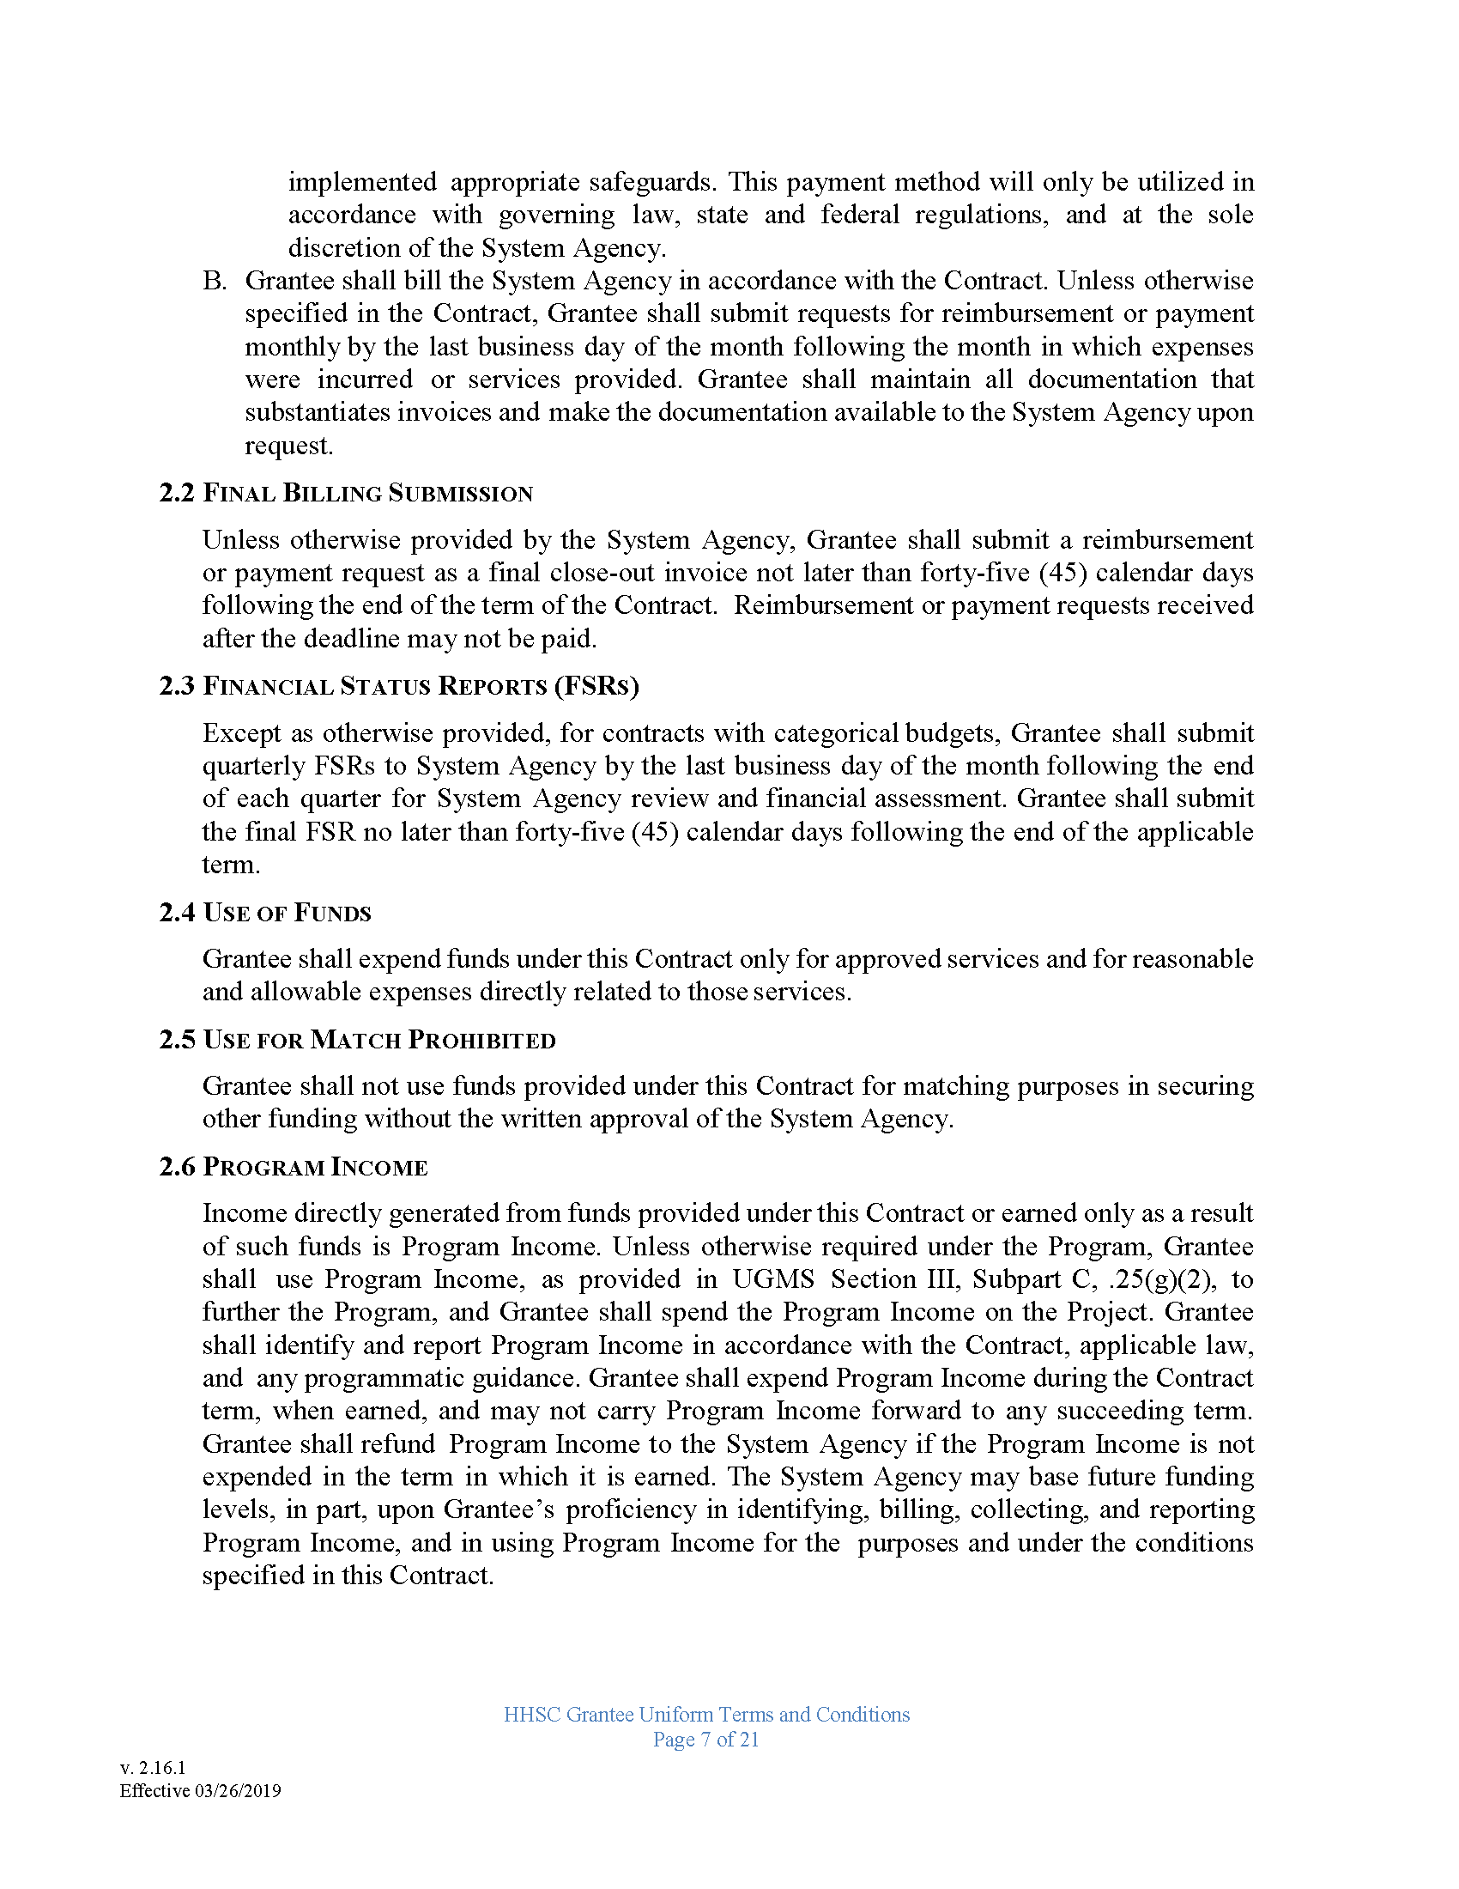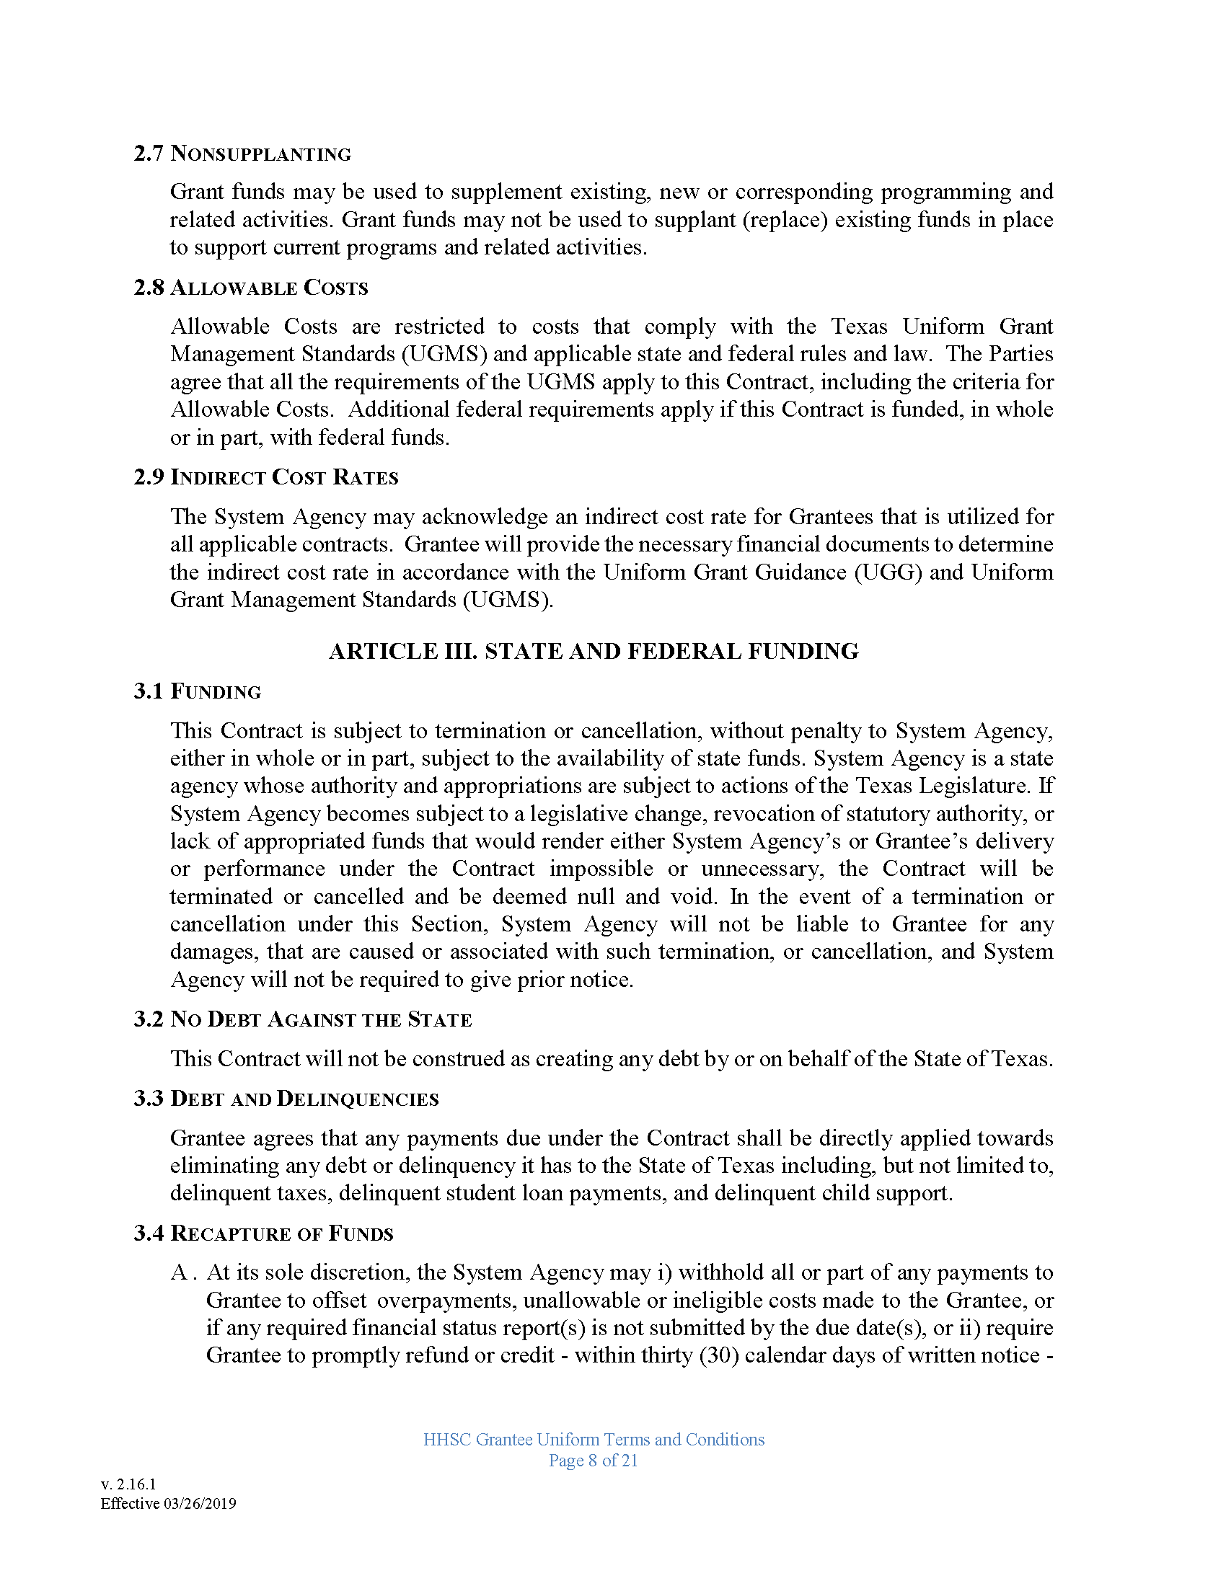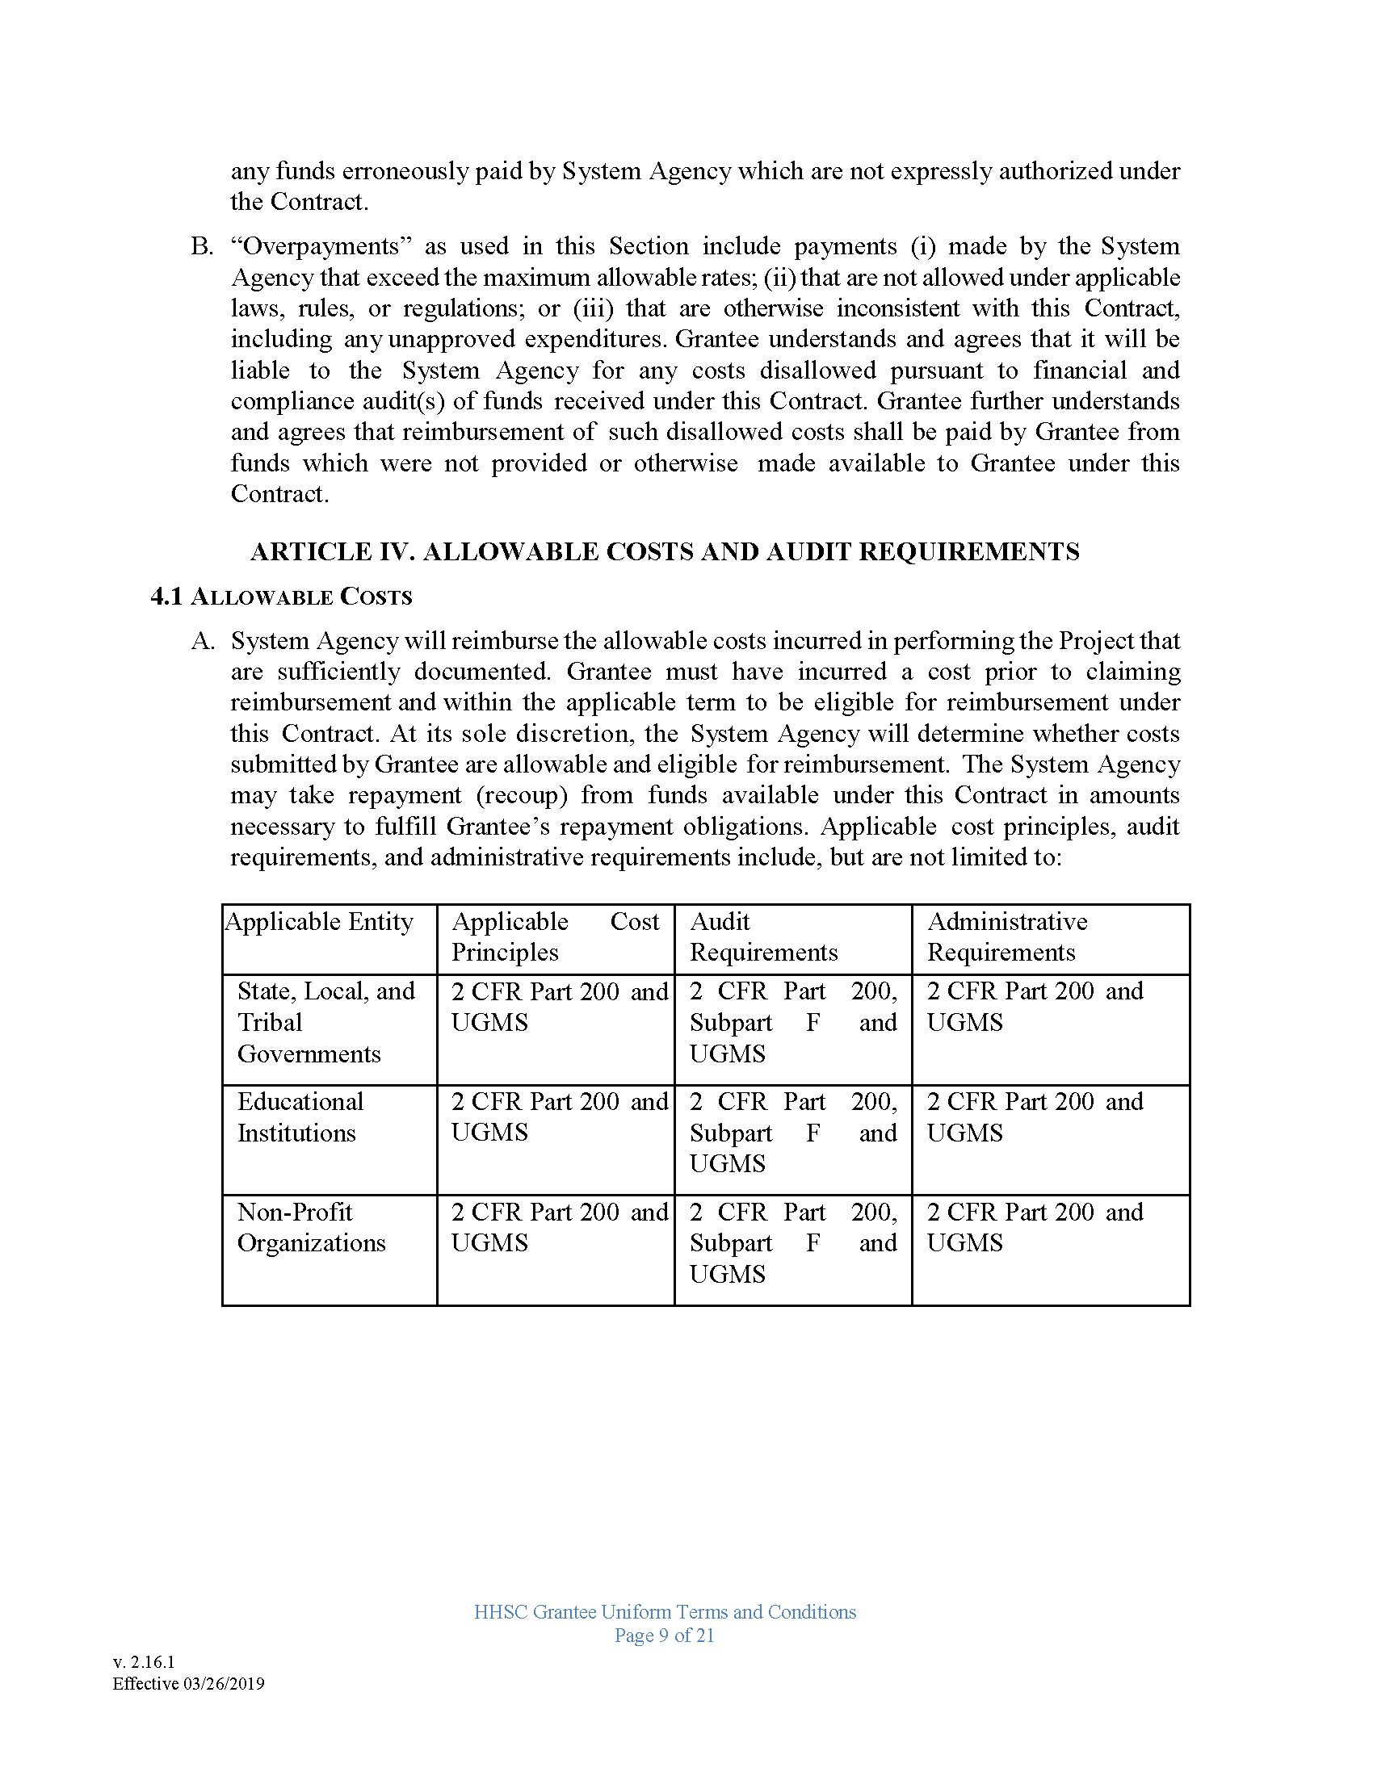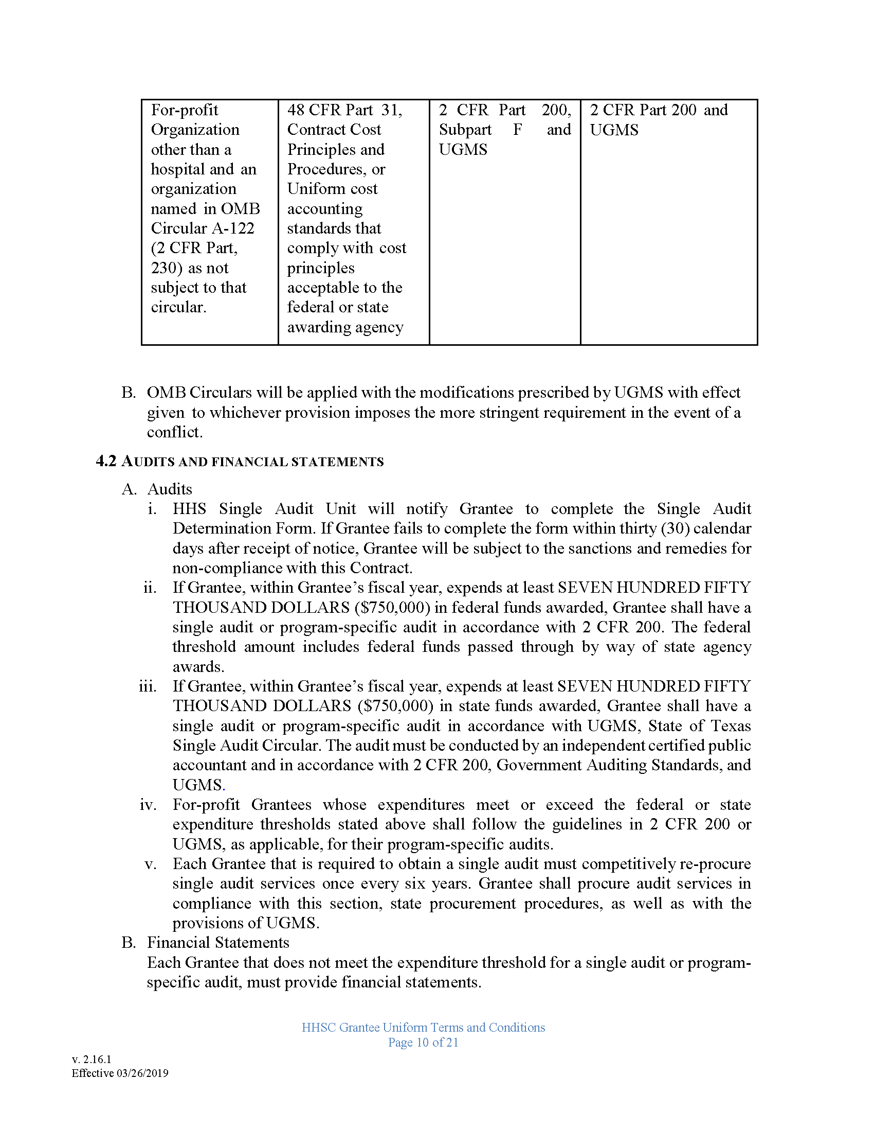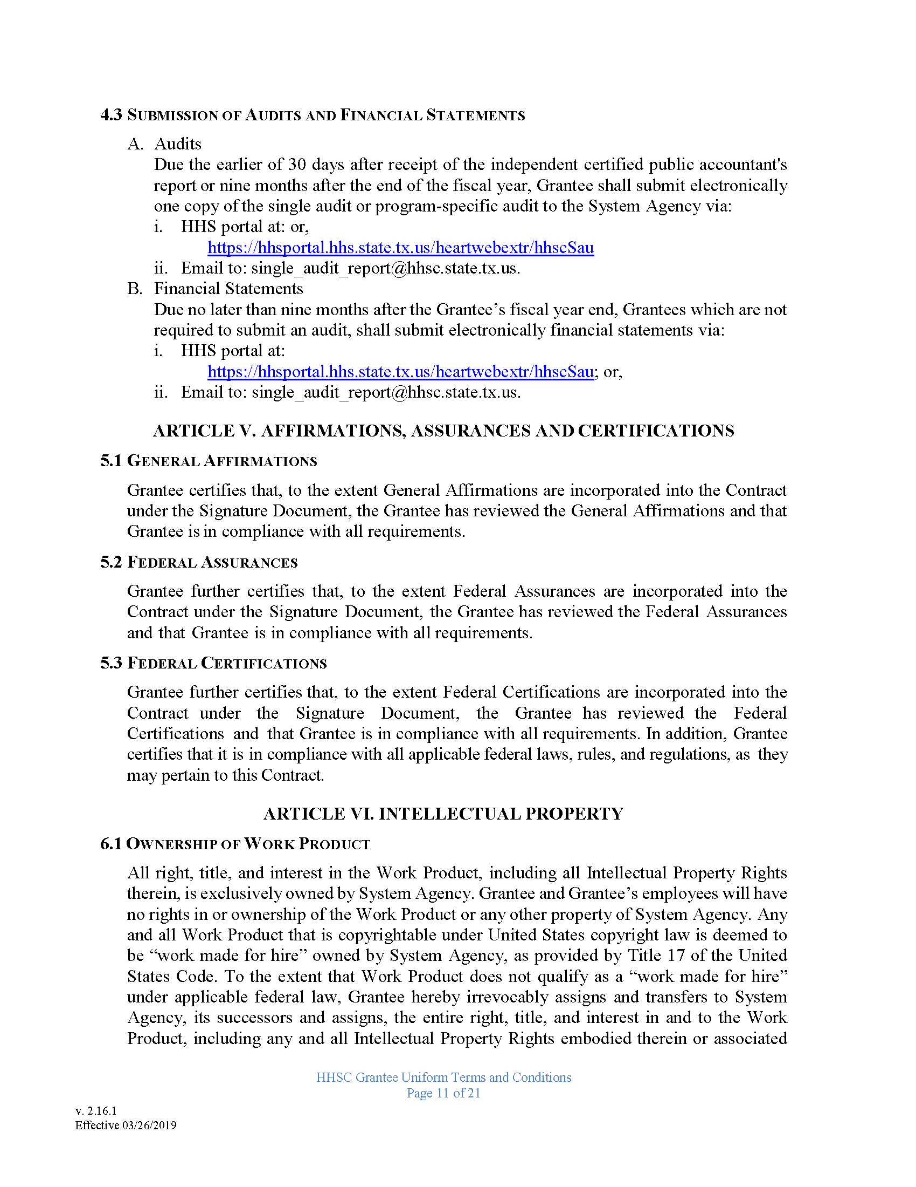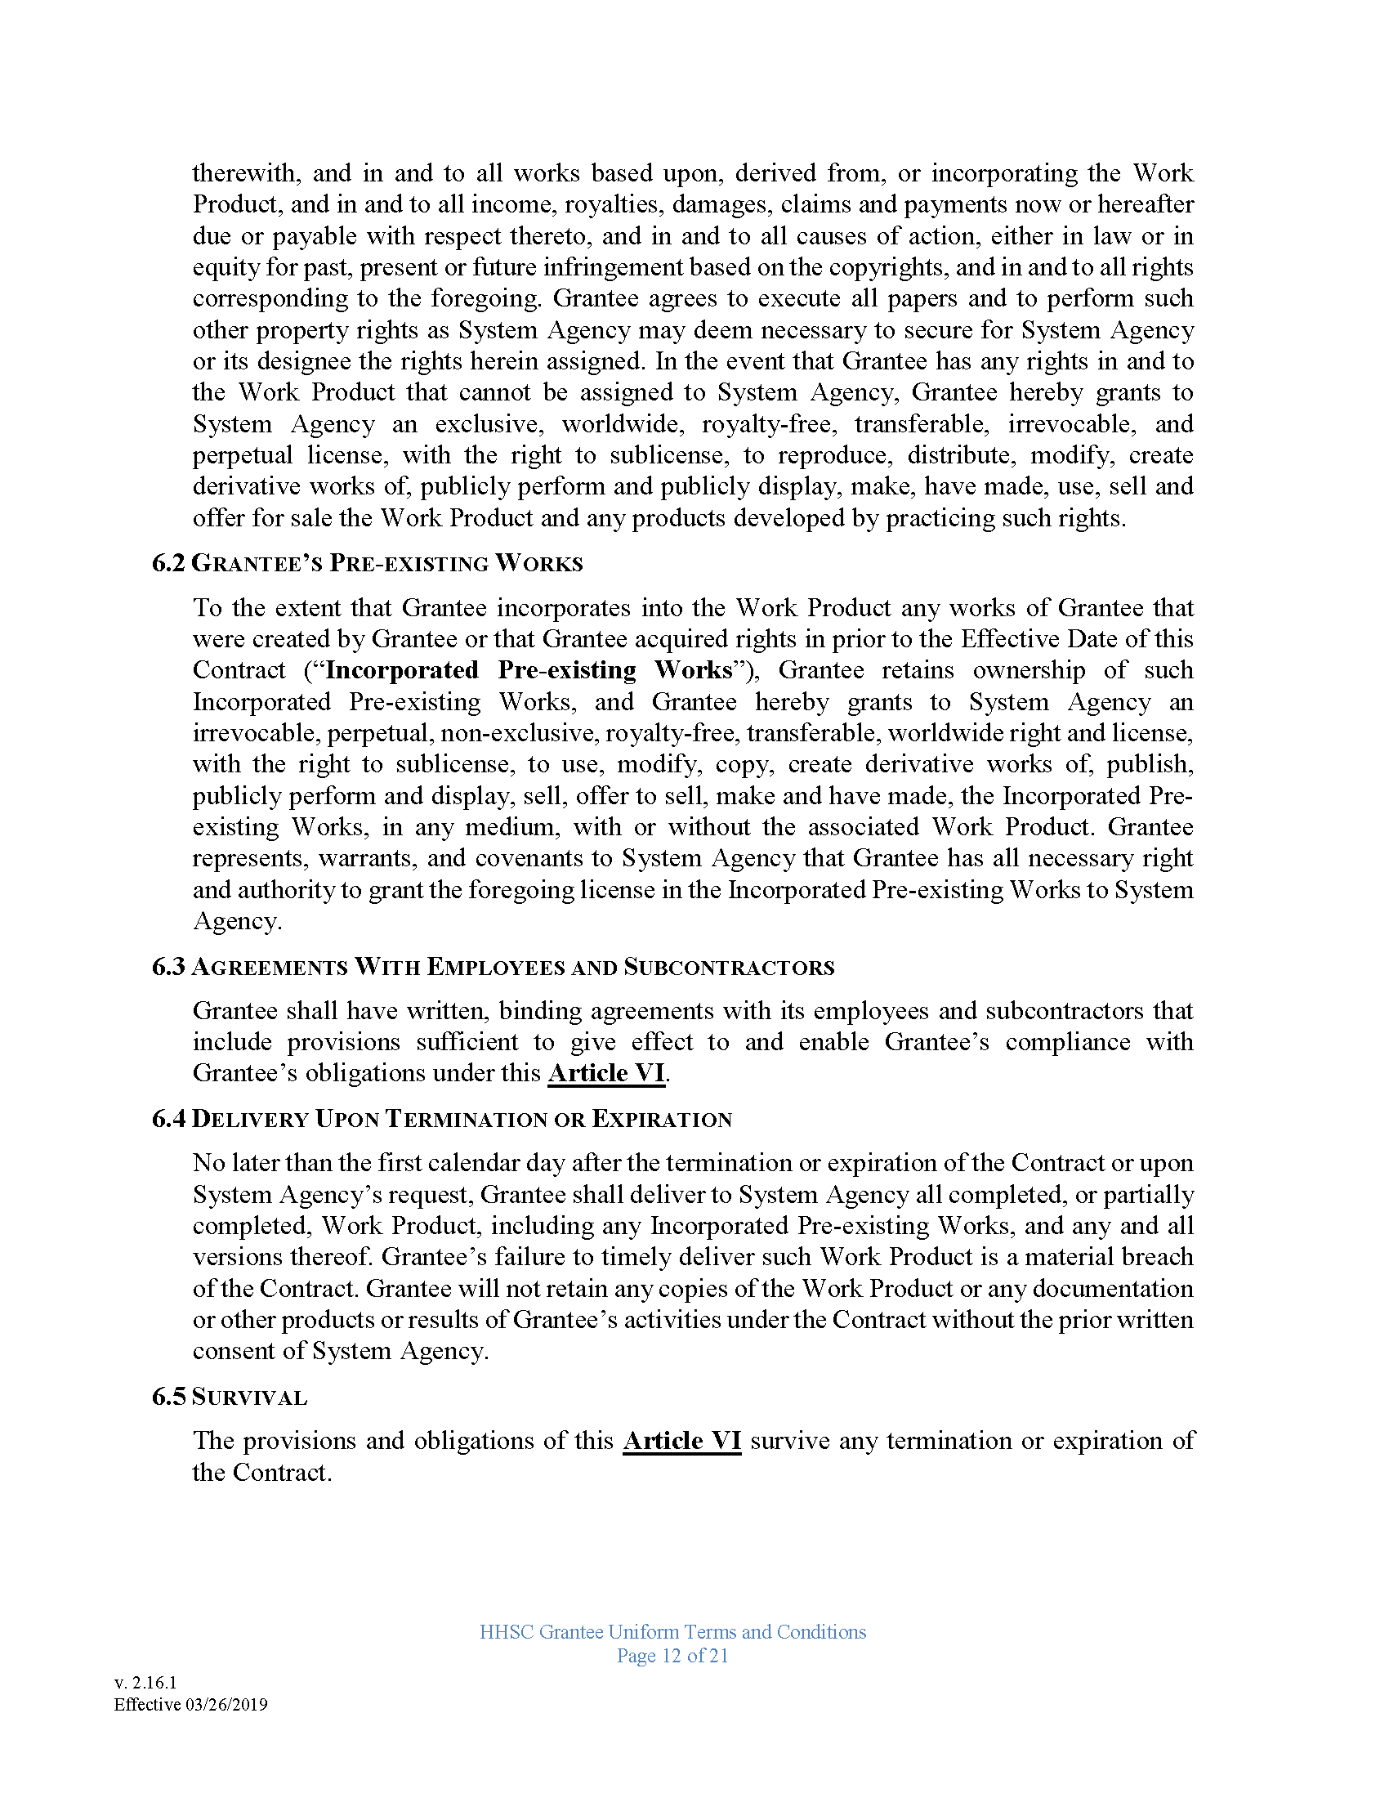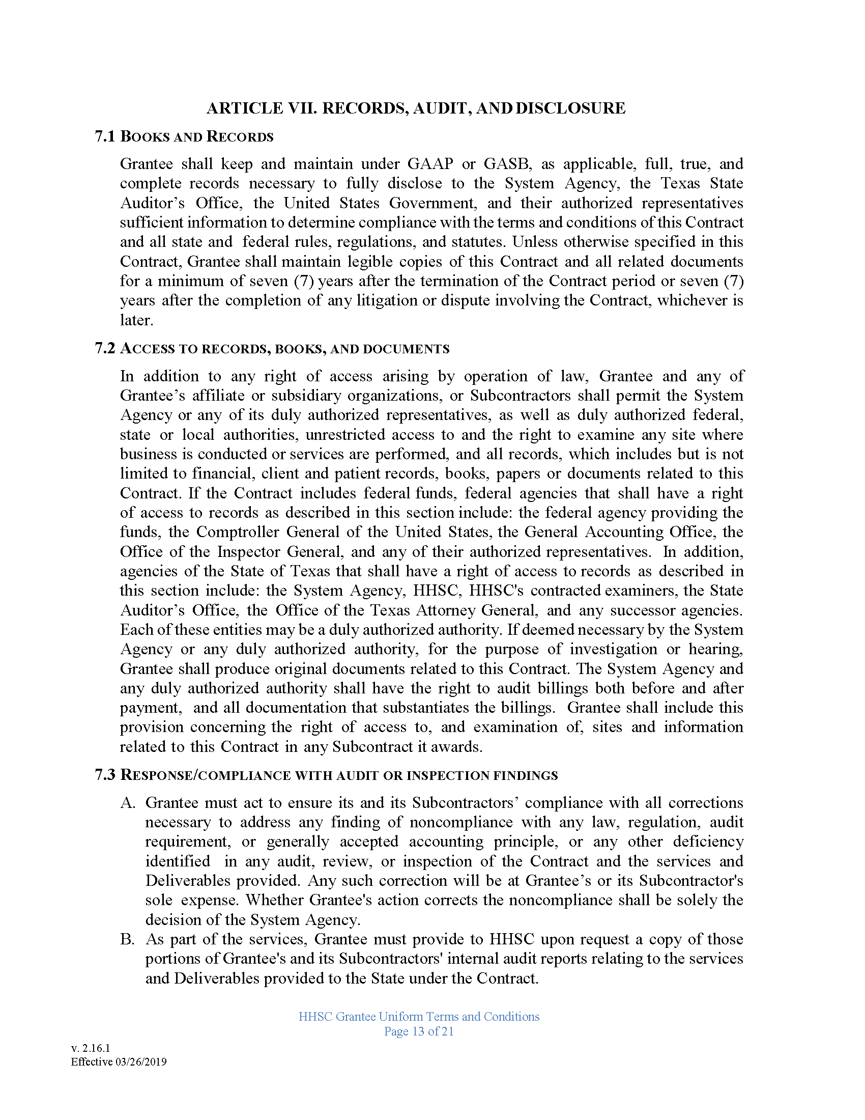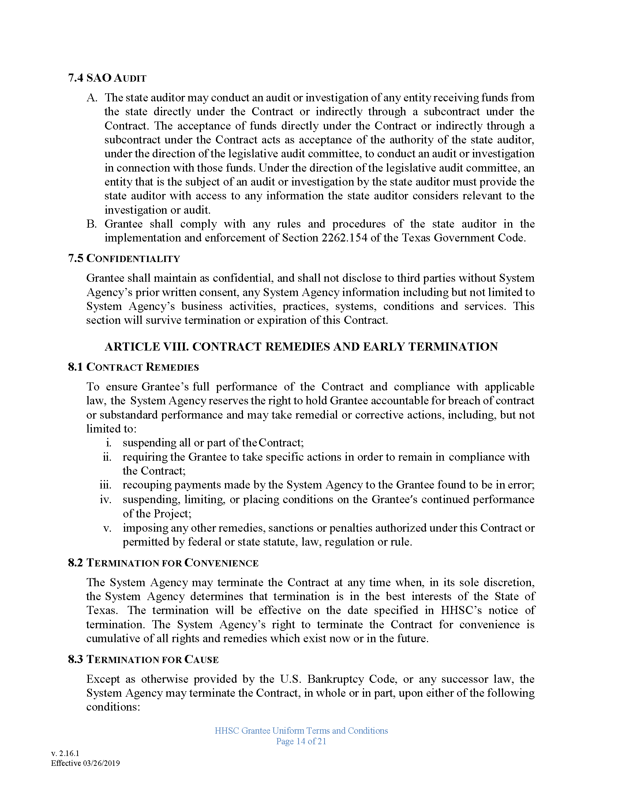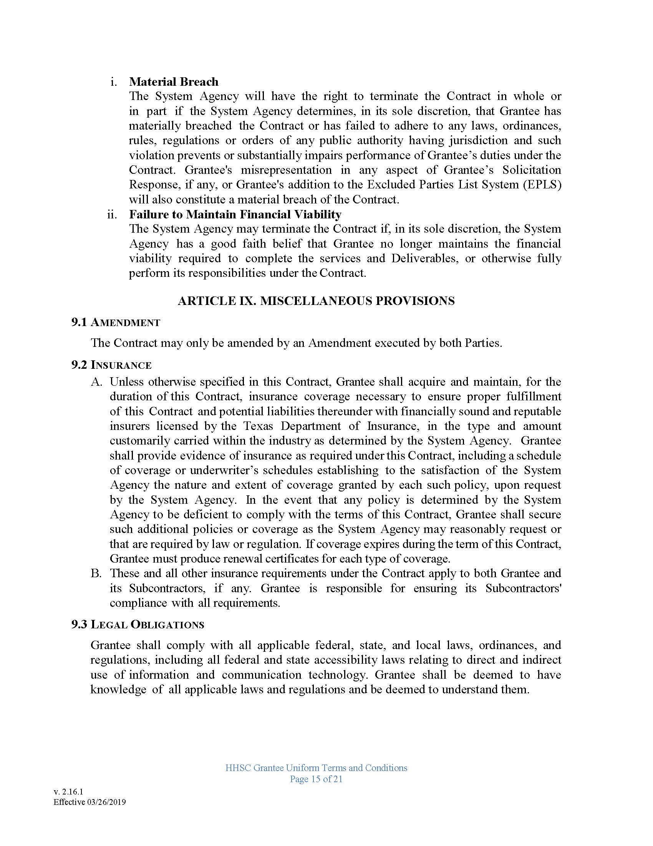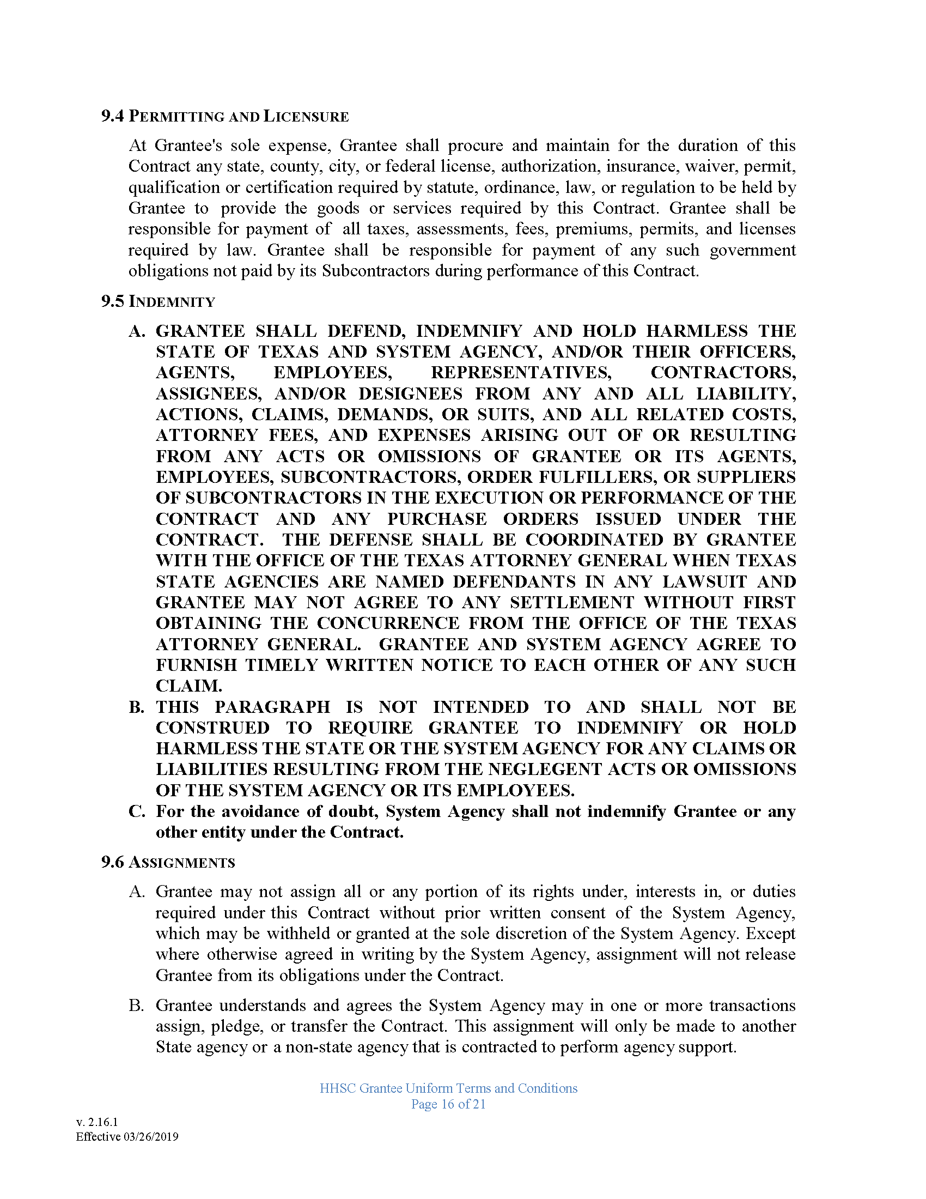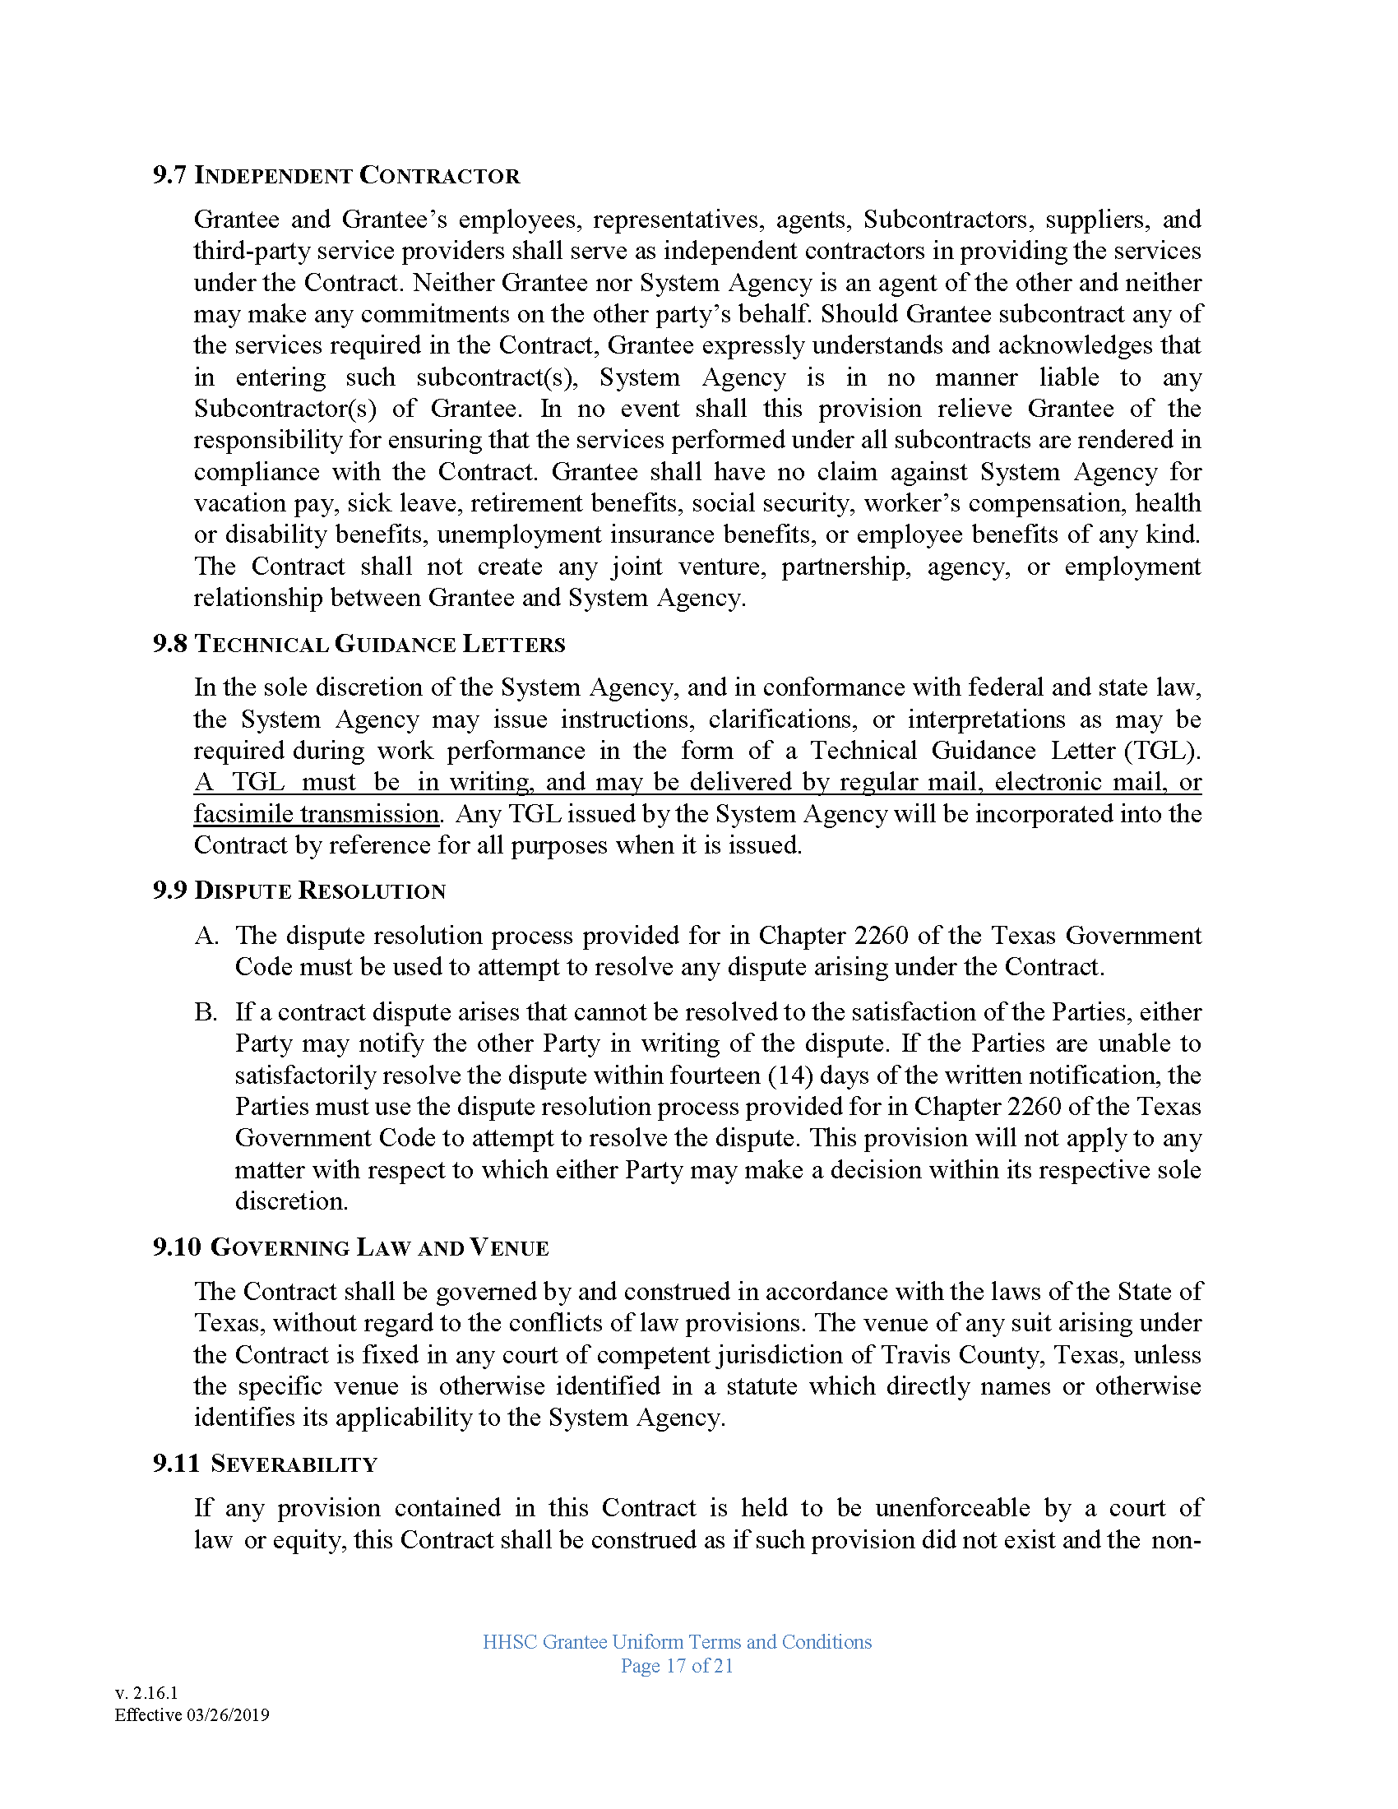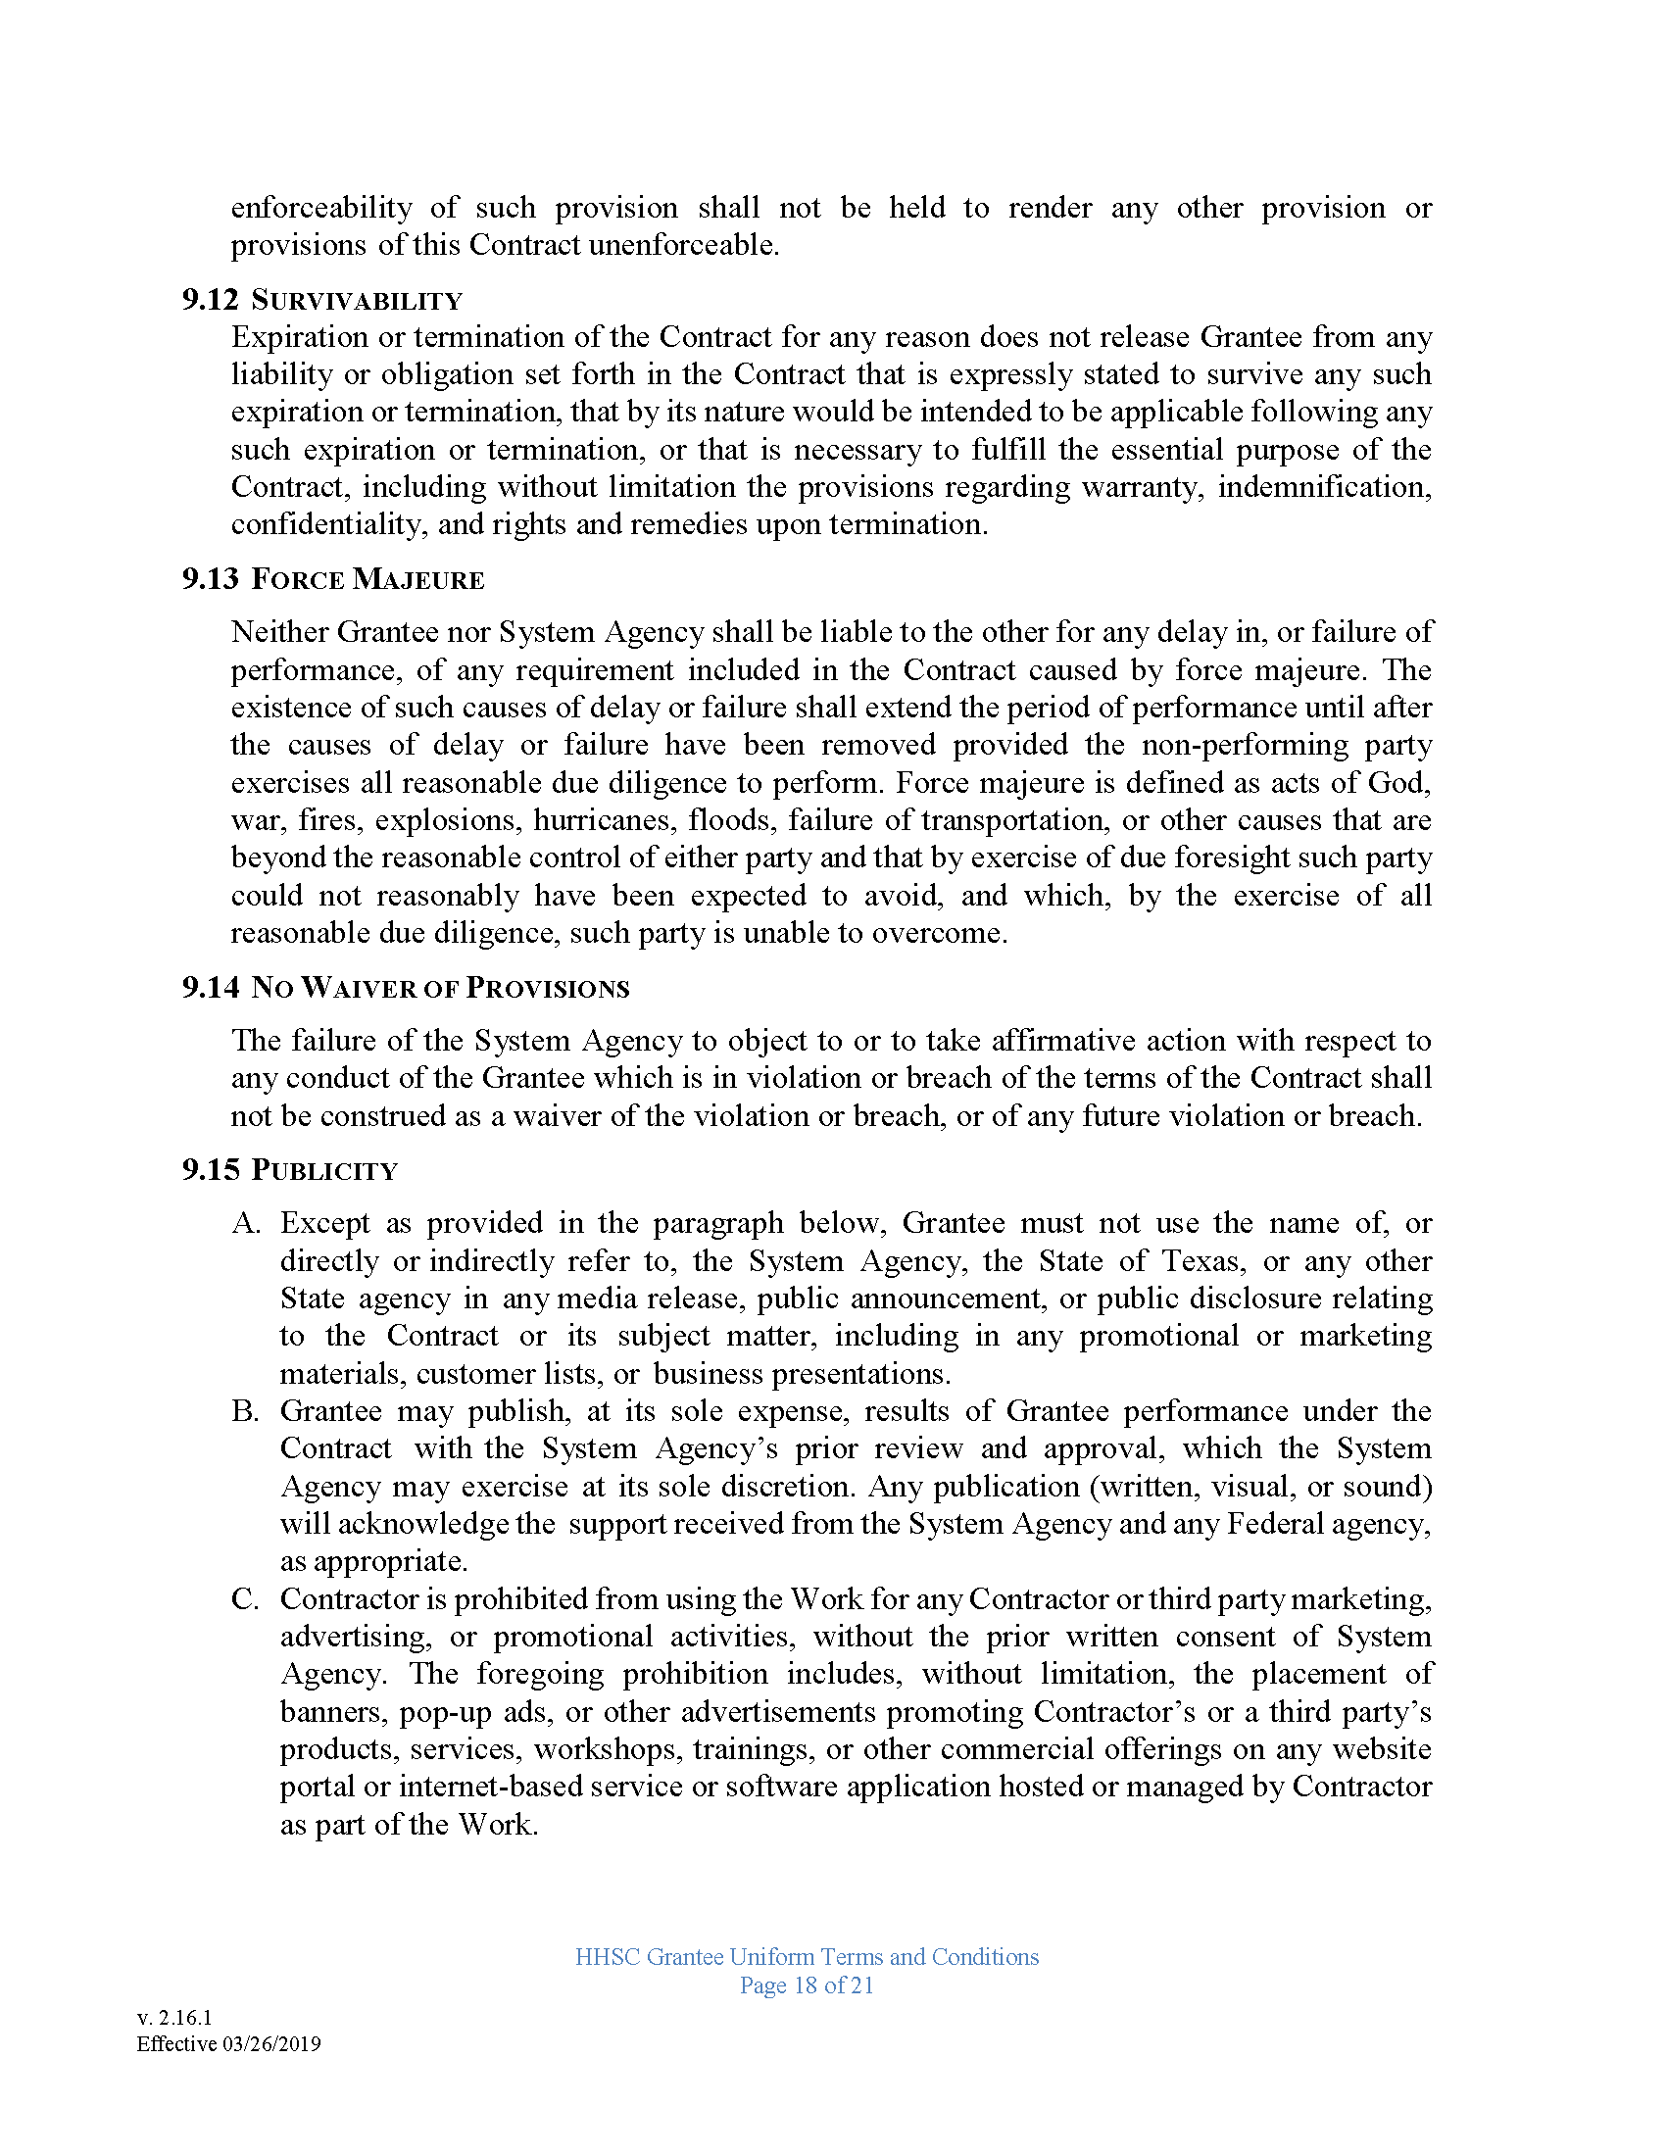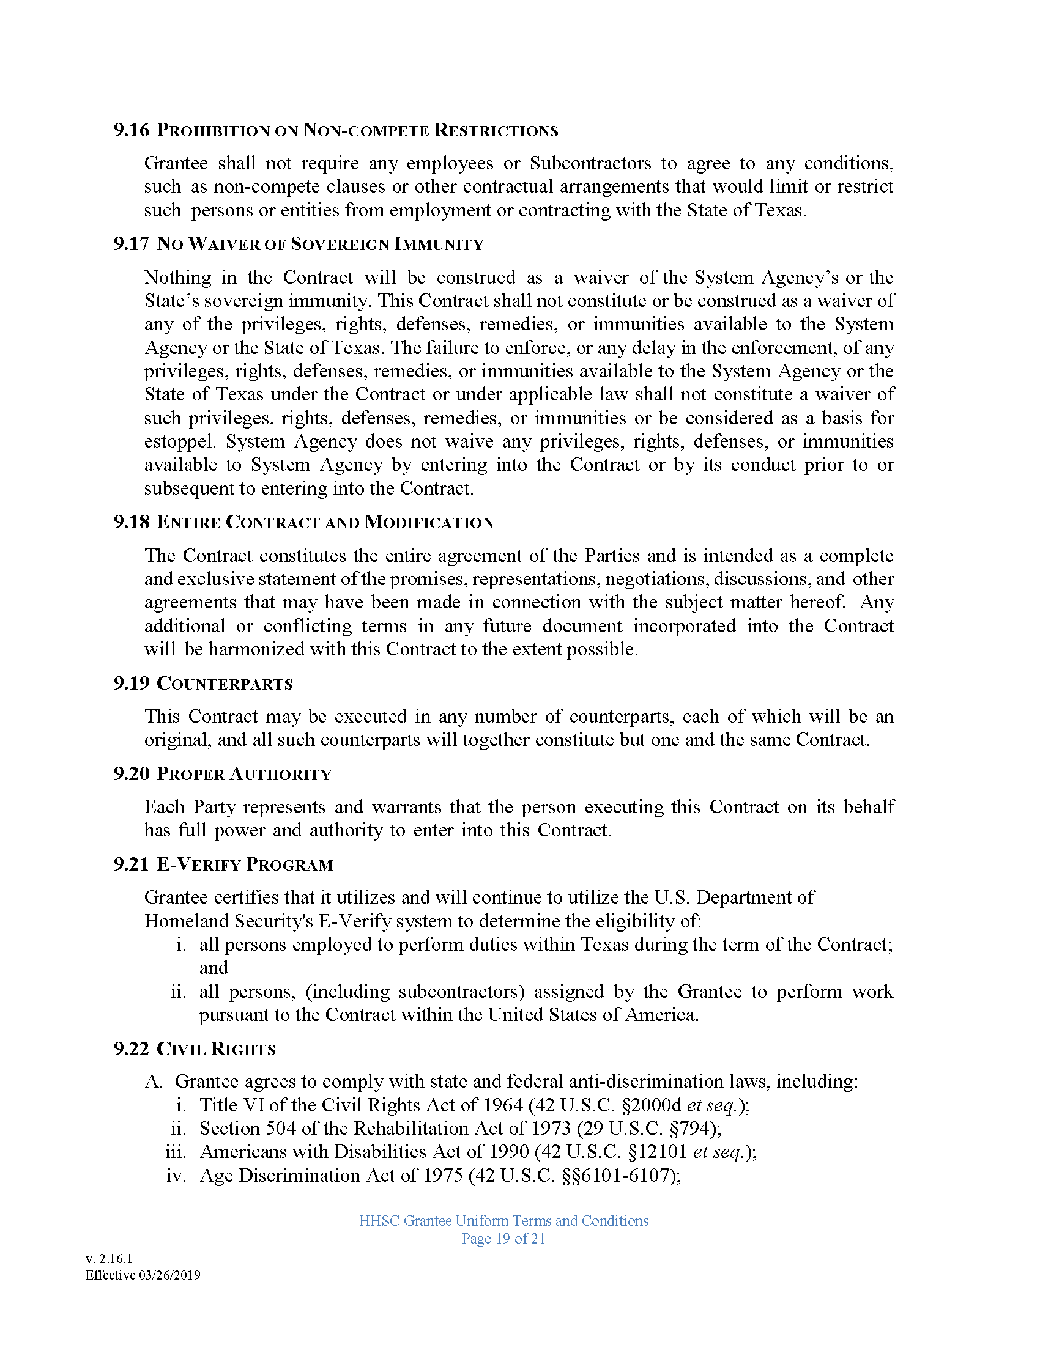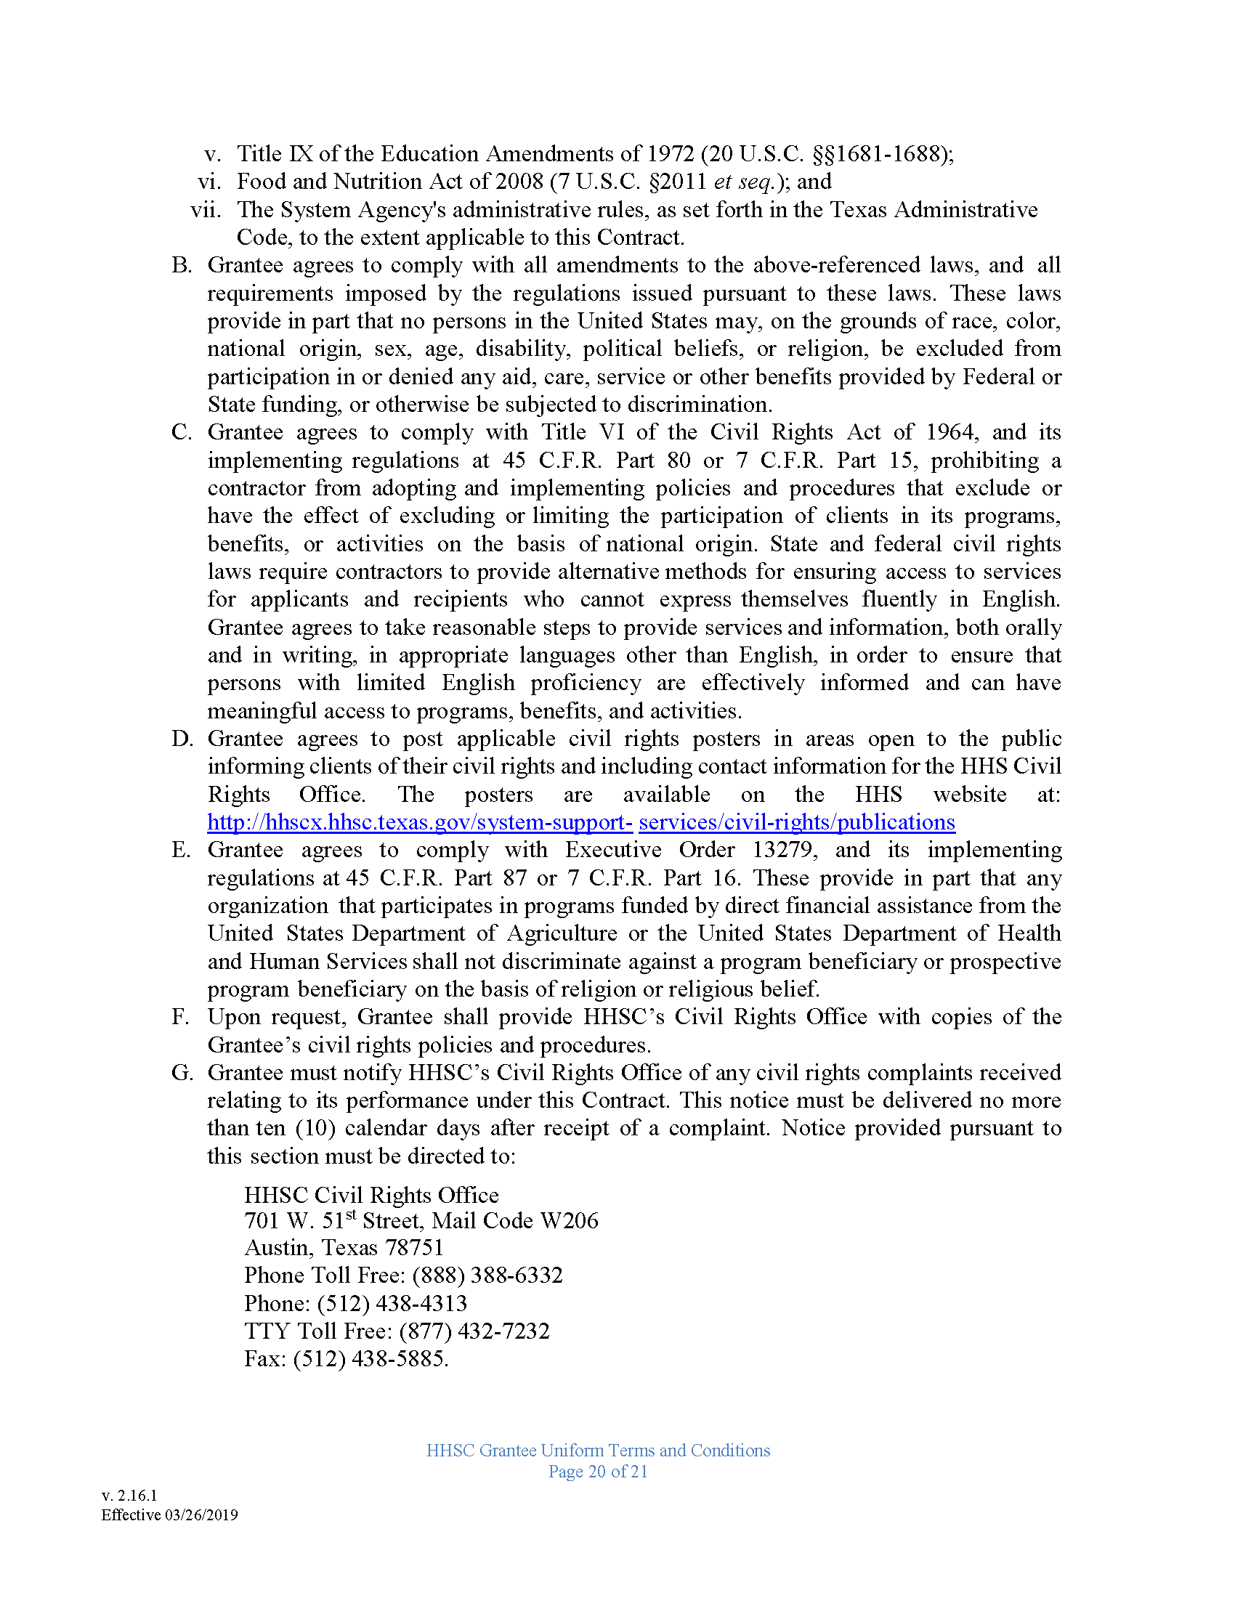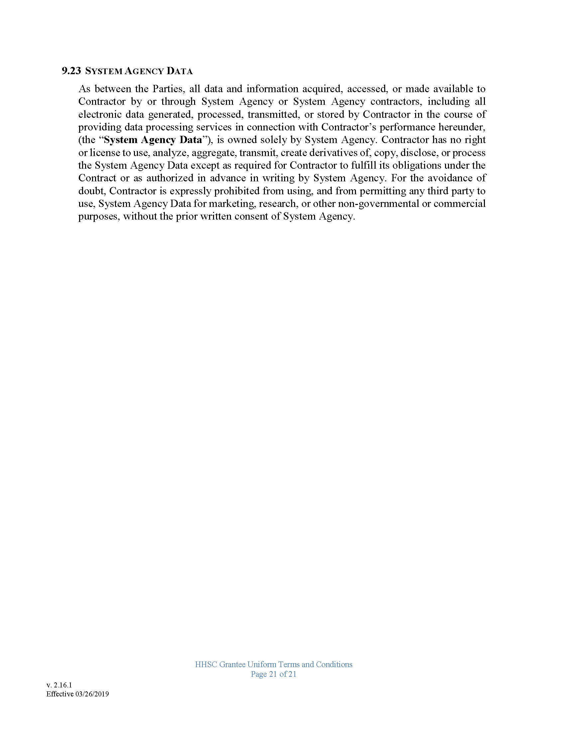

APPENDIX C: HHSC Data Use Agreement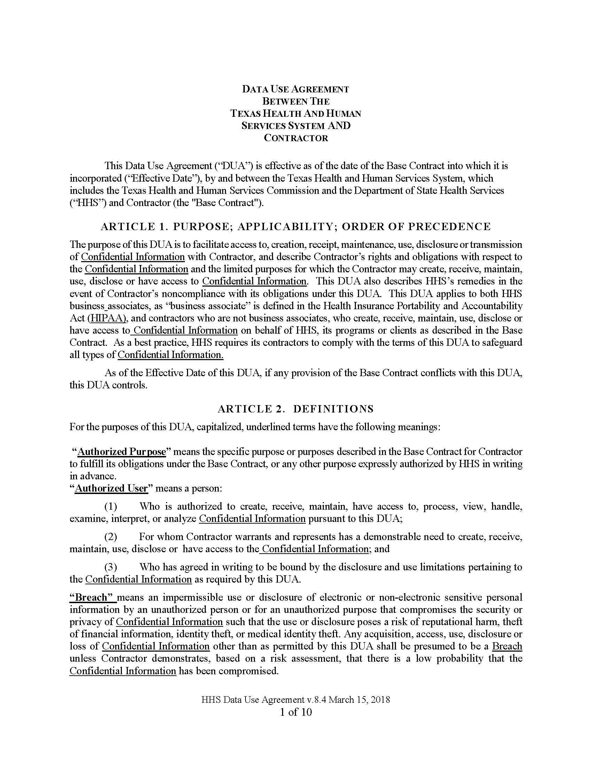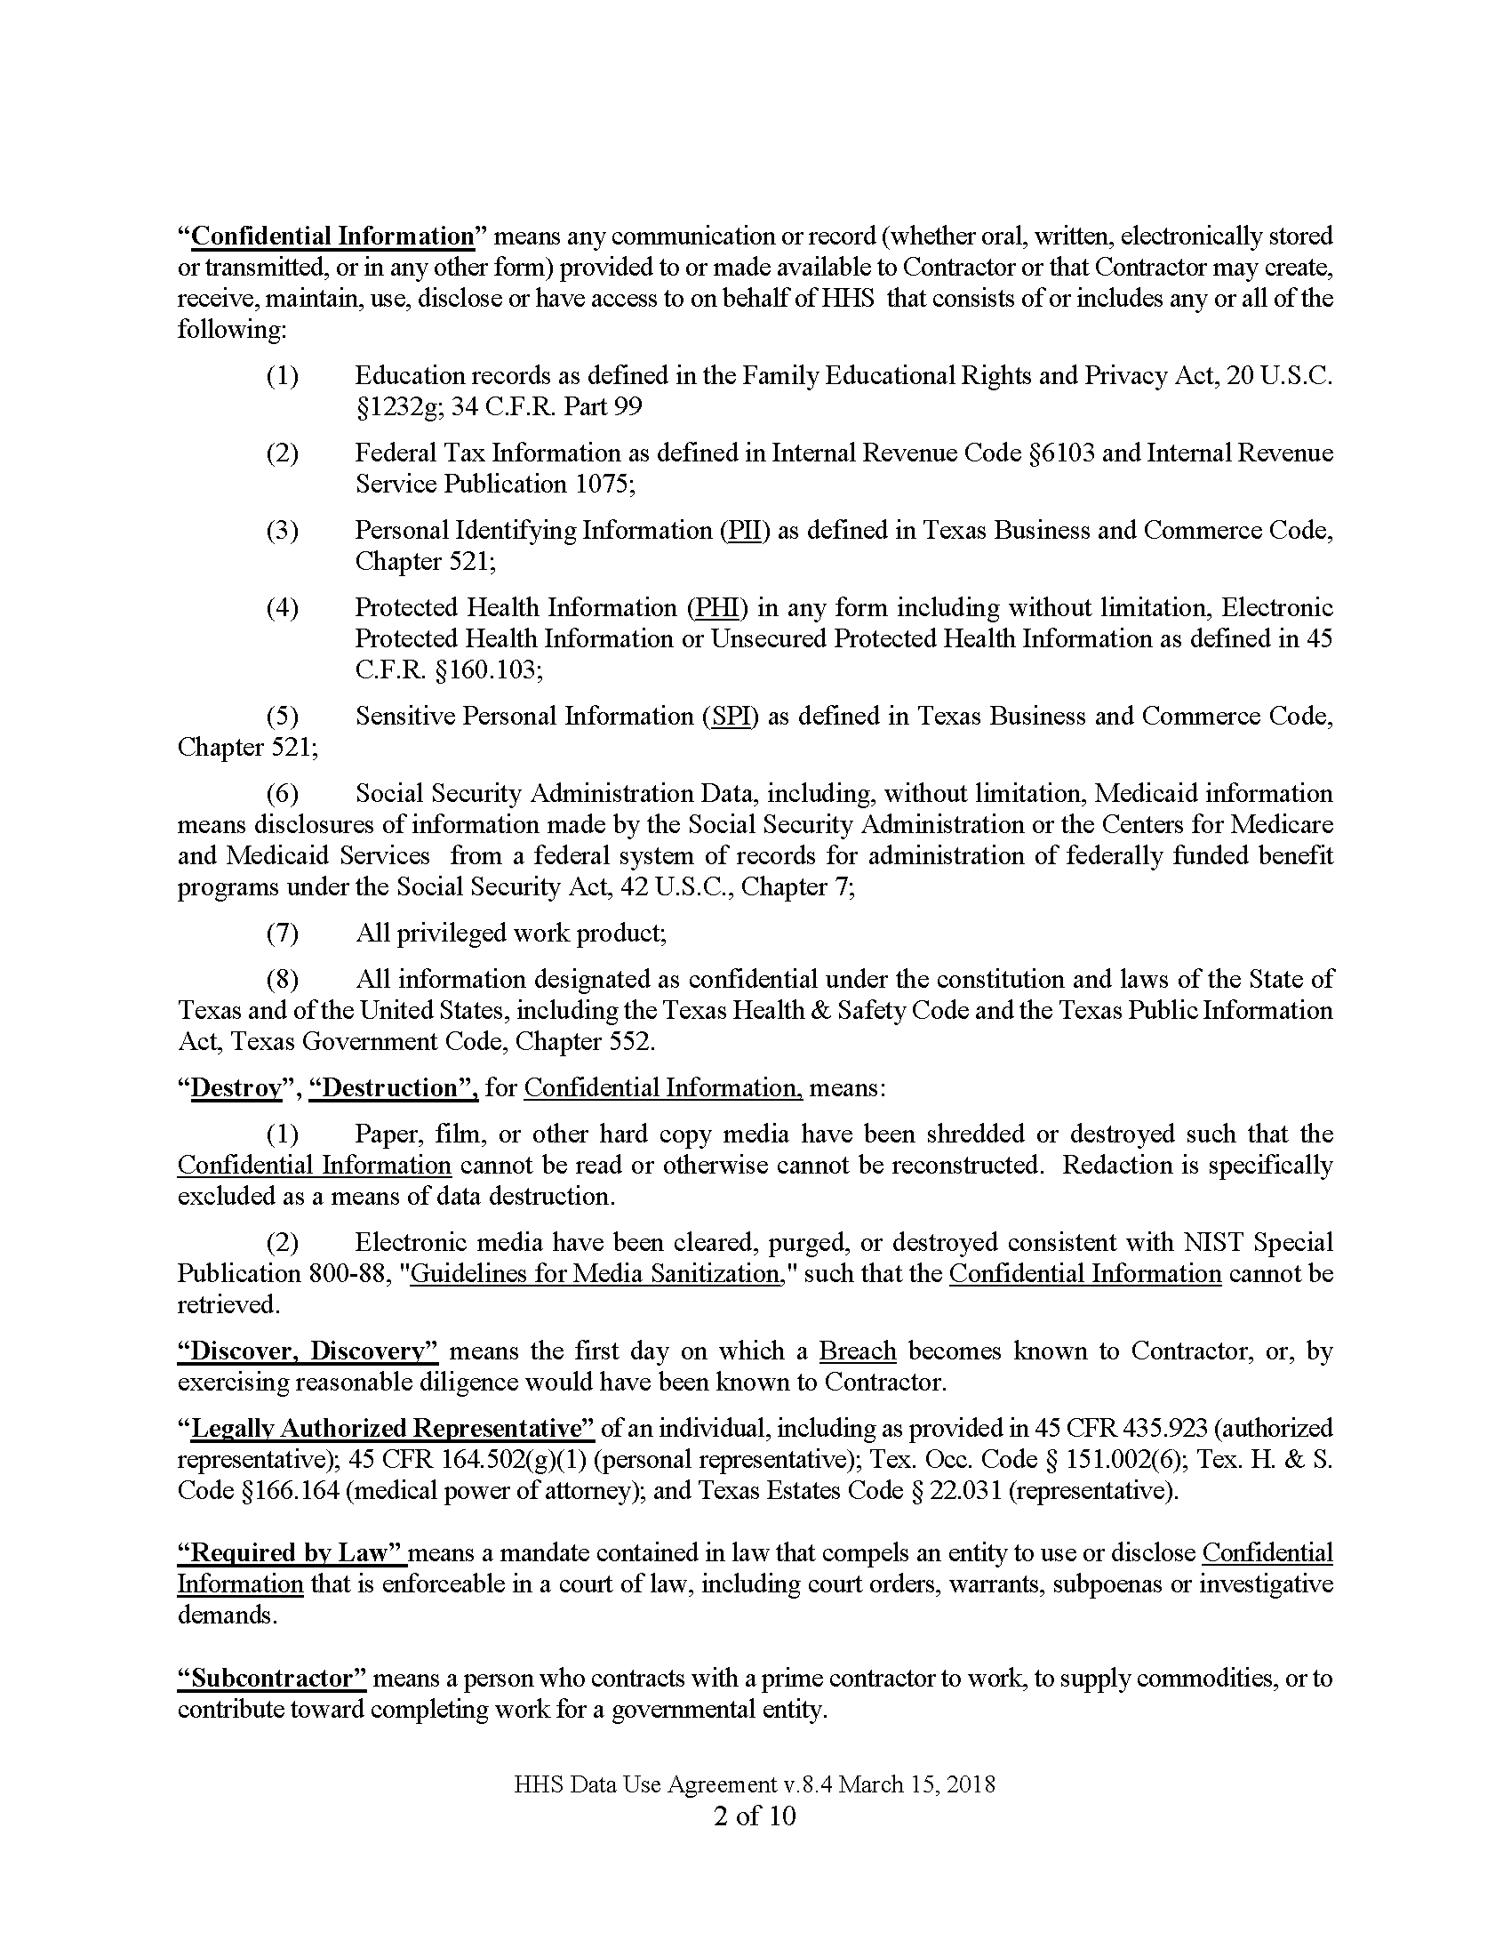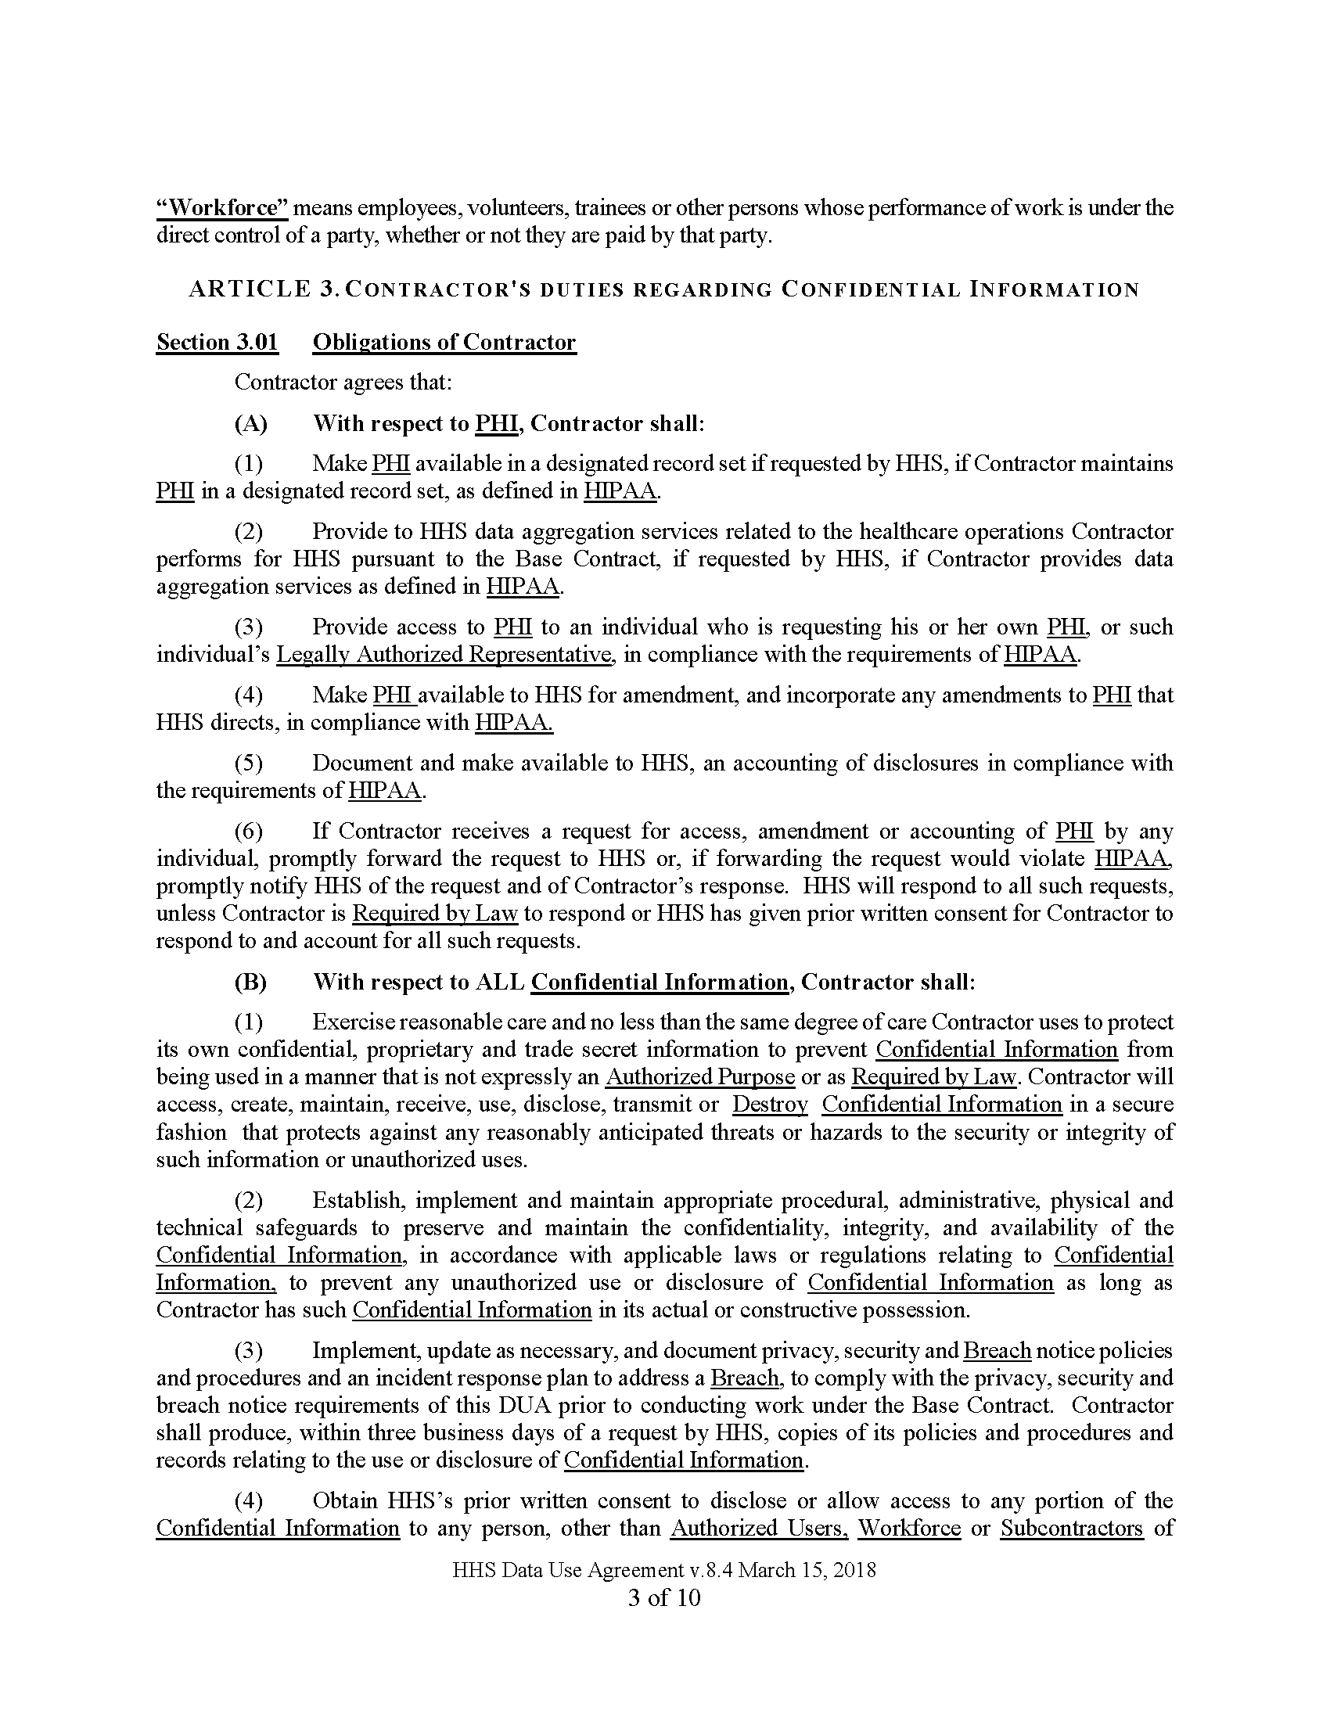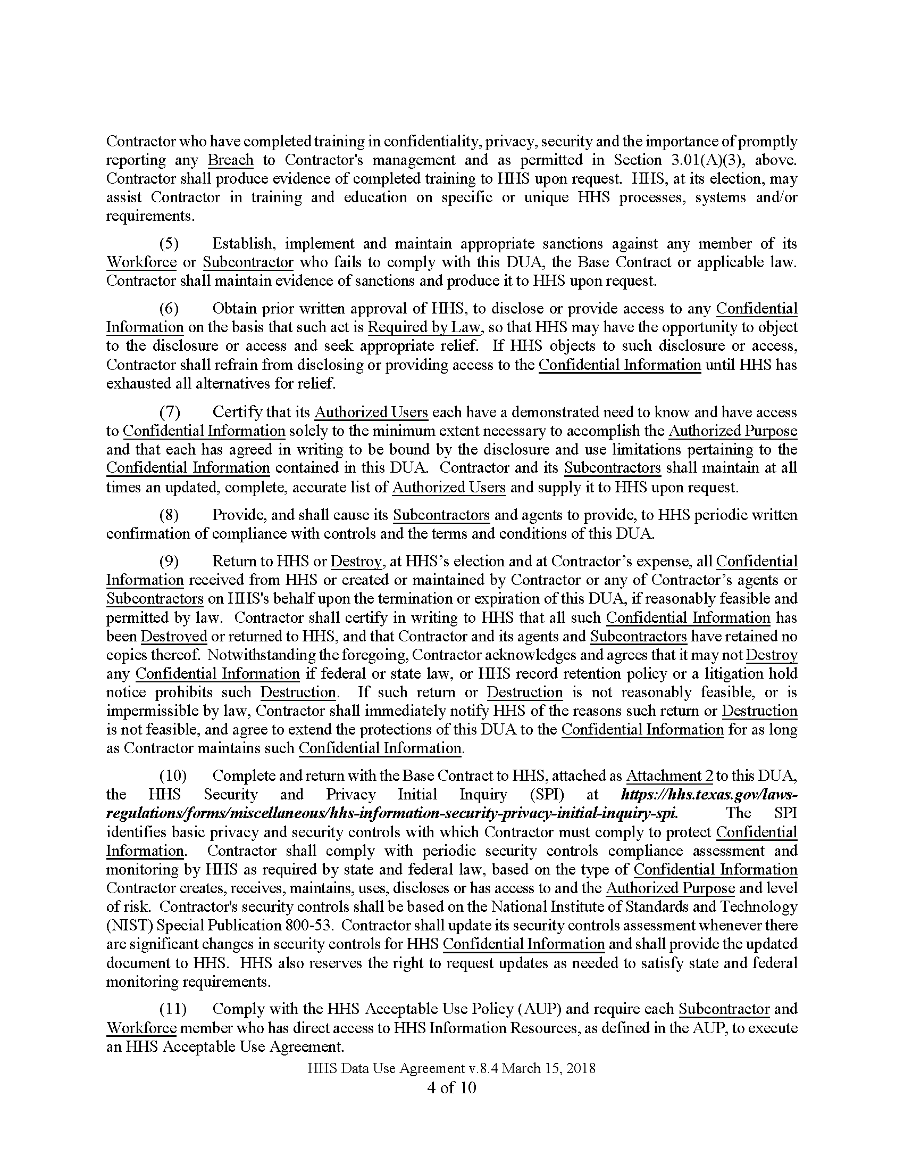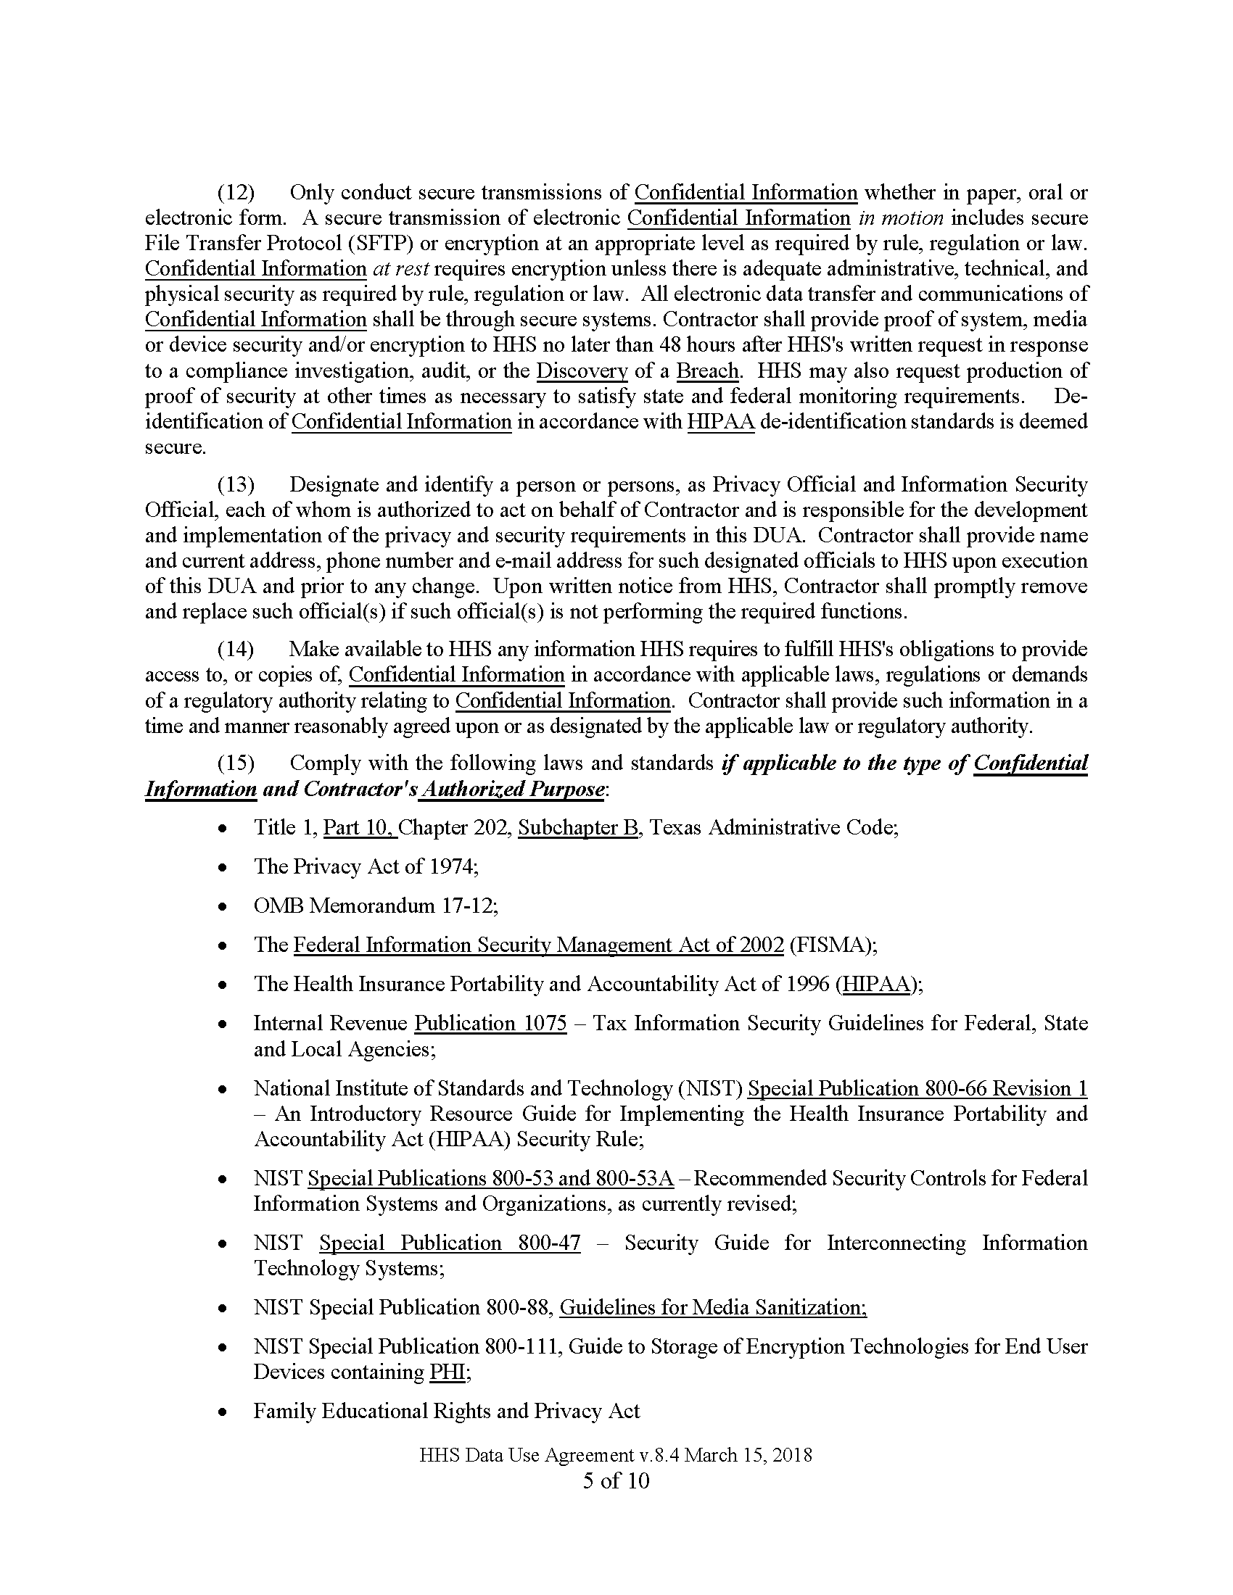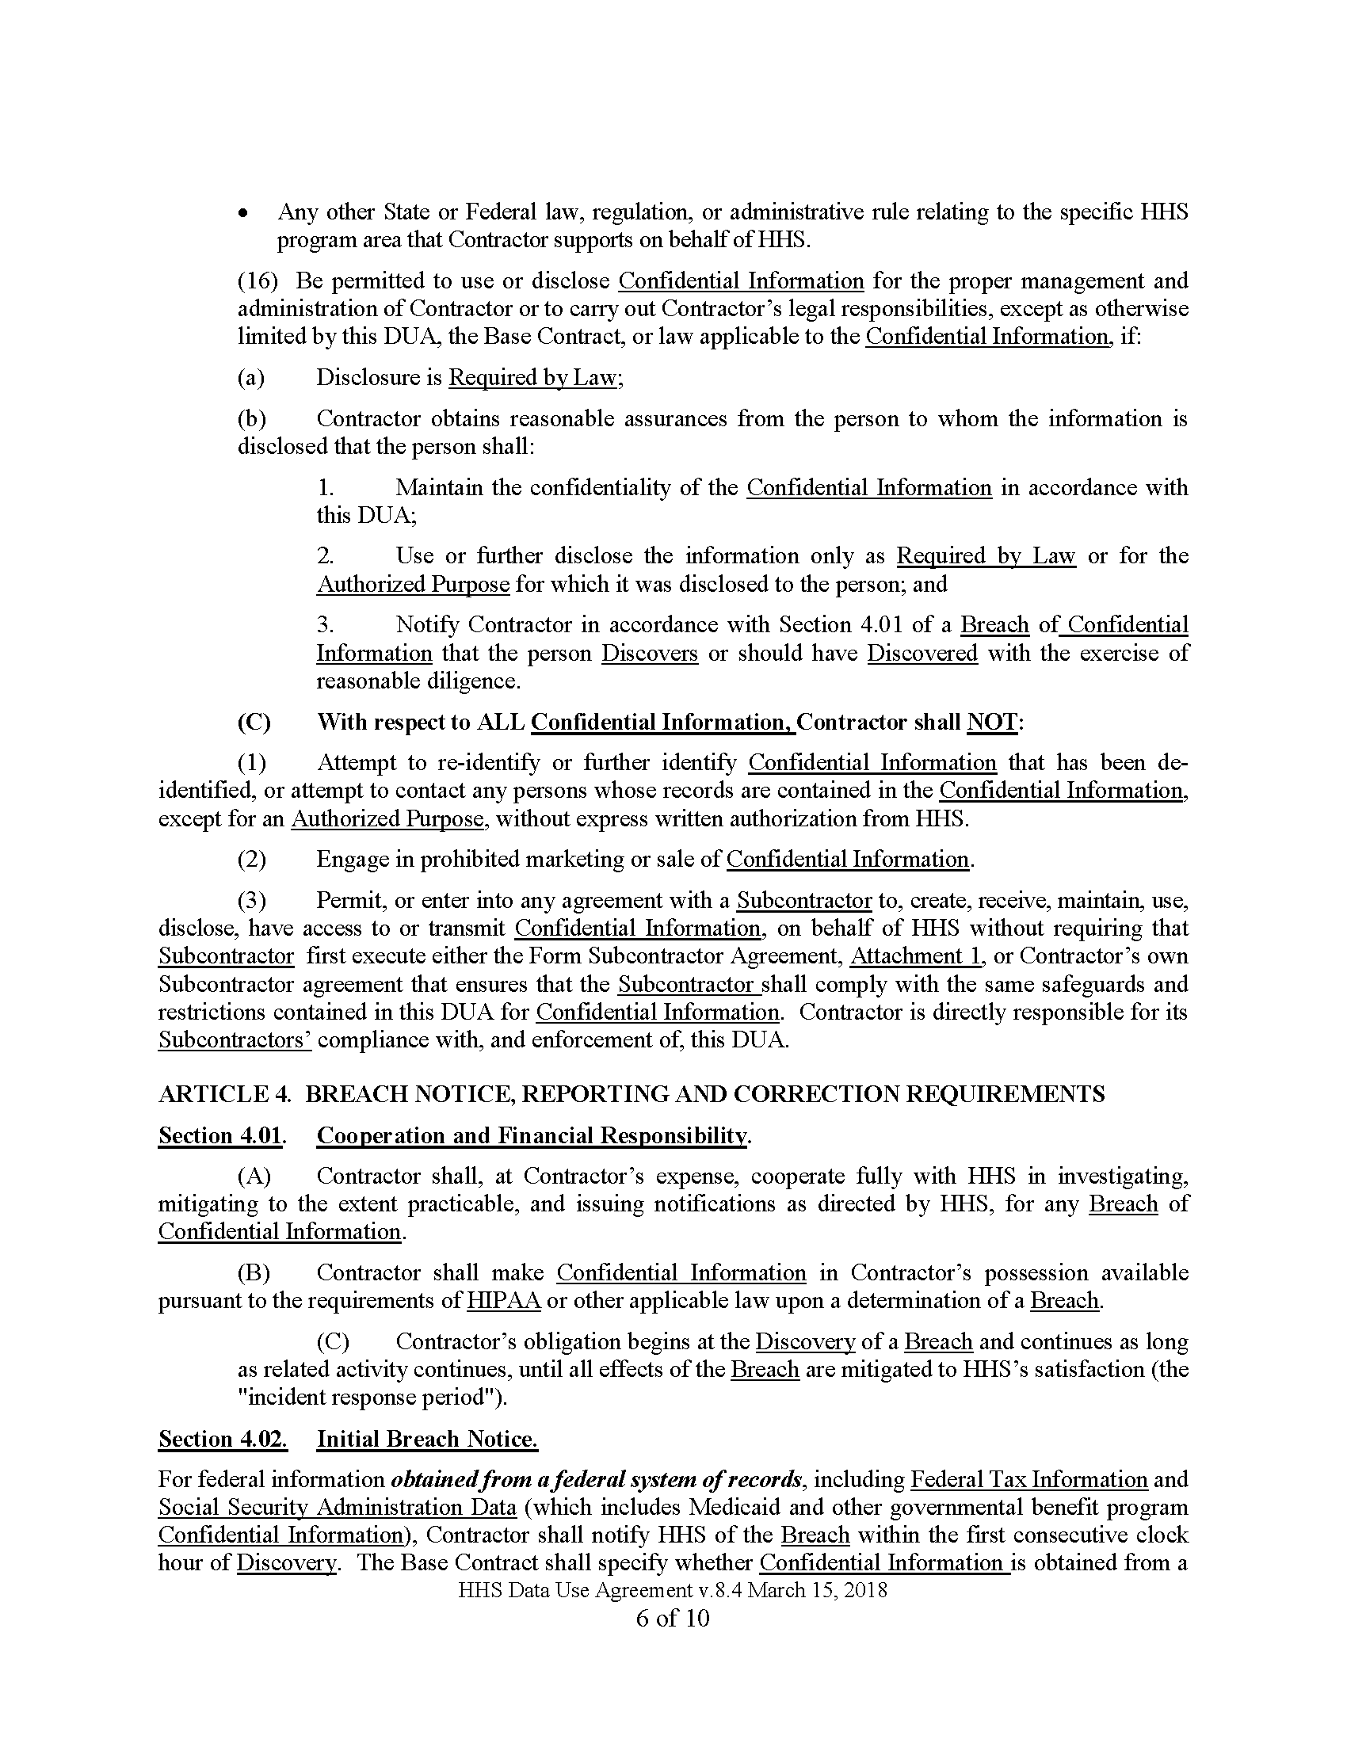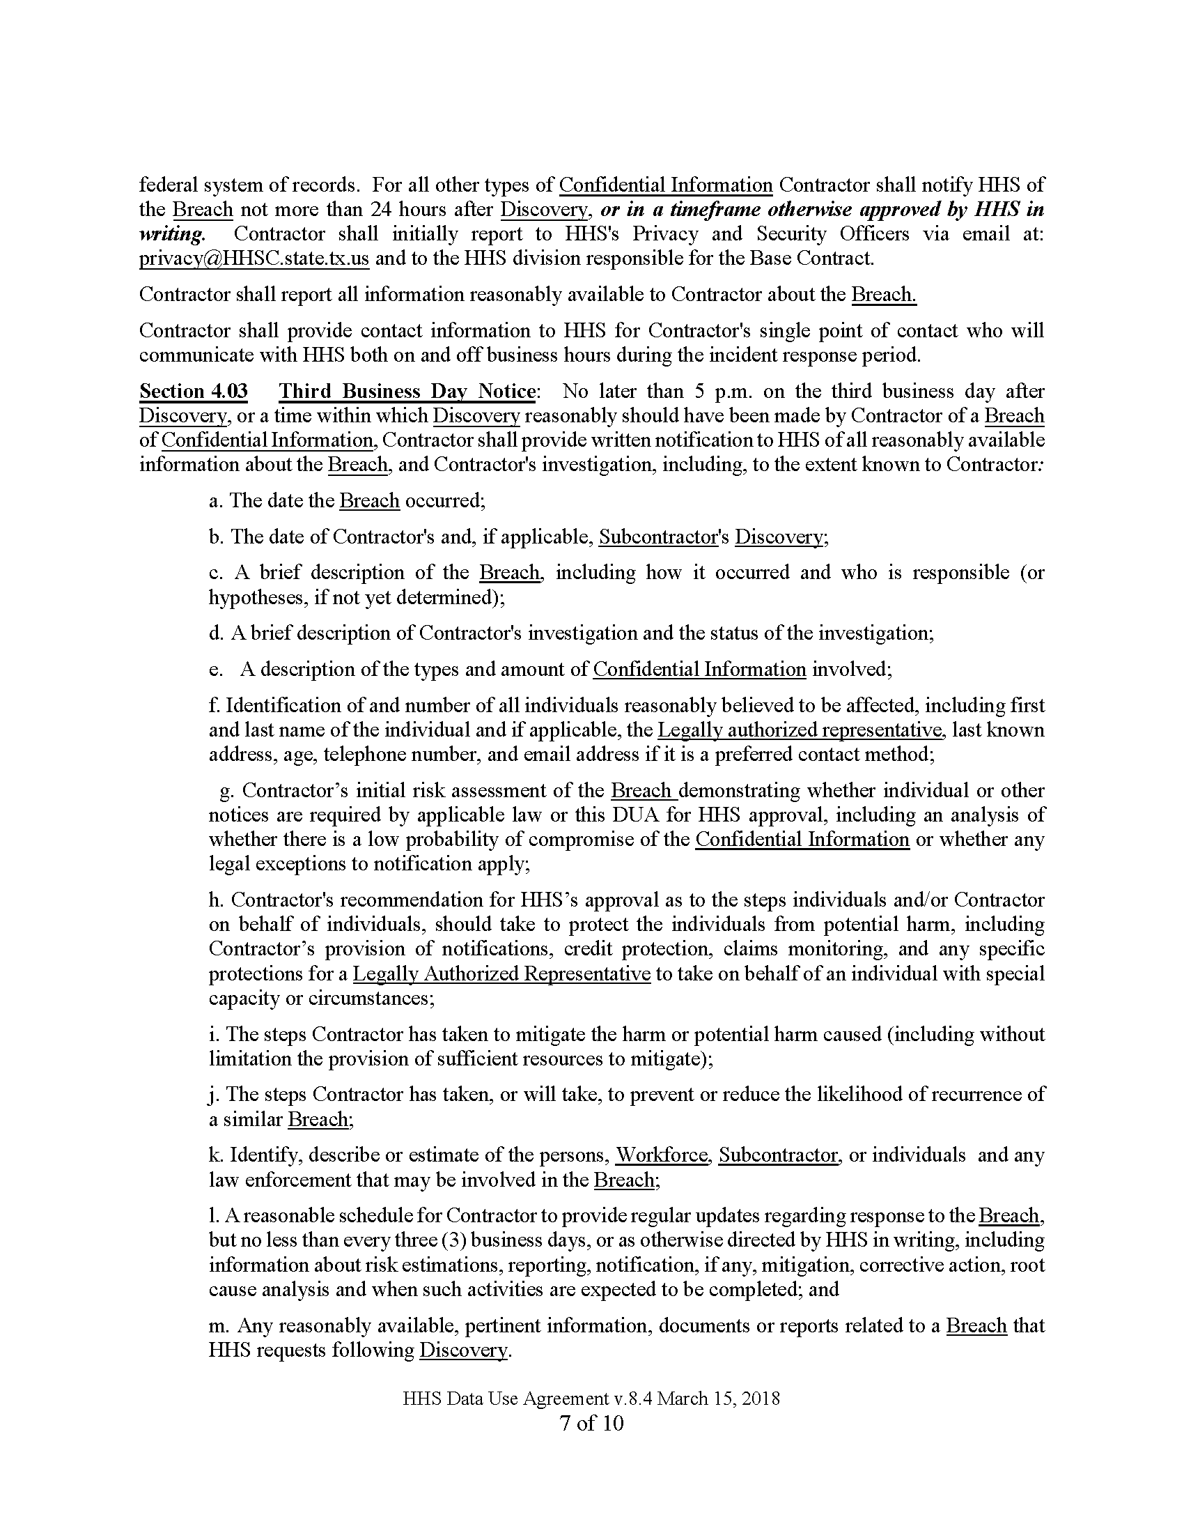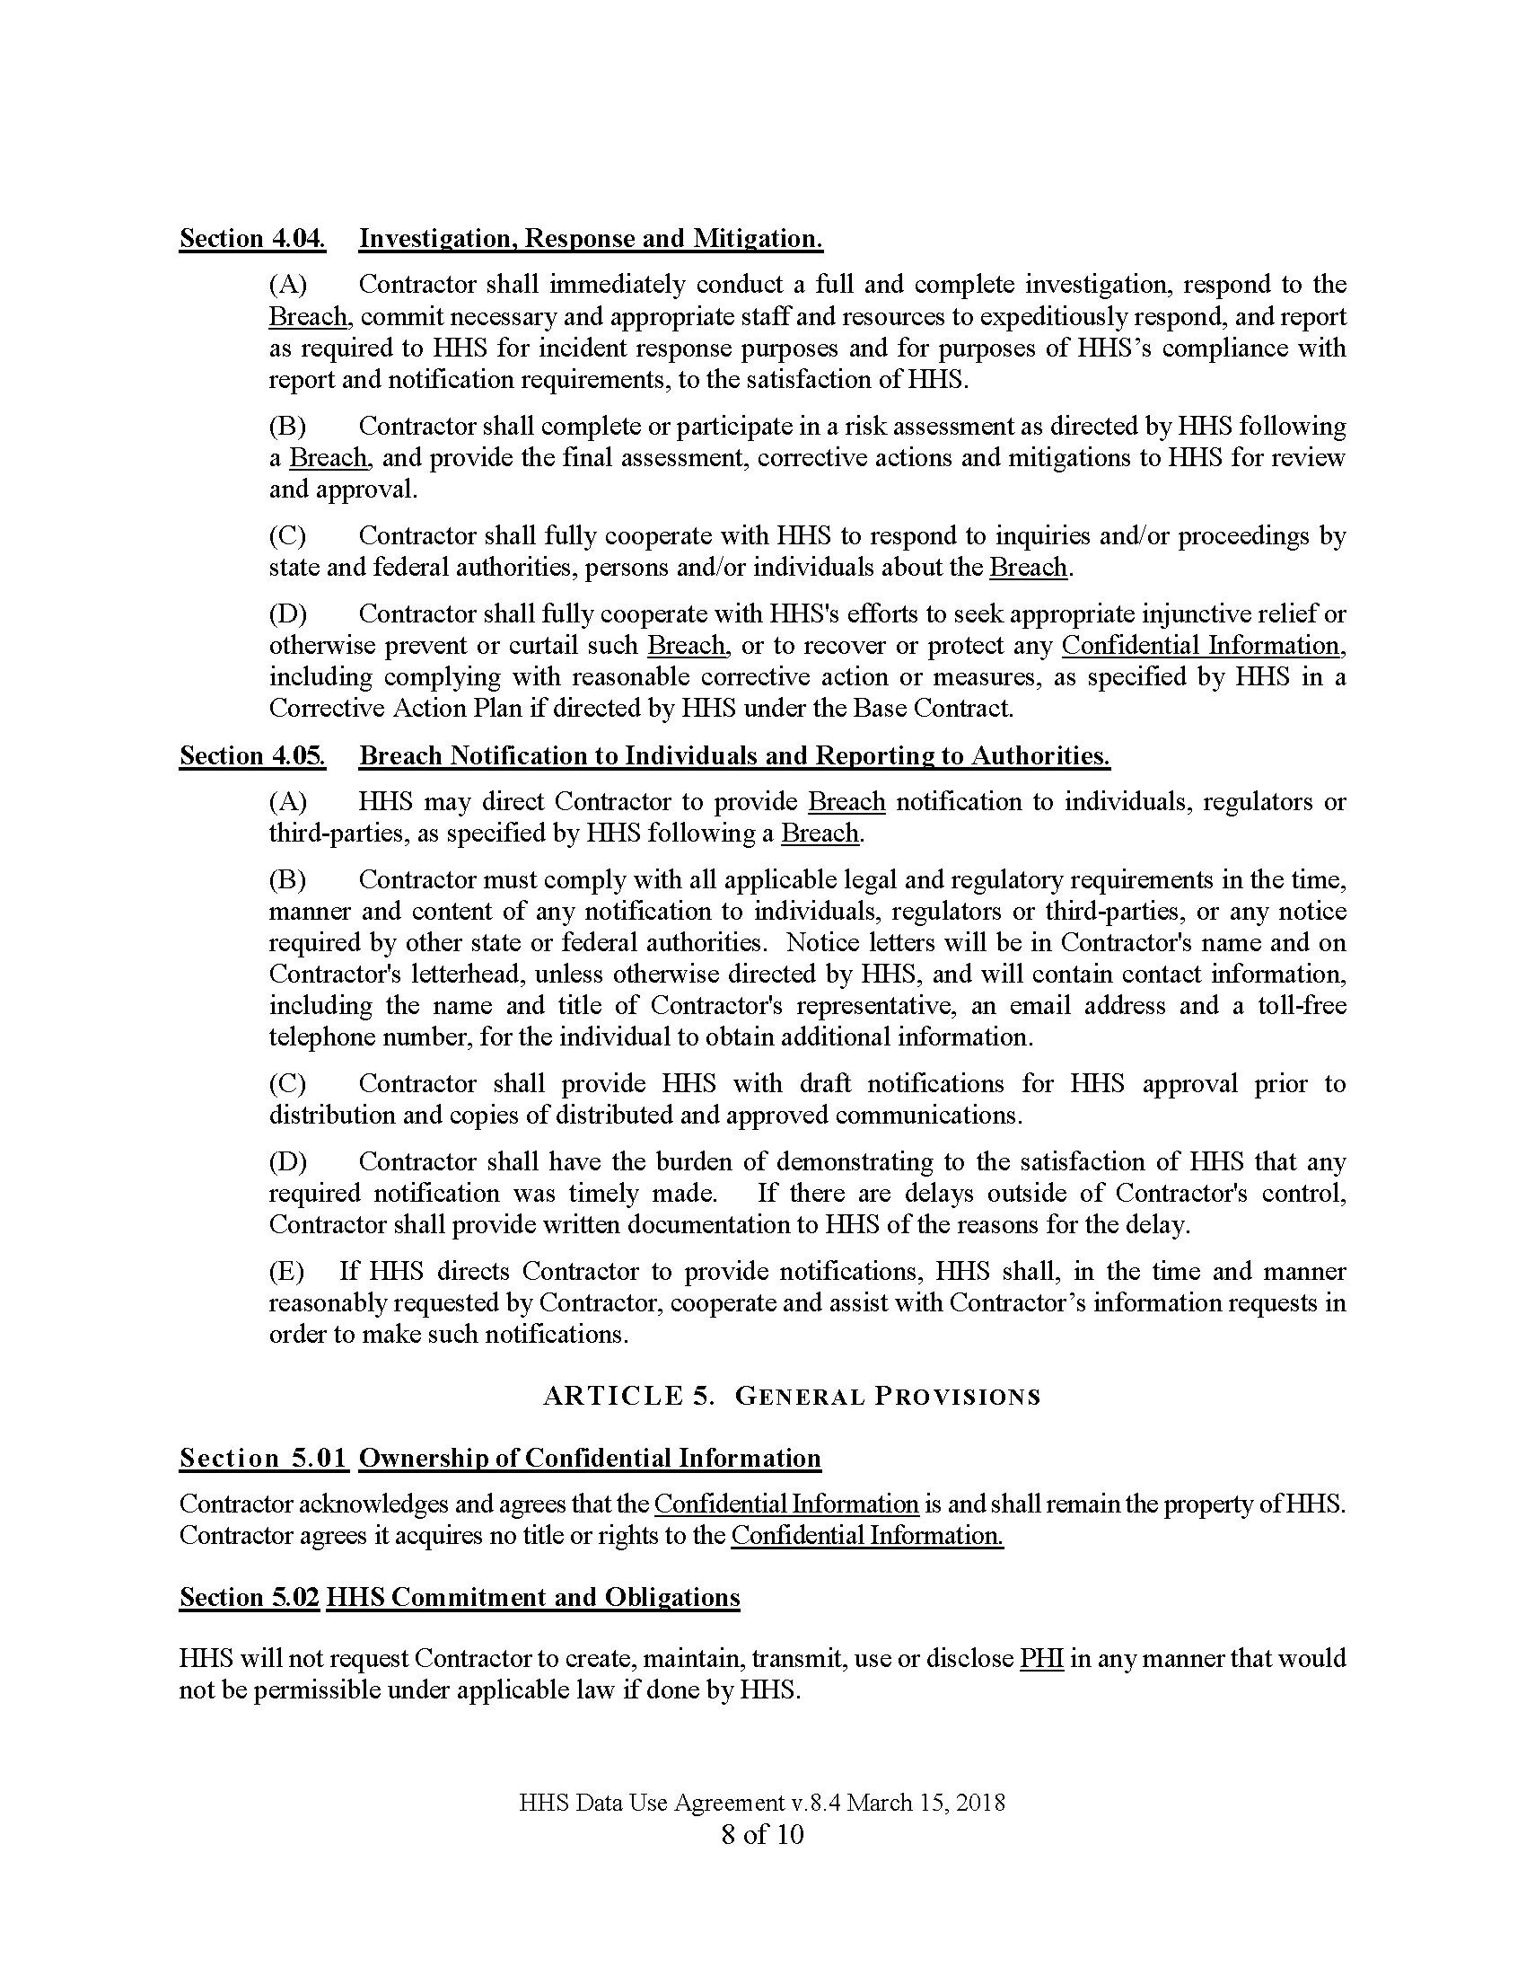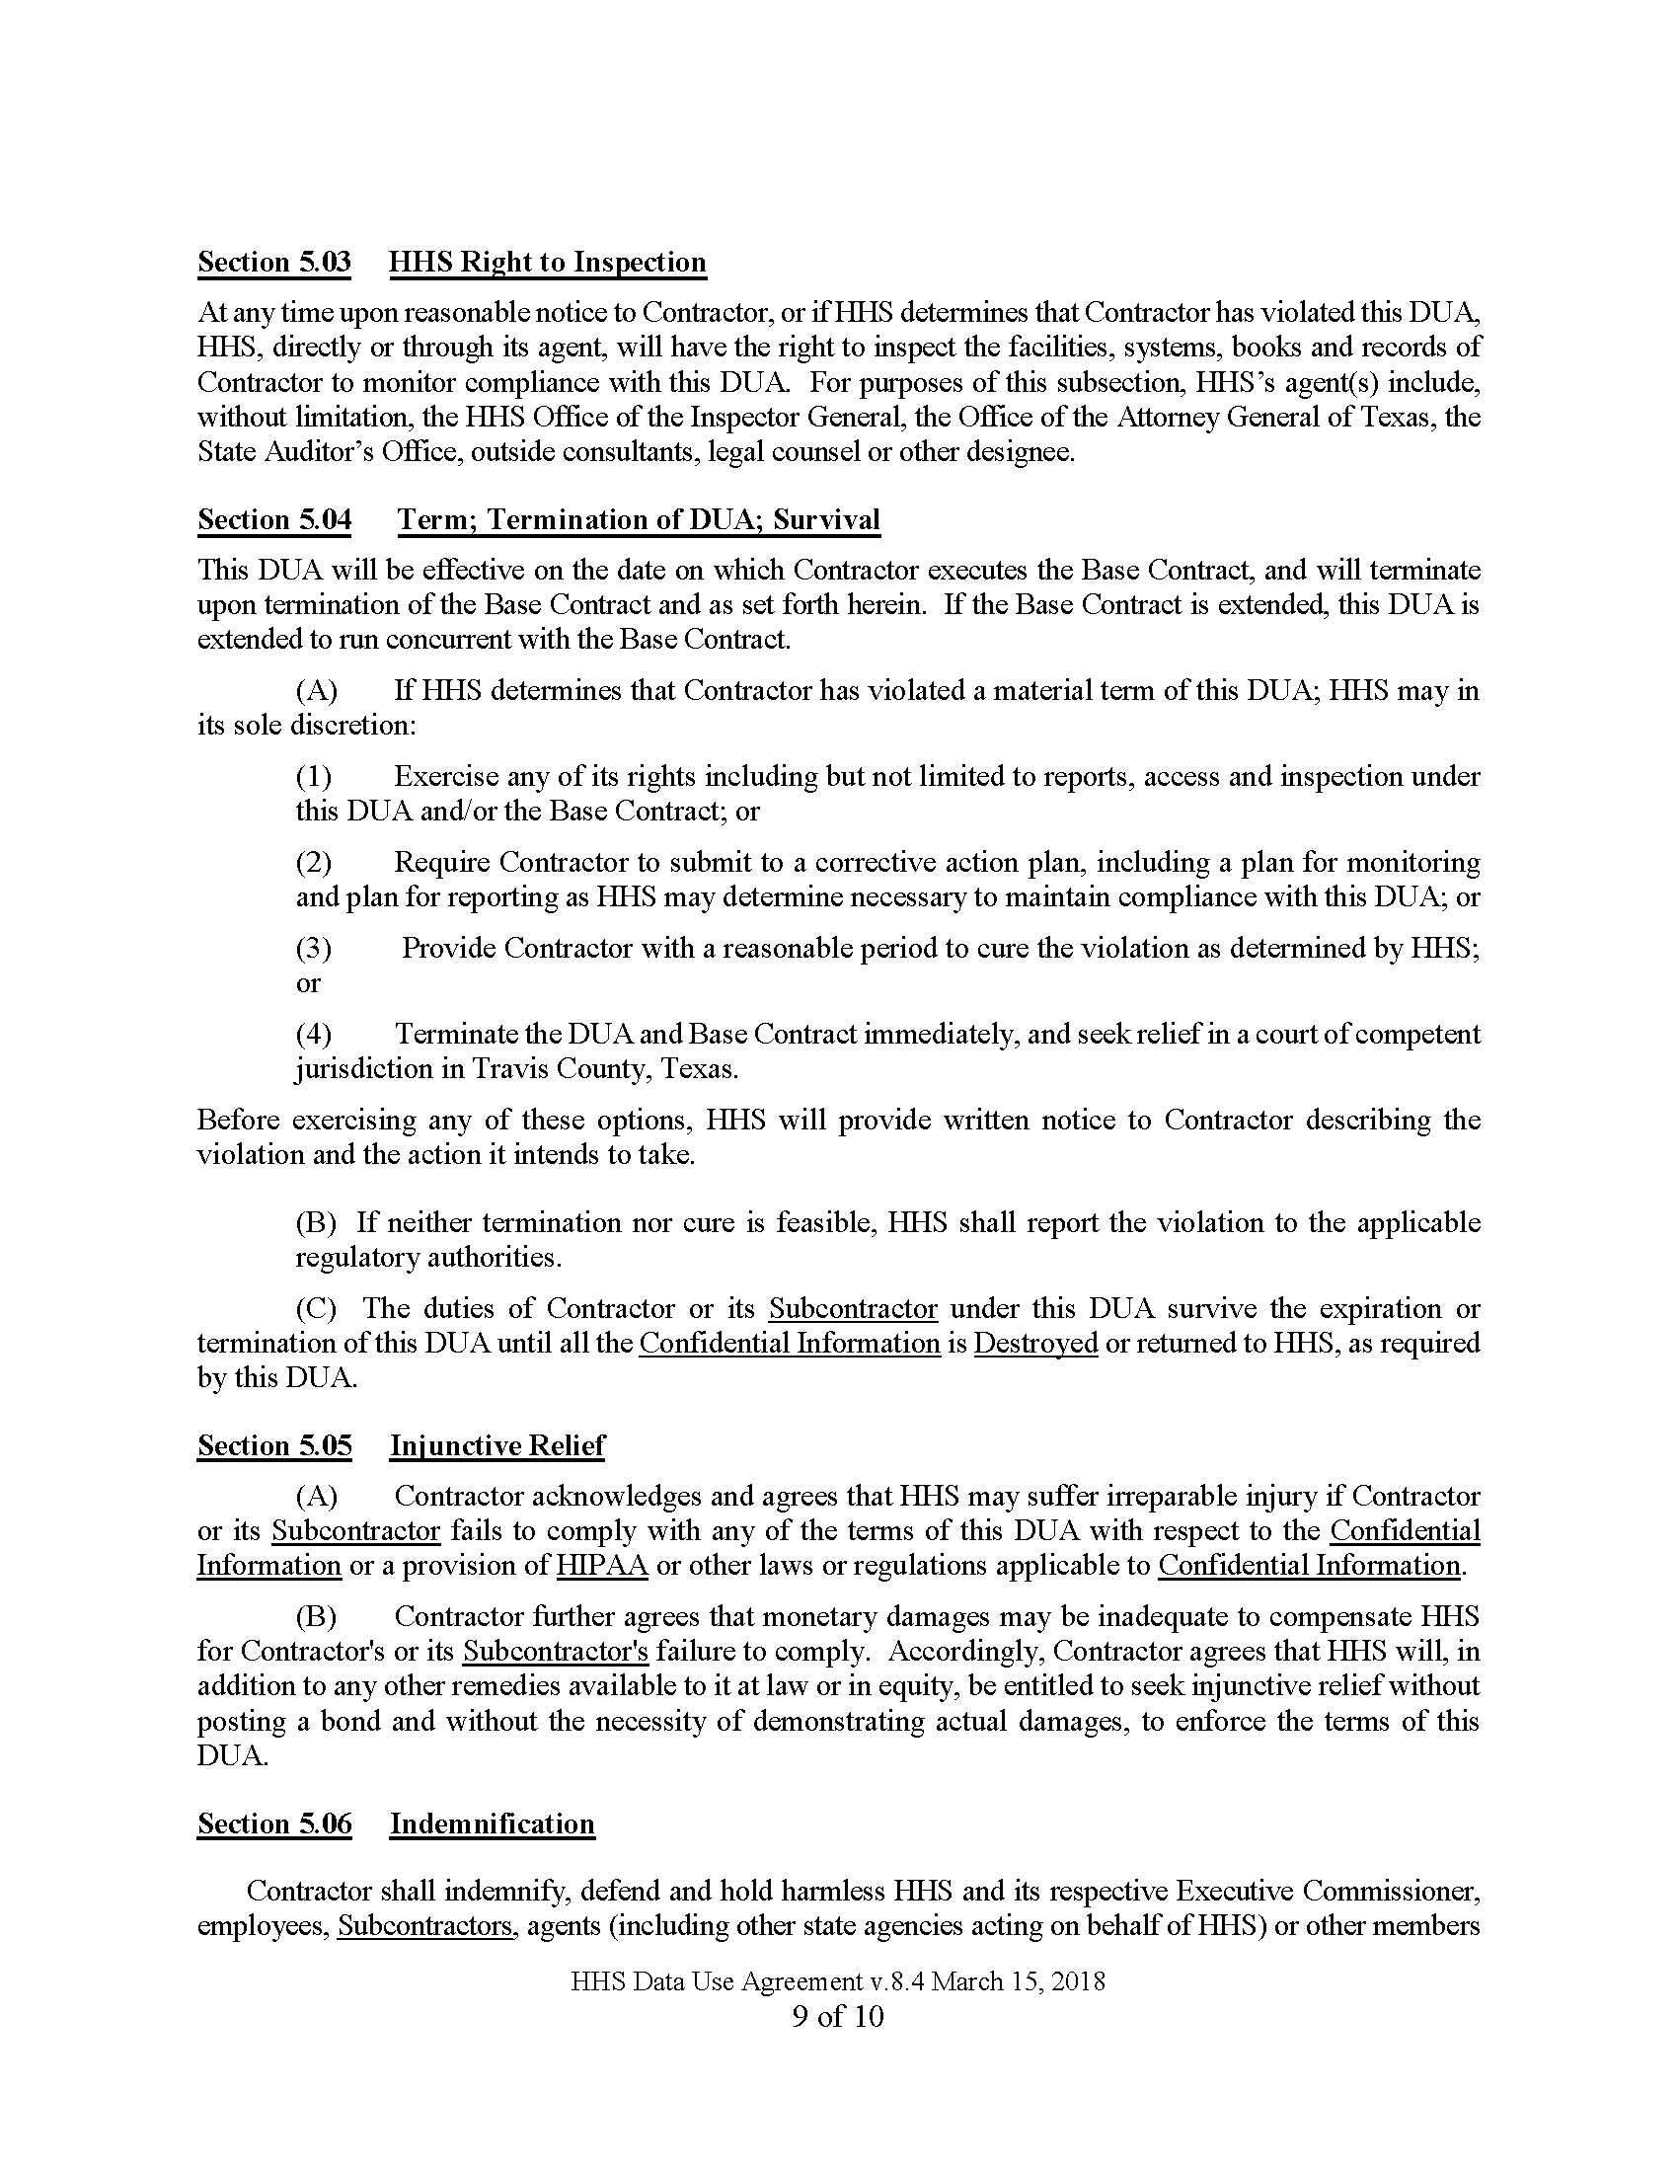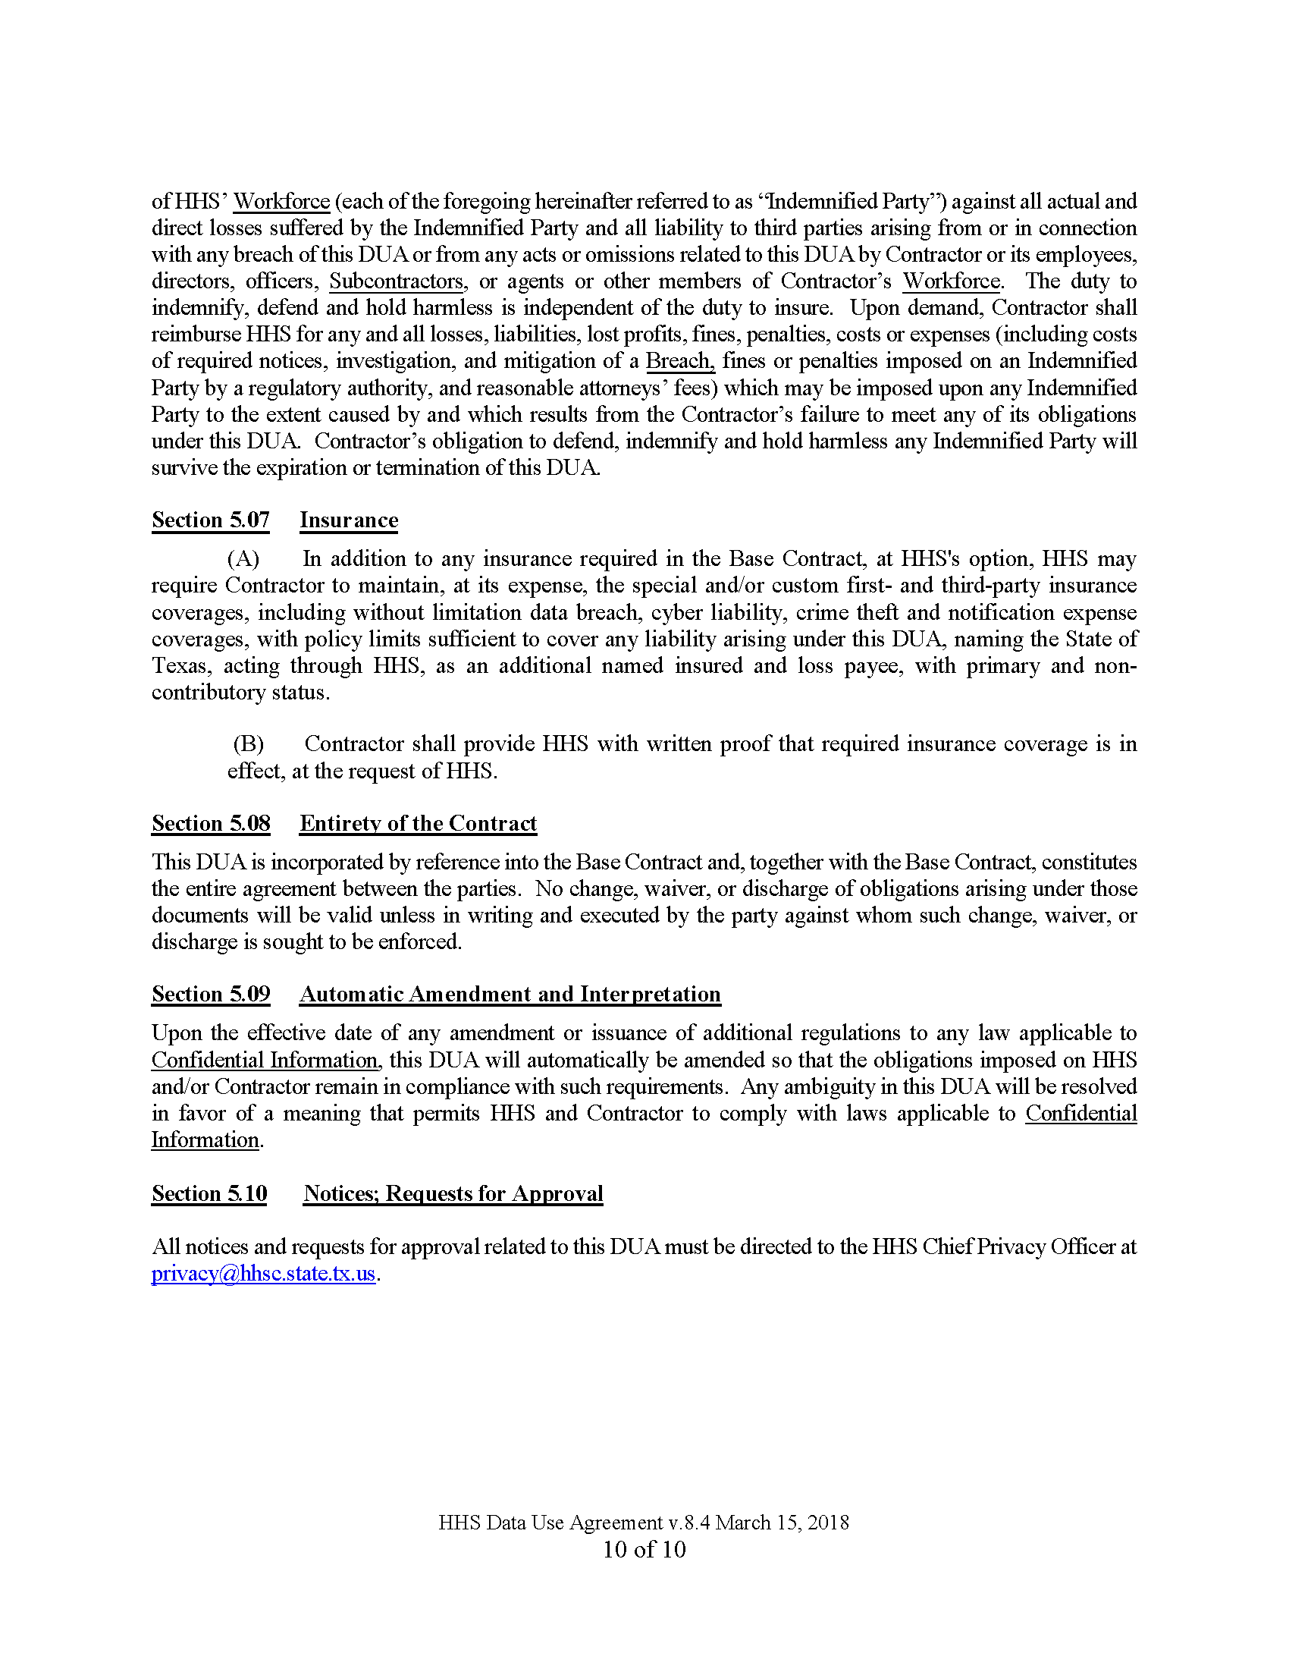

APPENDIX D: Contract Affirmations

